# Functional Specification – Report

Export Import Bank of Thailand

|  |  |
| --- | --- |
| Project Code: | EXPJ.B.PJ.TH.EXIMTH*CBS_IMP.CC |
| Reference: | DEP-FS11 |
| Release: | 2.5 |
| Status: | Released for External Distribution |
| Date | 10-Sep-23 |

Contents

Functional Specification – Report 1

Functional Summary 24

Report Specification 24

1. Financial Foreign Currency Internal Fund Transfer Report 24

1.1. Purpose 24

1.2. Background 24

1.3. Supported Sample Transaction and Case from Customer 25

1.4. Menu Modification 25

1.5. Screen Layout and Data Sheet 25

1.6. Business Rule / Business Logic 25

1.7. To-be Process 25

1.8. File / API Layout and Data Sheet 25

1.9 Report Layout and Data Sheet 26

1.10 Additional Impacts 26

2. Outward Clearing Cheque Return Report 27

2.1. Purpose 27

2.2. Background 27

2.3. Supported Sample Transaction and Case from Customer 27

2.4. Menu Modification 28

2.5. Screen Layout and Data Sheet 28

2.6. Business Rule / Business Logic 28

2.7. To-Be Process 29

2.8. File / API Layout and Data Sheet 29

2.9. Report Layout and Data Sheet 29

2.9.1. Cheque returned notification 29

2.9.2. Debit note 30

2.9.3. Cheque return report 31

2.10. Additional Impacts 32

3. Returned Cheque Notification and Debit Note 32

3.1. Purpose 33

3.2. Background 33

3.3. Supported Sample Transaction and Case from Customer 33

3.4. Menu Modification 34

3.5. Screen Layout and Data Sheet 34

3.6. Business Rule / Business Logic 35

3.7. To-Be Process 35

3.8. File / API Layout and Data Sheet 35

3.9. Report Layout and Data Sheet 35

3.9.1. Cheque Returned Voucher 35

3.9.2. Debit note 36

3.10. Additional Impacts 37

4. Debit Note/Credit Note 38

4.1. Purpose 38

4.2. Background 38

4.3. Supported Sample Transaction and Case from Customer 39

4.3.1. Debit note 39

4.3.1.1. Internal fund transfer currency conversion 39

4.3.1.2. Outgoing fund transfer 43

4.3.1.3. Cheque fees 45

4.3.1.4. Bank confirmation fees 47

4.3.1.5. TD Payout 50

4.3.1.6. CASA Account transfer 53

4.3.1.7. Overdraft interest 54

4.3.1.8. Withdraw from saving account and issue cashier cheque 56

4.3.1.9. Close account and the rest of the money is bank income 57

4.3.1.10. Close account and issue cashier cheque 58

4.3.1.11. Customer request to issue unclear cheque 59

4.3.1.12. Close account and issue unclear cheque 60

4.3.1.13. Freeze account and issue cashier cheque 61

4.3.1.14. Dormant account fees 63

4.3.2. Credit note 66

4.3.2.1. Outward clearing cheque 66

4.3.2.2. Interest payable 67

4.3.2.3. Incoming fund transfer 68

4.3.2.4. TD Placement 70

4.3.2.5. Fees refund 71

4.4. Menu Modification 72

4.5. Screen Layout and Data Sheet 72

4.6. Business Rule / Business Logic 72

4.7. To-be Process 73

4.8. File / API Layout and Data Sheet 73

4.9. Report Layout and Data Sheet 73

4.9.1. Debit note 73

4.9.2. Overdraft interest debit note 75

4.9.3. Dormant account fees debit note 76

4.9.4. Credit note 77

4.10. Additional Impacts 77

5. Account Opening Application Form 78

5.1. Purpose 78

5.2. Background 78

5.3. Supported Sample Transaction and Case from Customer 78

5.3.1. Current Application form 78

5.3.2. Saving Application form 78

5.3.3. FCD Application form 78

5.3.4. Special Saving form 78

5.3.5. Customer Clearing Account form 79

5.4. Menu Modification 79

5.5. Screen Layout and Data Sheet 79

5.6. Business Rule / Business Logic 79

5.7. To-be Process 80

5.8. File / API Layout and Data Sheet 80

5.9. Report Layout and Data Sheet 80

5.10. Additional Impacts 80

6. Pre-Dormant Notification Letter 80

6.1. Purpose 80

6.2. Background 80

6.3. Supported Sample Transaction and Case from Customer 81

6.4. Menu Modification 82

6.5. Screen Layout and Data Sheet 82

6.6. Business Rule / Business Logic 82

6.7. To-be Process 82

6.8. File / API Layout and Data Sheet 82

6.9. Report Layout and Data Sheet 82

6.10. Additional Impacts 82

7. Time Deposit Certificate 83

7.1. Purpose 83

7.2. Background 83

7.3. Supported Sample Transaction and Case from Customer 84

7.4. Menu Modification 84

7.5. Screen Layout and Data Sheet 84

7.6. Business Rule / Business Logic 84

7.7. To-be Process 84

7.8. File / API Layout and Data Sheet 84

7.9. Report Layout and Data Sheet 85

7.10. Additional Impacts 85

8. Non-Resident Report 86

8.1. Purpose 86

8.2. Background 86

8.3. Supported Sample Transaction and Case from Customer 86

8.4. Menu Modification 87

8.5. Screen Layout and Data Sheet 87

8.6. Business Rule / Business Logic 87

8.7. To-be Process 87

8.8. File / API Layout and Data Sheet 87

8.9. Report Layout and Data Sheet 87

8.10. Additional Impacts 88

9. Cheque Duty Fees Remittance Report 89

9.1. Purpose 89

9.2. Background 89

9.3. Supported Sample Transaction and Case from Customer 90

9.4. Menu Modification 90

9.5. Screen Layout and Data Sheet 91

9.6. Business Rule / Business Logic 91

9.7. To-be Process 91

9.8. File / API Layout and Data Sheet 91

9.9. Report Layout and Data Sheet 91

9.10. Additional Impacts 92

10. Daily Summary Clearing Cheque Report 93

10.1. Purpose 93

10.2. Background 93

10.3. Supported Sample Transaction and Case from Customer 93

10.4. Menu Modification 95

10.5. Screen Layout and Data Sheet 95

10.6. Business Rule / Business Logic 95

10.7. To-be Process 95

10.8. File / API Layout and Data Sheet 95

10.9. Report Layout and Data Sheet 95

10.10. Additional Impacts 96

11. Post Cheque Report 97

11.1. Purpose 97

11.2. Background 97

11.3. Supported Sample Transaction and Case from Customer 97

11.4. Menu Modification 98

11.5. Screen Layout and Data Sheet 98

11.6. Business Rule / Business Logic 98

11.7. To-be Process 98

11.8. File / API Layout and Data Sheet 98

11.9. Report Layout and Data Sheet 98

11.10. Additional Impacts 100

12. Not Post Cheque Report 101

12.1. Purpose 101

12.2. Background 101

12.3. Supported Sample Transaction and Case from Customer 101

12.4. Menu Modification 101

12.5. Screen Layout and Data Sheet 102

12.6. Business Rule / Business Logic 102

12.7. To-be Process 102

12.8. File / API Layout and Data Sheet 102

12.9. Report Layout and Data Sheet 102

12.10. Additional Impacts 103

13. Return Cheque Report 104

13.1. Purpose 104

13.2. Background 104

13.3. Supported Sample Transaction and Case from Customer 104

13.4. Menu Modification 105

13.5. Screen Layout and Data Sheet 105

13.6. Business Rule / Business Logic 105

13.7. To-be Process 105

13.8. File / API Layout and Data Sheet 105

13.9. Report Layout and Data Sheet 105

13.10. Additional Impacts 106

14. Cash Deposit Report >= 2 Million 106

14.1. Purpose 107

14.2. Background 107

14.3. Supported Sample Transaction and Case from Customer 107

14.4. Menu Modification 108

14.5. Screen Layout and Data Sheet 108

14.6. Business Rule / Business Logic 108

14.7. To-be Process 108

14.8. File / API Layout and Data Sheet 108

14.9. Report Layout and Data Sheet 108

14.10. Additional Impacts 109

15. Deposit Transaction more than 1 time 110

15.1. Purpose 110

15.2. Background 110

15.3. Supported Sample Transaction and Case from Customer 110

15.4. Menu Modification 111

15.5. Screen Layout and Data Sheet 111

15.6. Business Rule / Business Logic 111

15.7. To-be Process 111

15.8. File / API Layout and Data Sheet 112

15.9. Report Layout and Data Sheet 112

15.10. Additional Impacts 113

16. Overdraft / Accrued / Saving Interest Report 114

16.1. Purpose 114

16.2. Background 114

16.3. Supported Sample Transaction and Case from Customer 114

16.4. Menu Modification 117

16.5. Screen Layout and Data Sheet 117

16.6. Business Rule / Business Logic 118

16.7. To-be Process 118

16.8. File / API Layout and Data Sheet 118

16.9. Report Layout and Data Sheet 118

16.9.1. Overdraft interest report 118

16.9.2. Accrued interest report 119

16.9.3. Interest payable report 121

16.10. Additional Impacts 121

17. Statement 122

17.1. Purpose 122

17.2. Background 122

17.3. Supported Sample Transaction and Case from Customer 122

17.4. Menu Modification 126

17.5. Screen Layout and Data Sheet 126

17.6. Business Rule / Business Logic 126

17.7. To-be Process 126

17.8. File / API Layout and Data Sheet 126

17.9. Report Layout and Data Sheet 126

17.9.1. CA/SA 126

17.9.2. TD by sub-account 128

17.9.3. TD by consolidates 131

17.10. Additional Impacts 132

18. List of top 20 Customer by transaction amount 133

18.1. Purpose 133

18.2. Background 133

18.3. Supported Sample Transaction and Case from Customer 133

18.4. Menu Modification 134

18.5. Screen Layout and Data Sheet 134

18.6. Business Rule / Business Logic 134

18.7. To-be Process 134

18.8. File / API Layout and Data Sheet 134

18.9. Report Layout and Data Sheet 134

18.9.1. List 20 CusID 134

18.9.2. ข้อมูลบัญชีลูกค้าเพื่อจัดทำงบการเงิน 135

18.10. Additional Impacts 137

19. Account Balance Report 137

19.1. Purpose 137

19.2. Background 137

19.3. Supported Sample Transaction and Case from Customer 138

19.4. Menu Modification 141

19.5. Screen Layout and Data Sheet 141

19.6. Business Rule / Business Logic 141

19.7. To-be Process 141

19.8. File / API Layout and Data Sheet 141

19.9. Report Layout and Data Sheet 142

19.10. Additional Impacts 143

20. Overdraft Account Report 144

20.1. Purpose 144

20.2. Background 144

20.3. Supported Sample Transaction and Case from Customer 144

20.4. Menu Modification 145

20.5. Screen Layout and Data Sheet 145

20.6. Business Rule / Business Logic 145

20.7. To-be Process 145

20.8. File / API Layout and Data Sheet 146

20.9. Report Layout and Data Sheet 146

20.9.1. Overdraft without limit 146

20.9.2. With limit 147

20.10. Additional Impacts 148

21. Overdraft Account Summary Report 149

21.1. Purpose 149

21.2. Background 149

21.3. Supported Sample Transaction and Case from Customer 149

21.4. Menu Modification 149

21.5. Screen Layout and Data Sheet 149

21.6. Business Rule / Business Logic 149

21.7. To-be Process 150

21.8. File / API Layout and Data Sheet 150

21.9. Report Layout and Data Sheet 150

21.9.1. Overdraft without limit 150

21.10. Additional Impacts 150

22. Inactive Account Report 150

22.1. Purpose 151

22.2. Background 151

22.3. Supported Sample Transaction and Case from Customer 151

22.4. Menu Modification 152

22.5. Screen Layout and Data Sheet 152

22.6. Business Rule / Business Logic 152

22.7. To-be Process 152

22.8. File / API Layout and Data Sheet 153

22.9. Report Layout and Data Sheet 153

22.9.1. Inactive account with all credit limits and without limits (Dormant account) 153

22.9.2. Inactive account without limit 154

22.10. Additional Impacts 155

23. 50 bis Withholding Tax 155

23.1. Purpose 155

23.2. Background 155

23.3. Supported Sample Transaction and Case from Customer 155

23.4. Menu Modification 157

23.5. Screen Layout and Data Sheet 157

23.6. Business Rule / Business Logic 157

23.7. To-be Process 157

23.8. File / API Layout and Data Sheet 157

23.9. Report Layout and Data Sheet 157

23.10. Additional Impacts 159

24. PND Withholding Tax 160

24.1. Purpose 160

24.2. Background 160

24.3. Supported Sample Transaction and Case from Customer 160

24.4. Menu Modification 163

24.5. Screen Layout and Data Sheet 163

24.6. Business Rule / Business Logic 163

24.7. To-be Process 163

24.8. File / API Layout and Data Sheet 164

24.9. Report Layout and Data Sheet 164

24.9.1. Corporate (PND. 53) 164

24.9.2. Individual (PND. 2) 165

24.9.3. Summary (PND. 2A) 165

24.10. Additional Impacts 166

25. Withholding tax 166

25.1. Purpose 166

25.2. Background 166

25.3. Supported Sample Transaction and Case from Customer 166

25.4. Menu Modification 168

25.5. Screen Layout and Data Sheet 168

25.6. Business Rule / Business Logic 168

25.7. To-be Process 168

25.8. File / API Layout and Data Sheet 169

25.9. Report Layout and Data Sheet 169

25.9.1. Corporate 169

25.9.2. Individual 170

25.10. Additional Impacts 171

26. Tax of Interest text file 172

26.1. Purpose 172

26.2. Background 172

26.3. Supported Sample Transaction and Case from Customer 172

26.4. Menu Modification 176

26.5. Screen Layout and Data Sheet 176

26.6. Business Rule / Business Logic 176

26.7. To-be Process 176

26.8. File / API Layout and Data Sheet 176

26.9. Report Layout and Data Sheet 176

26.10. Additional Impacts 176

27. Overdraft Limit Report 177

27.1. Purpose 177

27.2. Background 177

27.3. Supported Sample Transaction and Case from Customer 177

27.4. Menu Modification 178

27.5. Screen Layout and Data Sheet 178

27.6. Business Rule / Business Logic 178

27.7. To-be Process 178

27.8. File / API Layout and Data Sheet 178

27.9. Report Layout and Data Sheet 178

27.10. Additional Impacts 179

28. Account Opening Report 180

28.1. Purpose 180

28.2. Background 180

28.3. Supported Sample Transaction and Case from Customer 180

28.4. Menu Modification 184

28.5. Screen Layout and Data Sheet 184

28.6. Business Rule / Business Logic 184

28.7. To-be Process 184

28.8. File / API Layout and Data Sheet 184

28.9. Report Layout and Data Sheet 184

28.9.1. Opened accounts report 184

28.9.2. Closed accounts report 185

28.9.3. report for accounts without credit limit 186

28.9.4 Others report 186

28.10. Additional Impacts 186

29. Pre-Dormant Report 187

29.1. Purpose 187

29.2. Background 187

29.3. Supported Sample Transaction and Case from Customer 187

29.4. Menu Modification 188

29.5. Screen Layout and Data Sheet 188

29.6. Business Rule / Business Logic 188

29.7. To-be Process 188

29.8. File / API Layout and Data Sheet 189

29.9. Report Layout and Data Sheet 189

29.9.1. Pre-dormant report 189

29.9.2. Dormant fees report 190

29.10. Additional Impacts 190

30. Uncollected Service Charge Report 191

30.1. Purpose 191

30.2. Background 191

30.3. Supported Sample Transaction and Case from Customer 191

30.4. Menu Modification 191

30.5. Screen Layout and Data Sheet 191

30.6. Business Rule / Business Logic 191

30.7. To-be Process 192

30.8. File / API Layout and Data Sheet 192

30.9. Report Layout and Data Sheet 192

30.10. Additional Impacts 193

31. Overdraft Projection Report 193

31.1. Purpose 193

31.2. Background 193

31.3. Supported Sample Transaction and Case from Customer 193

31.4. Menu Modification 193

31.5. Screen Layout and Data Sheet 193

31.6. Business Rule / Business Logic 193

31.7. To-be Process 194

31.8. File / API Layout and Data Sheet 194

31.9. Report Layout and Data Sheet 194

31.10. Additional Impacts 196

Document Acceptance & Release Notice

This is a managed document. Changes will only be issued as a complete replacement document covered by a release notice. All replaced documents shall be destroyed immediately and copies of any obsolete forms destroyed. This document has not been released for use until authorized by the Manager/Project Manager.

All reports mention in this DEP-FS11 Need to be able generated in CBS9. All the data

Needed for all the reports listed as part of the DEP-FS11 should be available in CBS9.

Supported sample transaction and case from customer (Export-Import Bank of Thailand) are used as requirement and design (Wireframe) for CBS9 to develop.

This is release **2.5** of the document.

|  |  |  |  |
| --- | --- | --- | --- |
| Reviewed & Approved |  | Date |  |
|  | | | |
| Accepted |  | Date |  |
|  | |  |  |
| Authorized |  | Date |  |
|  | | | |

Build Status

| Release | Date of Release | Prepared by | Reviewed by | Comments |
| --- | --- | --- | --- | --- |
| 1.0 | 15 June 2023 | Suksri Yodying | Marites Magsajo | Initial Release |
| 1.1 | 17 July 2023 | Suksri Yodying |  | To reflect the comments of EXIM-Deposits Team from the first review |
| 1.2 | 24 July 2023 | Suksri Yodying |  | To reflect the comments of EXIM-Deposits Team from the second review |
| 2.0 | 27 July 2023 | Suksri Yodying |  | Update OD interest projection and Debit note/Credit note form |
| 2.1 | 31 July 2023 | Suksri Yodying |  | Update business logic and sample report layout |
| 2.2 | 9 August 2023 | Suksri Yodying |  | To reflect the comments of EXIM-Deposits Team from the latest review |
| 2.3 | 1 September 2023 | Suksri Yodying |  | Update data items to comply with TOR |
| 2.4 | 6 September 2023 | Suksri Yodying |  | Update from EXIM business unit review |
| 2.5 | 10 September 2023 | Suksri Yodying |  | Add more samples of Debit/Credit Bank Confirmationadvice in section 4.3 |

Introduction

The Deposits workshop activity conducted at the Export-Import Bank of Thailand highlighted all requirements related to the report. However, during the same workshop, it was discovered that there are requirements. The report layout shown in this document are currently in use by Business Unit. If the CBS9 reports are similar, they may consider further.

Abbreviations

The following list defines the abbreviations used in this document.

|  |  |  |
| --- | --- | --- |
| CBS  DEP | -  - | Silverlake Symmetri Core Banking System  CBS9 Deposits Module |
| EXIM  TOR  FS | -  -  - | Export Import Bank of Thailand  Terms of Reference  Functional Specification |
| CA/SA  EOD | -  - | Current Account/ Savings Account  End of Day |
| THB | - | Thai Baht |

References

| ID | Title/Summary | TOR Status | Module |
| --- | --- | --- | --- |
| TOR-DPS#38 | ระบบต้องสร้างรายงานธุรกรรมเงินตราต่างประเทศ สำหรับรายการฝากถอน ระหว่างบัญชี ต่างสกุลเงิน เป็นราย Transaction ได้  The system must generate a foreign currency transaction report. for deposit and withdrawal between accounts in different currencies per transaction | Gap |  |
| TOR-DPS#55 | Outward Clearing: ในกรณีมีเช็คคืน จากการบันทึก Clearing Cheque ระบบสามารถทำรายการเช็คคืน โดยสามารถระบุเหตุผลการคืนเช็ค และสามารถบันทึกการกลับรายการบัญชีอย่างอัตโนมัติ โดยไม่ต้องมีการทำ Release hold การแสดงผลลัพธ์ใน Statement คือ Debit รายการคืนเช็ค ด้วยวันที่ Clearing Cheque Date  In case of cheque return from the Clearing Cheque, the system can perform a return cheque transaction. And able to define the reason for the cheque return. And can automatically record the reversal  The output in the Statement is Debit Cheque Return with Clearing Cheque Date | Gap |  |
| TOR-DPS#65 | สามารถออกใบเช็คคืน เพื่อเป็นหลักฐานให้ลูกค้า ตามแบบฟอร์มที่ธนาคารกำหนด  Able to issue a return cheque as evidence for customers according to the form prescribed by the bank | Gap |  |
| TOR-DPS#66 | สามารถออกใบเสร็จโดยอัตโนมัติเพื่อเก็บค่าธรรมเนียม เมื่อออกใบเช็คคืนให้ลูกค้า  Able to issue receipt automatically to collect fees. When issuing a return cheque to the customer | Gap |  |
| TOR-DPS#67 | การบันทึกรายการฝาก-ถอน ทุกรายการ ระบบต้องสร้างใบแจ้งหัก/เข้าบัญชี (Debit/Credit Note) ตามรูปแบบที่ธนาคารกำหนด โดยสามารถเปลี่ยนแปลงได้ และสามารถเรียกดู/สั่งพิมพ์ย้อนหลังได้  To save data in every deposit-withdrawal transaction, the system must create a debit/credit note in the bank specific form which can be changed and viewed / printed backwards | Gap |  |
| TOR-DPS#68 | สามารถสร้างและสั่งพิมพ์ข้อมูลบนแบบฟอร์มที่ธนาคารกำหนดได้ในระบบ เช่น แบบฟอร์มคำขอเปิดบัญชีเงินฝากและแบบฟอร์มอื่นที่เกี่ยวข้อง  Able to create and print forms specified by the bank in the system, such as the request form for opening a deposit account and other related forms. | Gap |  |
| TOR-DPS#69 | บัญชีที่ไม่มีการเคลื่อนไหวติดต่อกัน 12 เดือน ให้แสดงข้อมูลบนหนังสือออกตามแบบฟอร์มที่ธนาคารกำหนด โดยเรียกรายงานตามประเภทบัญชีหรือทั้งหมดได้  Accounts that have been inactive for 12 consecutive months shall show the information on the letter issued in accordance with the form prescribed by the bank. You can retrieve reports by account type or all. | Gap |  |
| TOR-DPS#70 | สามารถสร้างบัตรเงินฝาก ประเภทบัญชีเงินฝากประจำ ตามรูปแบบที่ธนาคารกำหนด  Able to create a deposit card Fixed deposit account type according to the form specified by the bank | Gap |  |
| TOR-DPS#71 | สามารถค้นหาและจัดทำรายงานสรุปยอดเงินฝากของบัญชีที่เป็นคนต่างชาติ (Non-Resident) เช่น รายงานสรุป Transaction รายวัน, รายงานเงินฝากในบัญชีเกินข้อกำหนดของธปท.  Able to search and prepare a summary of deposit balances of foreign accounts. (Non-resident) such as a daily transaction summary report, a report on deposits in accounts exceeding the BOT's requirements. | Gap |  |
| TOR-DPS#72 | สามารถสร้างรายงานนำส่งอากร (อส.4ก) เพื่อใช้ประกอบการนำส่งค่าอากรไปยังกรมสรรพากร โดยสามารถเรียกพิมพ์รายงานตามช่วงเวลาได้ โดยแบ่งตามประเภทเช็คดังนี้  1) เช็คธสน.  2) Cashier Cheque  Able to create a duty remittance report (Form Aor.Sor. 4 Kor) to support the submission of duties to the Revenue Department which can print reports at intervals Divided by type of check as follows:  1) Check the Bank of Thailand  2) Cashier Check | Gap |  |
| TOR-DPS#73 | สามารถทำสรุปรายงาน Cheque เเบบรายวัน เพื่อตรวจสอบสถานะต่าง ๆ ของ Cheque เช่น การกระทบยอด Cheque เป็นต้น  Able to generate summary cheque daily report to check various status of cheque, such as reconciliation of cheque, etc. | Gap |  |
| TOR-DPS#74 | สร้างรายงานเช็คที่ Post ได้  Able to create a Post cheque report | Gap |  |
| TOR-DPS#75 | สร้างรายงานเช็คที่ไม่สามารถ Post Auto  Able to create a unauto post cheque report |  |  |
| TOR-DPS#76 | สร้างรายงานเช็คคืน  Able to create a return cheque report | Gap |  |
| TOR-DPS#77 | สามารถเรียกรายงานเช็คคืนตามช่วงเวลาและ/หรือลูกค้าที่กำหนดได้  Return cheque reports can be retrieved at specified intervals and/or customers. | Gap |  |
| TOR-DPS#78 | ระบบสามารถสร้างรายงานสำหรับการฝากเงินตั้งแต่ 2 ล้านบาทขึ้นไปได้ ตามช่วงระยะเวลาที่กำหนด  The system can generate reports for deposit of 2 million baht or more according to the specified period. | Gap |  |
| TOR-DPS#79 | ระบบสามารถสร้างรายงานการฝากเงินมากกว่า 1 ครั้งในวันเดียวกันต่อ 1 บัญชีได้  The system can generate report for deposit more than 1 time per 1 account on the same day. | Gap |  |
| TOR-DPS#80 | สามารถสร้างรายงานดอกเบี้ยค้างรับ/ค้างจ่าย, รายงานดอกเบี้ยรับ/ดอกเบี้ยจ่าย โดยสามารถเรียกรายงานของทุกบัญชีหรือแยกตามประเภทบัญชี, สกุลเงิน, สาขา ได้ ในรูปแบบ Online โดยเลือกเงื่อนไขข้อมูลได้ตามที่ธนาคารกำหนด  Able to generate accrued interest / accrued reports, interest income / interest reports, can retrieve reports of all accounts or classified by account type, currency, branch. in near real-times | Gap |  |
| TOR-DPS#81 | สามารถเรียกดู และสั่งพิมพ์รายการเคลื่อนไหวในบัญชี (Statement) รายบัญชี ทุกประเภทบัญชี ตามช่วงเวลาได้ เช่น ประจำวัน, รายเดือน และย้อนหลังได้ กรณีเงินฝากประจำสามารถสร้างและเรียกได้แบบเป็นรายบัญชีและบัญชีย่อยได้  Able to view and print a list of transaction movements (Statement) for each account according to a period of time, such as daily, monthly and past. | Gap |  |
| TOR-DPS#82 | สามารถสรุปรายงานของยอดธุรกรรมตามความต้องการของผู้ใช้งานระบบโดยไม่ต้องอาศัยฝ่ายปฏิบัติการเทคโนโลยีสารสนเทศ ข้อมูลที่ต้องการ เช่น สาขา, Customer ID, ชื่อลูกค้า, เลขที่บัญชี, ประเภทบัญชี, Term, Currency, Amount  Able to summarize reports of transaction amount according to the needs of system users without the need for information technology operations. Required information such as branch, Customer ID, customer name, account number, Term, Currency, Amount. | Gap |  |
| TOR-DPS#83 | สามารถออก Statement ประจำเดือนเพื่อส่งให้ลูกค้า โดยสามารถกำหนดเงื่อนไขการเรียกข้อมูลได้ เช่น เฉพาะบัญชีที่เคลื่อนไหว หรือบัญชีทั้งหมดเป็นต้น โดยสามารถสั่งพิมพ์ทั้งหมดหรือเป็นกลุ่มได้อย่างต่อเนื่อง  Able to issue monthly statement to send to customers You can set retrieval conditions, for example, only active accounts. or all accounts etc. All or batch can be printed continuously. | Gap |  |
| TOR-DPS#84 | สามารถออก Statement ประจำเดือน 6 และ 12 โดยสร้างทุกบัญชีลูกค้า (รวมบัญชีที่ไม่เคลื่อนไหว) สำหรับบัญชีลูกค้าทุกประเภท  Able to issue 6 and 12 monthly statements by creating every customer account (including dormant accounts) for all customer accounts | Gap |  |
| TOR-DPS#85 | สร้างรายงานยอดเงินฝากคงเหลือในบัญชี แยกตามประเภทบัญชี รูปแบบ เป็น All Account และสามารถ Search Criteria ตามประเภทลูกค้า เช่น ประเภทลูกค้าบุคคลธรรมดา, นิติบุคคล, Non-Resident เป็นต้น  Generate account balance report Classified by account type, formatted as All Account, and able to define Search criteria according to customer type such as individual customers, non resident juristic persons, etc. | Gap |  |
| TOR-DPS#86 | สร้างรายงานบัญชีกระแสรายวันที่เป็นหนี้เบิกเกินบัญชี รูปแบบเป็น All Account  Generate overdraft account report formatted as All Account | Gap |  |
| TOR-DPS#87 | กรณีบัญชีเป็นหนี้เบิกเกินบัญชี ตั้งแต่ 3 เดือน หรือ 90 วัน ระบบสามารถสร้างรายงานเฉพาะบัญชีตามเงื่อนไขนี้ ได้  In case of the account is overdraft from 3 months or 90 days, the system can generate a report for only the account under this condition. | Gap |  |
| TOR-DPS#88 | ระบบสามารถสร้างและเรียกดูรายงานบัญชีที่ Inactive โดยสามารถกำหนดเงื่อนไขในช่วงระยะเวลาที่กำหนดได้ในระบบ และสามารถสั่งพิมพ์ออกมาเป็นรูปแบบไฟล์นามสกุล .Txt หรือ .CSV ได้  The system can generate and retrieve reports on Inactive accounts. Conditions can be set for a specified period of time in the system. and can be printed out as a file extension of .Txt or .CSV | Gap |  |
| TOR-DPS#89 | สามารถออกใบภาษีหัก ณ ที่จ่ายเมื่อมีการหักภาษีจากดอกเบี้ย เช่น WHT, 50ทวิ  Able to issue withholding tax slip when tax is deducted from interest, eg WHT, 50bis. | Gap |  |
| TOR-DPS#90 | สามารถสร้างรายงานแสดงข้อมูลดอกเบี้ยและภาษีหัก ณ ที่จ่าย เพื่อนำส่งจำนวนเงินภาษี เช่น ภงด. 2, ภงด.2ก. ภงด 53 เป็นต้น  Able to generate a report showing interest and withholding tax information to submit tax amounts such as PND. 2, PND. 2, PND. 53, etc. | Gap |  |
| TOR-DPS#91 | สามารถสร้างรายงานนำส่งภาษีหัก ณ ที่จ่ายเพื่อใช้ประกอบการนำส่งค่าภาษีไปยังกรมสรรพากร โดยสามารถเรียกพิมพ์รายงานตามช่วงเวลาได้  Able to generate withholding tax remittance report to support tax remittance to the Revenue Department which can print reports at intervals | Gap |  |
| TOR-DPS#92 | สามารถสร้างข้อมูลภาษีจากการจ่ายดอกเบี้ย ตามรูปแบบ ที่กรมสรรพากรกำหนด เช่น Text File และสามารถนำข้อมูลไป Upload เข้าระบบของสรรพากร โดยสามารถแยกตามประเภทลูกค้าได้ เช่น ภงด 2 ภงด 2 ก หรือ ภงด 53 เป็นต้น  อ้างอิงการสร้างข้อมูลภาษี ตาม Tax/Localization Function G-67  Can support the creation of tax information from interest payment according to the format specified by the Revenue Department such as Text File and can be uploaded into the revenue system which can be classified by customer type, such as PND 2, PND 2 Gor, or PND 53, etc.' Refer to tax data generation according to Tax/Localization Function G-67. | Gap |  |
| TOR-DPS#93 | สร้างรายงานวงเงินเบิกเกินบัญชี รูปแบบเป็น All Account โดยแสดงข้อมูลอย่างน้อย เช่น จำนวนเงินตามวงเงิน ยอดเงินเบิกเกินบัญชีใช้ไป และจำนวนเงินคงค้างตามวงเงิน เป็นต้น  Create an overdraft limit report, formatted as All Account, showing at least information such as the limit amount. Overdraft balance used and the outstanding amount according to the limit, etc. | Gap |  |
| TOR-DPS#94 | สามารถสร้างรายงานต่าง ๆ ที่เกี่ยวข้อง เช่น ปริมาณการเปิดบัญชีตามประเภทบัญชี และรายพนักงาน, รายงานบัญชีที่ไม่มีวงเงินสินเชื่อ  Able to generate various related report such as account opening by account type and marketing, report for accounts without credit limit | Gap |  |
| TOR-DPS#95 | ระบบสามารถออกรายงานบัญชีที่ไม่มีการเคลื่อนไหวติดต่อกัน 12 เดือน เป็น .csv หรือ Text file และสามารถตั้งค่าจำนวนเดือนเป็น Parameter ได้  The system can issue a 12-month inactivity report as a .csv or a text file, and the number of months can be set as a parameter. | Gap |  |
| TOR-DEP#04 | รายงานสรุปประจำวันบัญชีเงินฝากสกุลเงินต่างประเทศ ในกรณีที่มียอดคงเหลือน้อยกว่าค่าธรรมเนียมการฝาก  Daily Summary Foreign Currency Report in case the balance is zero or the balance is less than the deposit fee | Gap |  |
| TOR-DEP#09 | สืบเนื่องจาก DEP-04 ในกรณีที่มียอดเงินคงเหลือไม่พอให้หักค่าธรรมเนียมการฝากเงินให้รายงานแสดง 'Uncollection Amount'  According to DEP-04, in case of insufficient balance for deosit fee to be deducted, the report shall show 'Uncollection Amount' | Gap |  |
| TOR-DEP#21 | รองรับการพิมพ์ Statement ได้ทั้ง รายวัน รายสัปดาห์ รายเดือน โดยเชื่อมต่อกับ E-Service  Statements which can be printed on daily, weekly and monthly frequency. Interface with e-Service. | Gap |  |

# Functional Summary

This section provides a report layout list of the software product or any modifications on existing Symmetri CBS9 product.

|  |  |  |
| --- | --- | --- |
| ID | Title/Summary | References |
| EXIM_TH_DEP_FS11 | Report | TOR |

# Report Specification

## Financial Foreign Currency Internal Fund Transfer Report

|  |  |
| --- | --- |
| DPS-38 ระบบต้องสร้างรายงานธุรกรรมเงินตราต่างประเทศ สำหรับรายการฝากถอน ระหว่างบัญชี ต่างสกุลเงิน เป็นราย Transaction ได้ | The system must generate a foreign currency transaction report. for deposit and withdrawal between accounts in different currencies per transaction |

### Purpose

The purpose of this report is to support foreign currency transaction for deposit and withdrawal between accounts in different currencies per transaction.

### Background

* + 1. EXIM Current Business Practice (as-is)
* As is report produced by manually.
* Daily report

1.2.2 BDS Current Functionality

* This report retrieved information from “Internal Funds Transfer” function with details in Debit Account Details section and Credit Account Details section.

### Supported Sample Transaction and Case from Customer

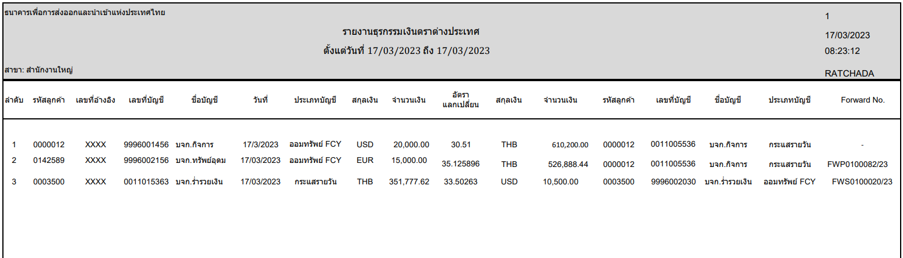

### Menu Modification

Not Applicable.

### Screen Layout and Data Sheet

Not Applicable.

### Business Rule / Business Logic

* Generate report for both Thai currency and Foreign currency transaction of the customer.
* Online report
* Daily report

### To-be Process

The system retrieves information from “Internal Funds Transfer” function with details in Debit Account Details section and Credit Account Details section which can be separated by client branch.

|  |  |
| --- | --- |
| Paper size | A4 |
| Reprinting require | Yes |
| Searching criteria | Client branch, Date range, Account type (Debit, Credit), Account no (Debit, Credit) ,Currency (Debit, Credit) |

### File / API Layout and Data Sheet

Not Applicable.

### Report Layout and Data Sheet

|  |  |
| --- | --- |
| Report Field | Description |
| Header | |
| Page | Display number of page |
| Printed date | Display printed date |
| Printed time | Display printed time |
| Printed by | Display user who login to system |
| Date from____ To ___ | Display date from…to… depend on searching criteria |
| Debit Detail | |
| สาขา (Branch) | Display branch name |
| ลำดับ (No.) | Display sequential of transaction |
| รหัสลูกค้า (Customer ID) | Display customer id |
| เลขที่อ้างอิง (Transaction No) | Display transaction no. |
| เลขที่บัญชี (Account No) | Display account no. |
| ชื่อบัญชี (Account name) | Display account name |
| วันที่ (Date) | Display transaction date |
| ประเภทบัญชี (Account type) | Display account type |
| สกุลเงิน (Currency) | Display currency |
| จำนวนเงิน (Amount) | Display amount |
| อัตราแลกเปลี่ยน (Exchange rate) | Display exchange rate |
| Credit Detail |  |
| สกุลเงิน (Currency) | Display currency |
| จำนวนเงิน (Amount) | Display amount |
| รหัสลูกค้า (Customer ID) | Display customer id |
| เลขที่บัญชี (Account No) | Display account no. |
| ชื่อบัญชี (Account name) | Display account name |
| ประเภทบัญชี (Account type) | Display account type |
| Forward No. | Display forward contract no. |



### Additional Impacts

Not Applicable.

## Outward Clearing Cheque Return Report

|  |  |
| --- | --- |
| DPS-55 Outward Clearing: ในกรณีมีเช็คคืน จากการบันทึก Clearing Cheque ระบบสามารถทำรายการเช็คคืน โดยสามารถระบุเหตุผลการคืนเช็ค และสามารถบันทึกการกลับรายการบัญชีอย่างอัตโนมัติ โดยไม่ต้องมีการทำ Release hold  การแสดงผลลัพธ์ใน Statement คือ Debit รายการคืนเช็ค ด้วยวันที่ Clearing Cheque Date | In case of cheque return from the Clearing Cheque, the system can perform a return cheque transaction. And able to define the reason for the cheque return. And can automatically record the reversal  The output in the Statement is Debit Cheque Return with Clearing Cheque Date |

### Purpose

The purpose is to provide Outward Clearing Cheque Return Report. For deposited other bank cheques.

### Background

* + 1. EXIM Current Business Practice (as-is)
* As is report produced by AS/400.
* Online report

2.2.2 CBS9 Current Functionality

* Checking CBS9 report.

### Supported Sample Transaction and Case from Customer

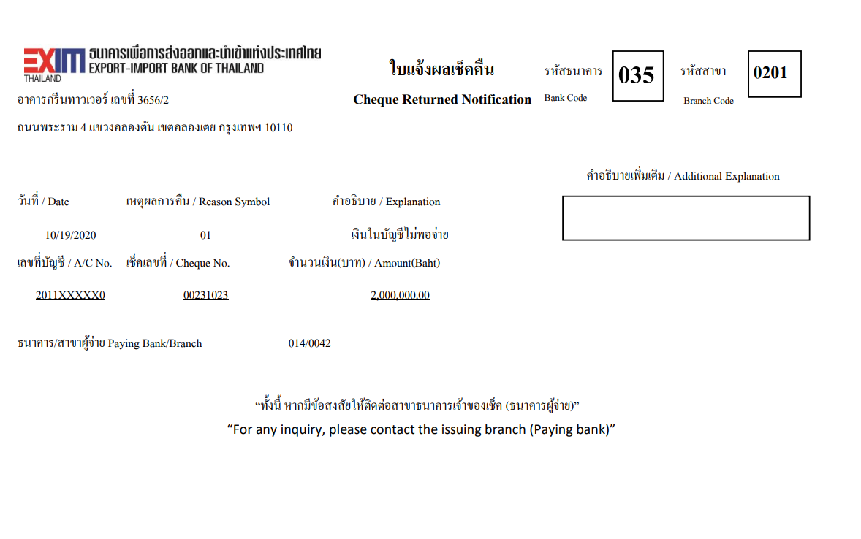

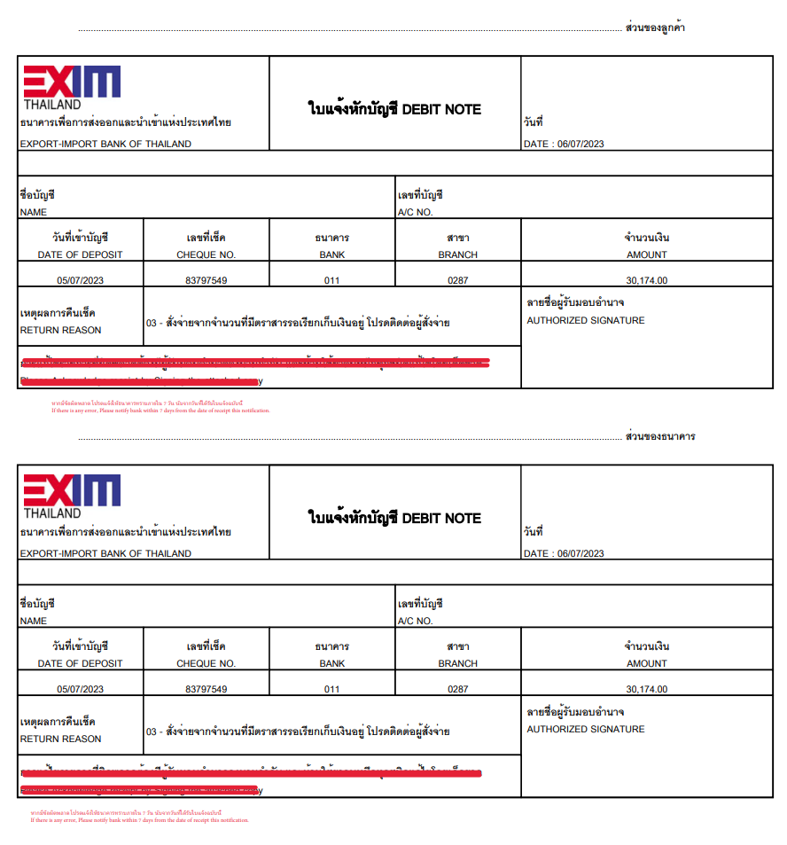

### Menu Modification

Not Applicable.

### Screen Layout and Data Sheet

Not Applicable.

### Business Rule / Business Logic

* Print cheque returned notification and debit note upon approve transaction.
* Cheque return report is require online on request.

### To-Be Process

The system retrieves the Outward Cheque returned transaction which can be separated by client branch.

|  |  |
| --- | --- |
| Paper size | A4 |
| Reprinting require | Yes |
| Searching criteria | Branch code, Account no, Cheque no, Date range, Transaction no., Reason code |

### File / API Layout and Data Sheet

Not Applicable.

### Report Layout and Data Sheet

#### Cheque returned notification

| Report Field | Description |
| --- | --- |
| Header | | |
| Bank code | Display EXIM bank code |
| Paying branch | Display EXIM branch code |
| Branch address | Display branch address |
| Detail | | |
| Date | Display return deposit date |
| Symbol | Display reason code |
| Explanation | Display reason description |
| Additional explanation | Display additional explanation |
| A/C No. | Display account number |
| Cheque No. | Display check number |
| Amount | Display cheque amount |
| Paying bank/Branch | Display paying bank/Branch |



#### Debit note

| Report Field | Description |
| --- | --- |
| Header | | |
| Date | Return transaction date |
| Detail | | |
| Name | Display account name |
| A/C NO. | Display account number |
| Date of deposit | Display deposit transaction date |
| Cheque no. | Display cheque number |
| Bank | Display paying bank |
| Branch | Display paying bank branch |
| Amount | Display amount |
| เหตุผลการคืนเช็ค (Reason) | Display return reason |



#### Cheque return report

| Report Field | Description |
| --- | --- |
| Header | | |
| Transaction Date | Display date from…to… depend on searching criteria |
| Page | Display number of page |
| Printed date | Display printed date |
| Printed time | Display printed time |
| Printed by | Display user who login to system |
| Detail | | |
| สาขา (Branch) | Display EXIM customer branch |
| เลขที่บัญชี (Account number) | Display account number |
| ชื่อลูกค้า (Account name) | Display account name |
| ลำดับ (No.) | Display sequential of transaction |
| รหัสธนาคาร (Bank) | Display paying bank |
| รหัสสาขา (Branch) | Display paying bank branch |
| เลขที่เช็ค (Cheque number) | Display cheque number |
| จำนวนเงิน (Amount) | Display cheque amount |
| เหตุผลการคืนเช็ค (Reason) | Display return cheque reason, Ex. The payer’s signature is incorrect |
| รวม (Total) | Displays the total amount of each account number |
| รวมทั้งหมด (Grand total) | Display grand total number of cheques and amount |



### Additional Impacts

Not Applicable.

## Returned Cheque Notification and Debit Note

|  |  |
| --- | --- |
| DPS-65 สามารถออกใบเช็คคืน เพื่อเป็นหลักฐานให้ลูกค้า ตามแบบฟอร์มที่ธนาคารกำหนด | Able to issue a return cheque as evidence for customers according to the form prescribed by the bank |
| DPS-66 สามารถออกใบเสร็จโดยอัตโนมัติเพื่อเก็บค่าธรรมเนียม เมื่อออกใบเช็คคืนให้ลูกค้า | Able to issue receipt automatically to collect fees. When issuing a return cheque to the customer |

### Purpose

The purpose is to provide Returned Cheque Voucher and Debit Note. For cheques that interface with ICAS, there is a return cheque.

### Background

* + 1. EXIM Current Business Practice (as-is)
* As is report produced by AS/400.
* Generate Returned Cheque Notification and Debit Note.

3.2.2 CBS9 Current Functionality

This report retrieved information from “Manual Inward Return” function by specify the reason for making the cheque return.

### Supported Sample Transaction and Case from Customer

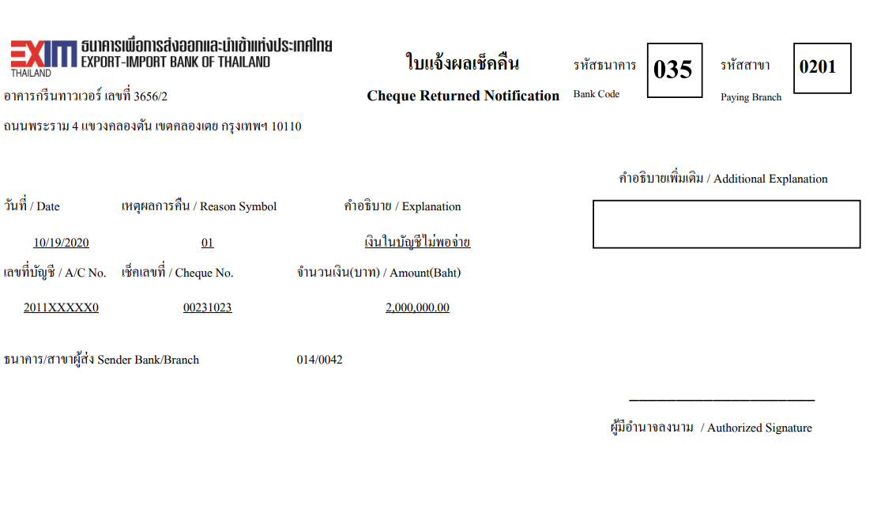

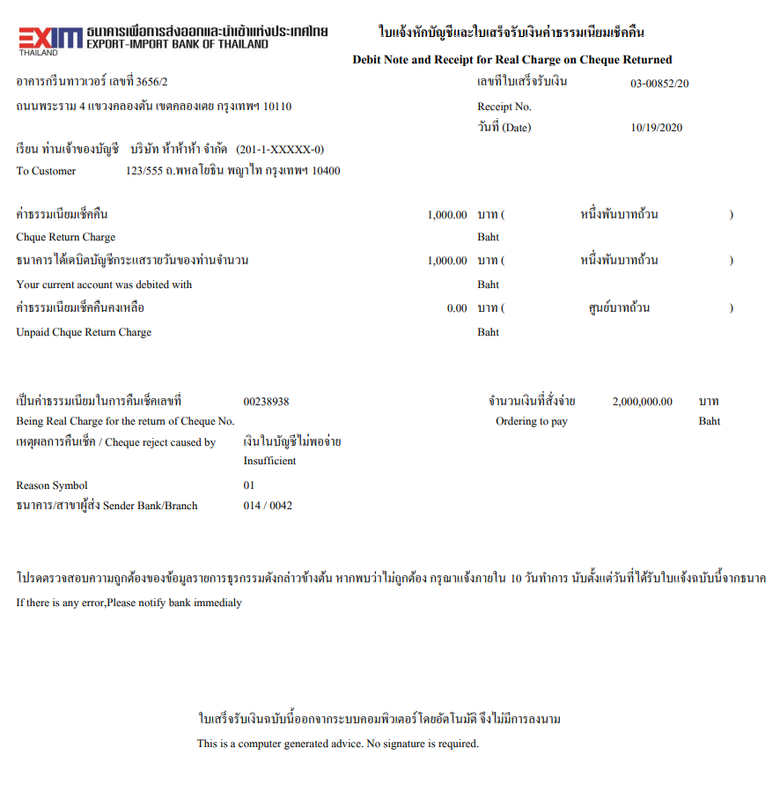

### Menu Modification

Not Applicable.

### Screen Layout and Data Sheet

Not Applicable.

### Business Rule / Business Logic

* If reason is Insufficient funds then print Cheque Returned notification and Debit Note.
* If others reason then print only Cheque Returned notification.

### To-Be Process

The system retrieves information from “Manual Inward Return” function.

|  |  |
| --- | --- |
| Paper size | A4 |
| Reprinting require | Yes |
| Searching criteria | Branch code, Account no, Cheque no, Date range, Transaction no., Reason code |

### File / API Layout and Data Sheet

* Debit note send to e-Service

### Report Layout and Data Sheet

#### Cheque Returned Voucher

| Report Field | Description |
| --- | --- |
| Header | | |
| Bank code | Display EXIM bank code |
| Paying branch | Display EXIM paying branch |
| Branch address | Display branch address |
| Detail | | |
| Date | Display return transaction date |
| Symbol | Display reason code |
| Explanation | Display reason description |
| Additional explanation | Display additional explanation |
| A/C No. | Display account number |
| Cheque No. | Display check number |
| Amount | Display cheque amount |
| Sending bank/Branch | Display sending bank/Branch |



#### Debit note

| Report Field | Description |
| --- | --- |
| Header | | |
| Receipt No. | Display receipt number |
| Date | Display date |
| Branch address | Display branch address |
| Detail | | |
| Customer name | Display customer name |
| Account no. | Display account number |
| Customer address | Display customer address |
| Cheque return charge | Display charge amount and amount in Thai letter |
| Your current account was debit with | Display charge amount and amount in Thai letter |
| Unpaid cheque return charge | Display Unpaid cheque return charge and amount in Thai letter |
| Cheque No. | Display cheque number |
| Ordering to pay | Display cheque amount |
| Cheque reject caused by | Display reason description |
| Reason symbol | Display reason code |
| Sending bank/Branch | Display Sending bank/Branch |



### Additional Impacts

Not Applicable.

## Debit Note/Credit Note

|  |  |
| --- | --- |
| DPS-67 การบันทึกรายการฝาก-ถอน ทุกรายการ ระบบต้องสร้างใบแจ้งหัก/เข้าบัญชี (Debit/Credit Note) ตามรูปแบบที่ธนาคารกำหนด โดยสามารถเปลี่ยนแปลงได้ และสามารถเรียกดู/สั่งพิมพ์ย้อนหลังได้ | To save data in every deposit-withdrawal transaction, the system must create a debit/credit note in the bank specific form which can be changed and viewed / printed backwards |

### Purpose

The purpose is to provide debit note and credit note for all transaction.

### Background

* + 1. EXIM Current Business Practice (as-is)
* As is debit note and credit note produced by AS/400.
  + 1. CBS9 Current Functionality
* Checking CBS9 report.

### Supported Sample Transaction and Case from Customer

#### Debit note

##### Internal fund transfer currency conversion

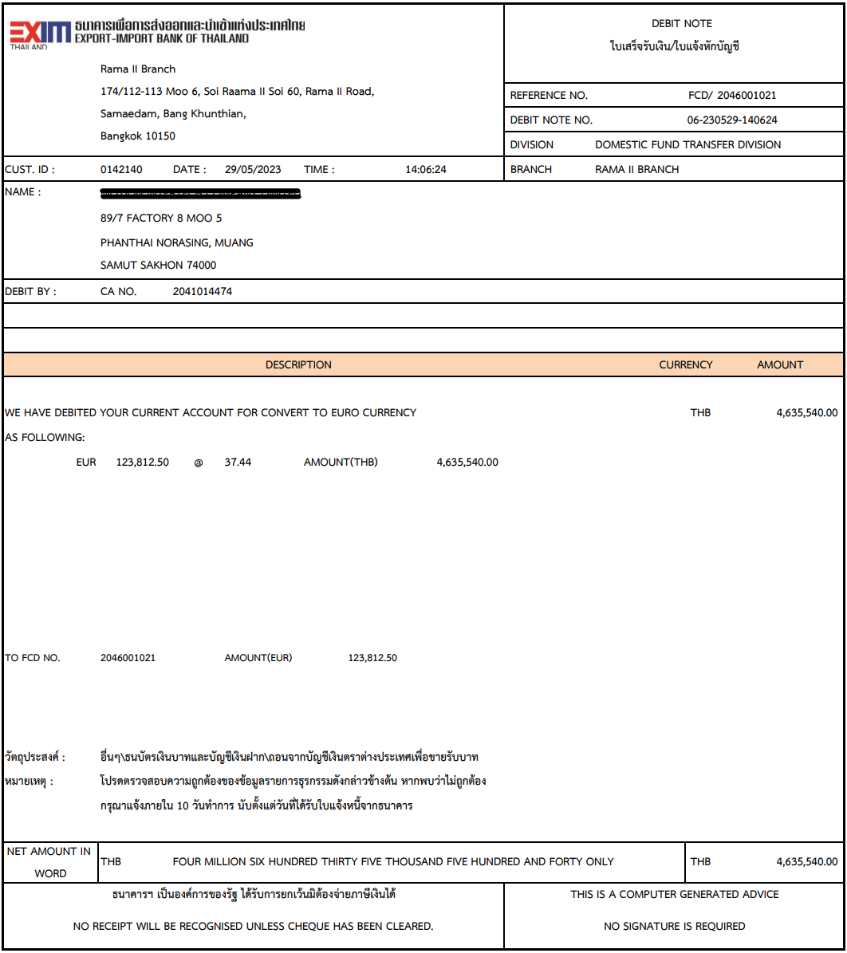

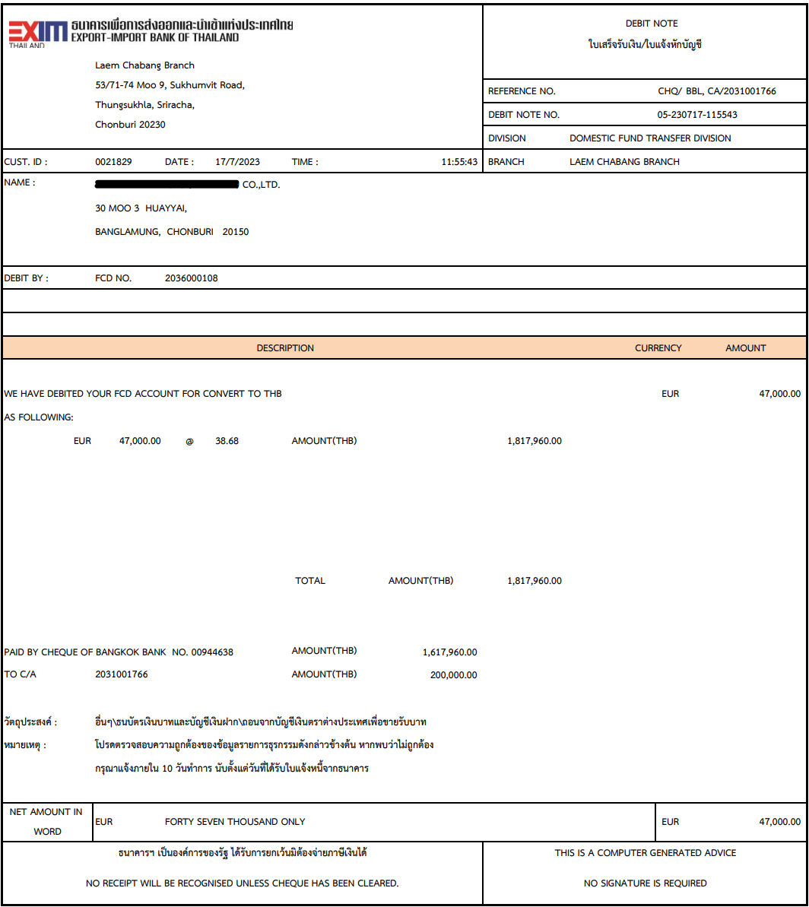

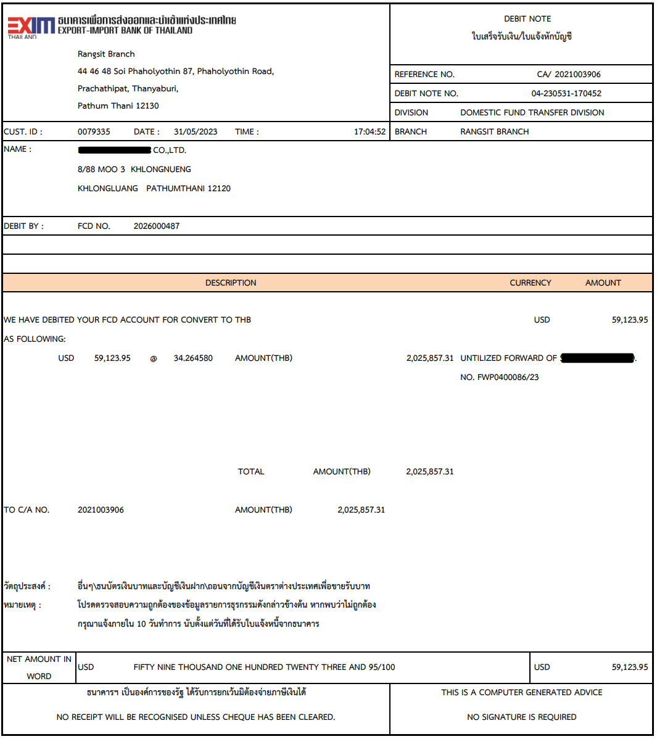

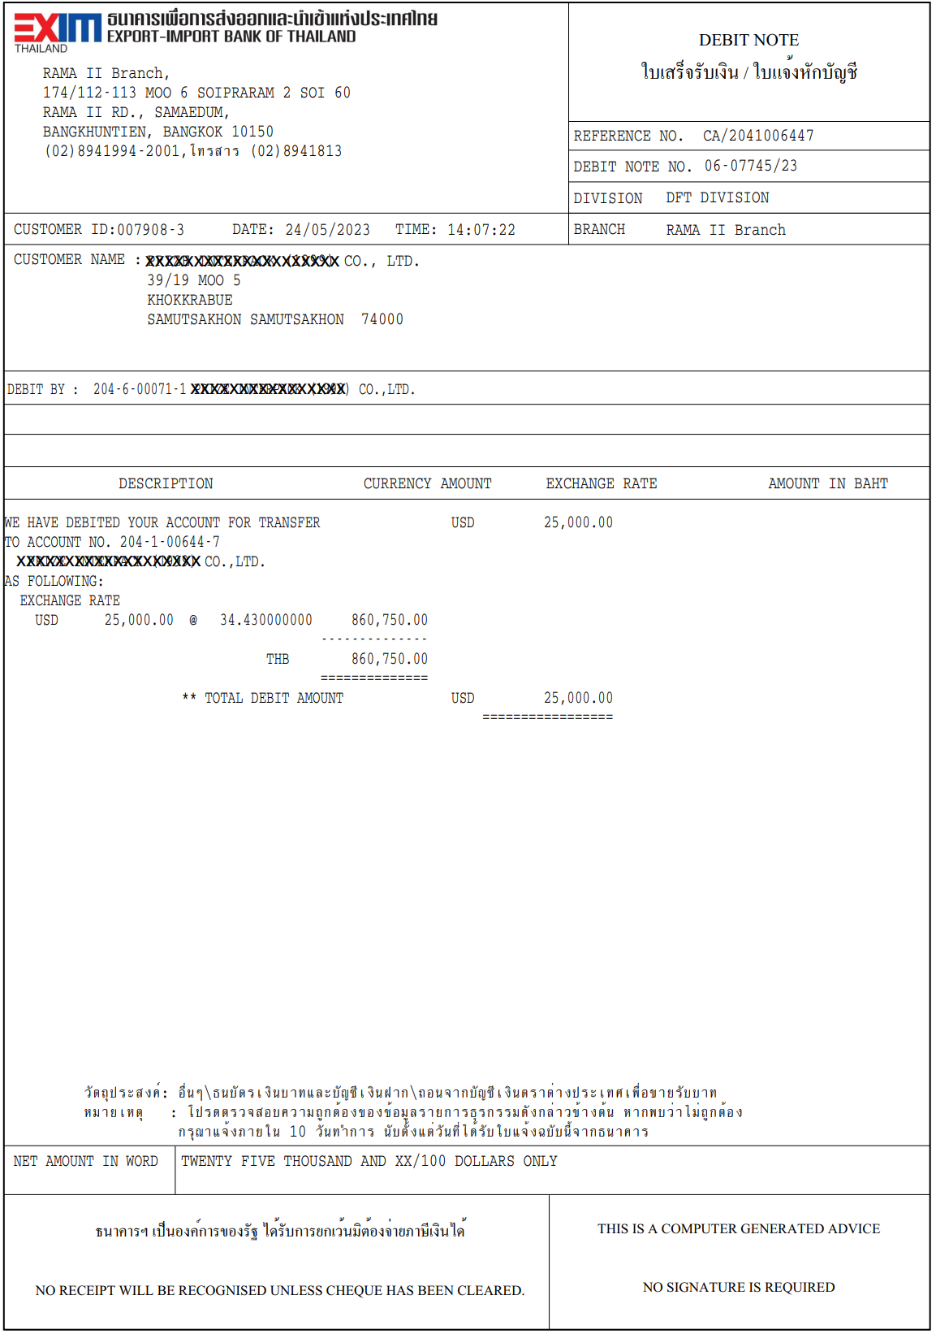

##### Outgoing fund transfer

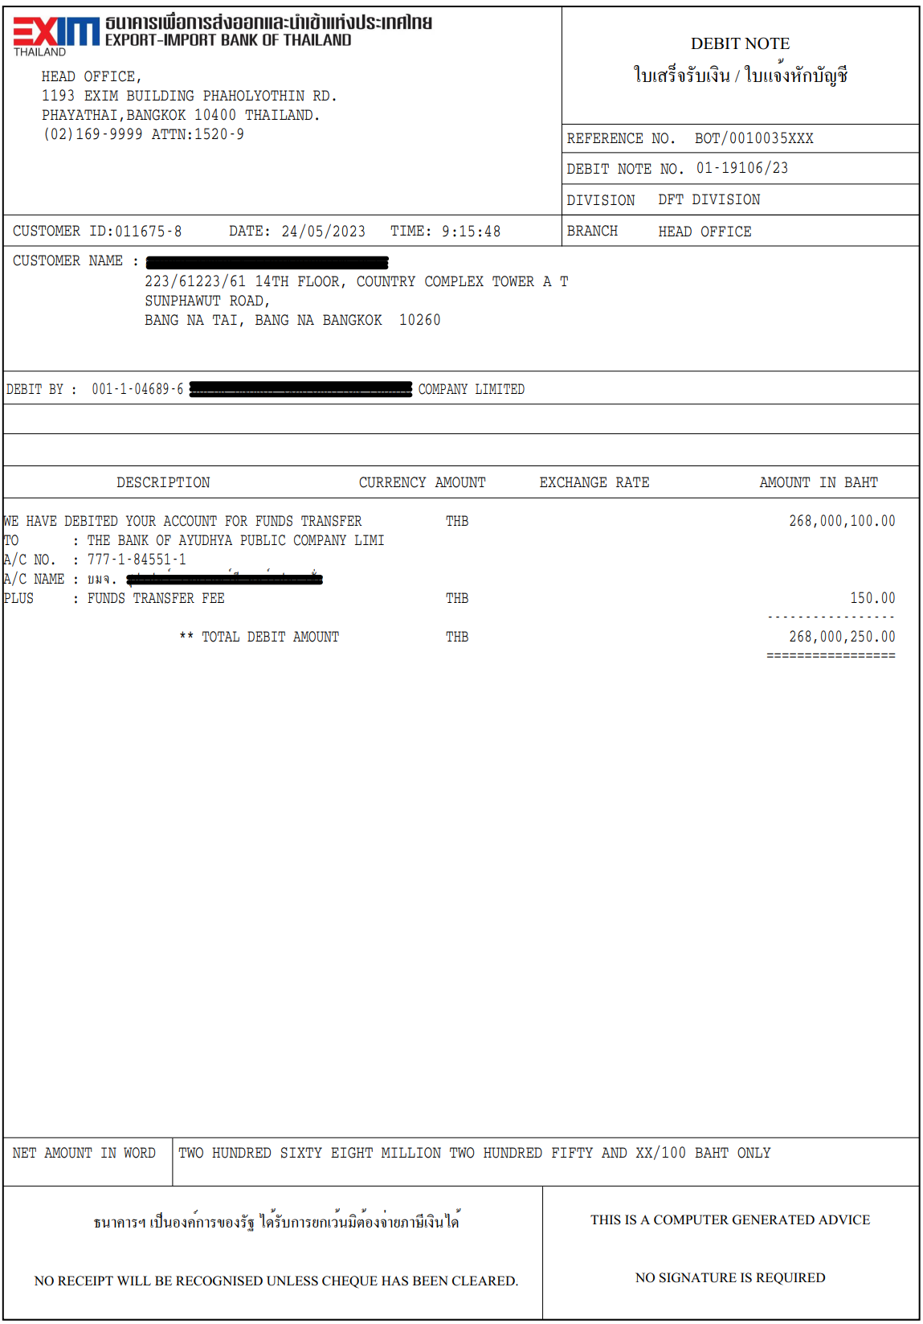

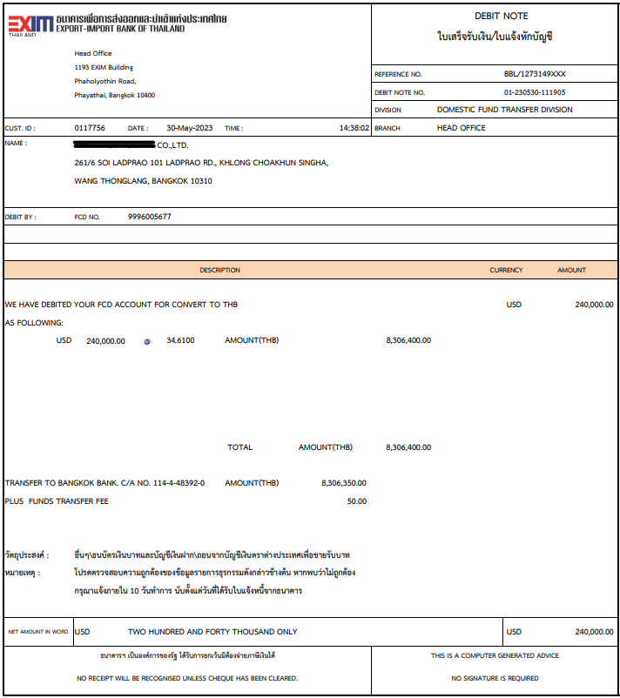

##### Cheque fees

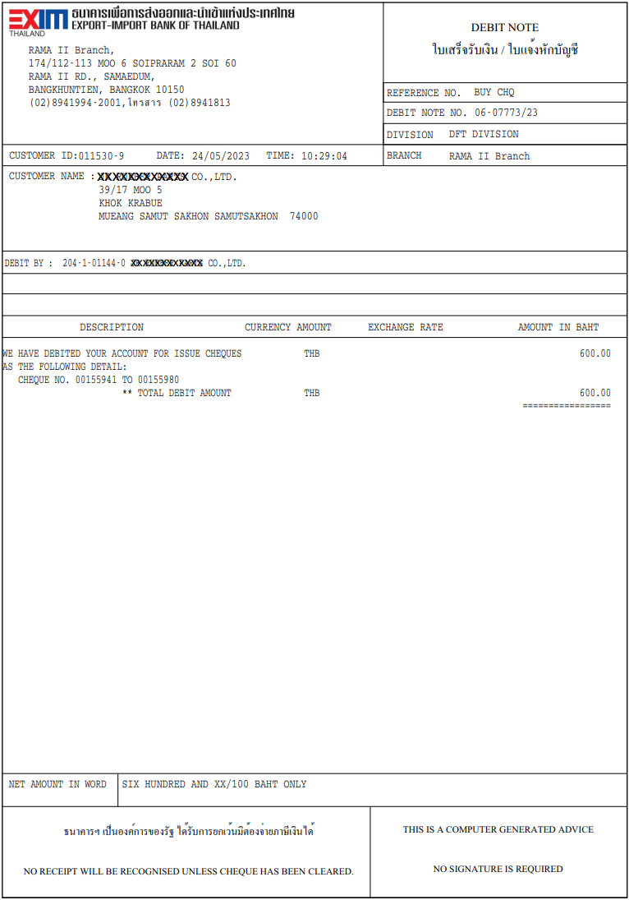

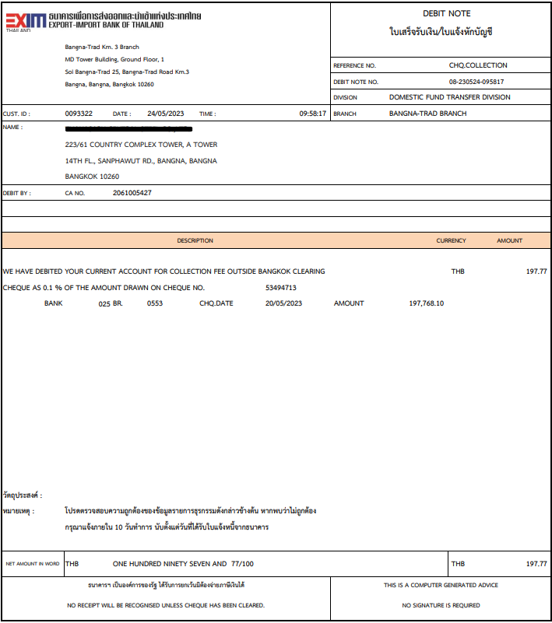

##### Bank confirmation fees

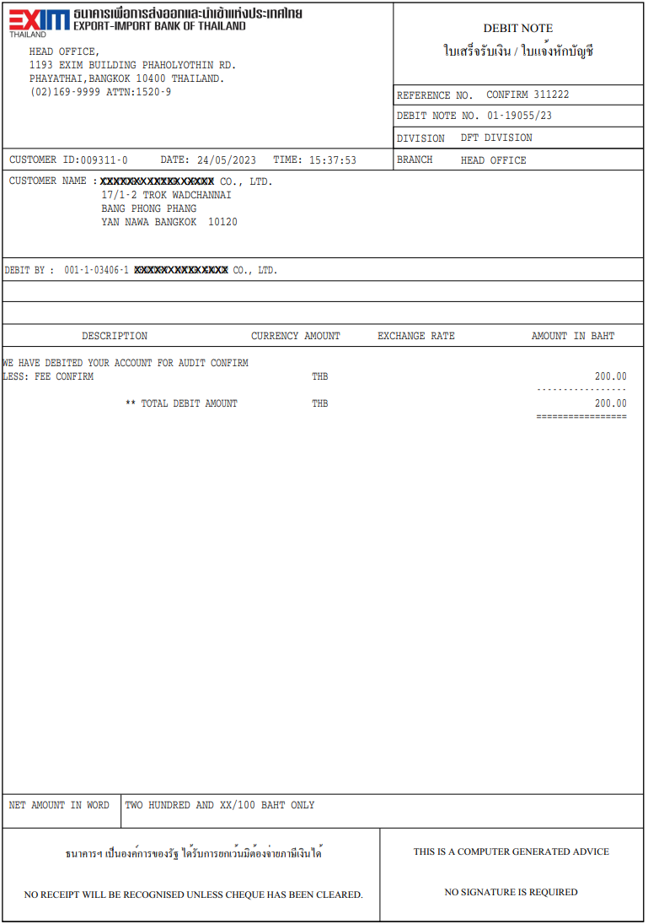

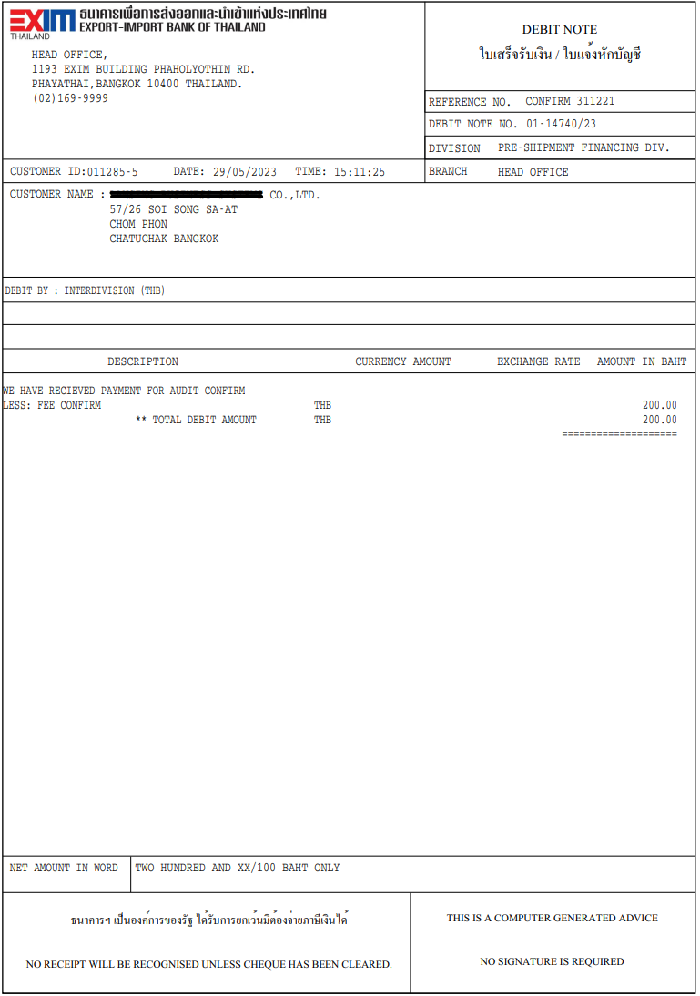

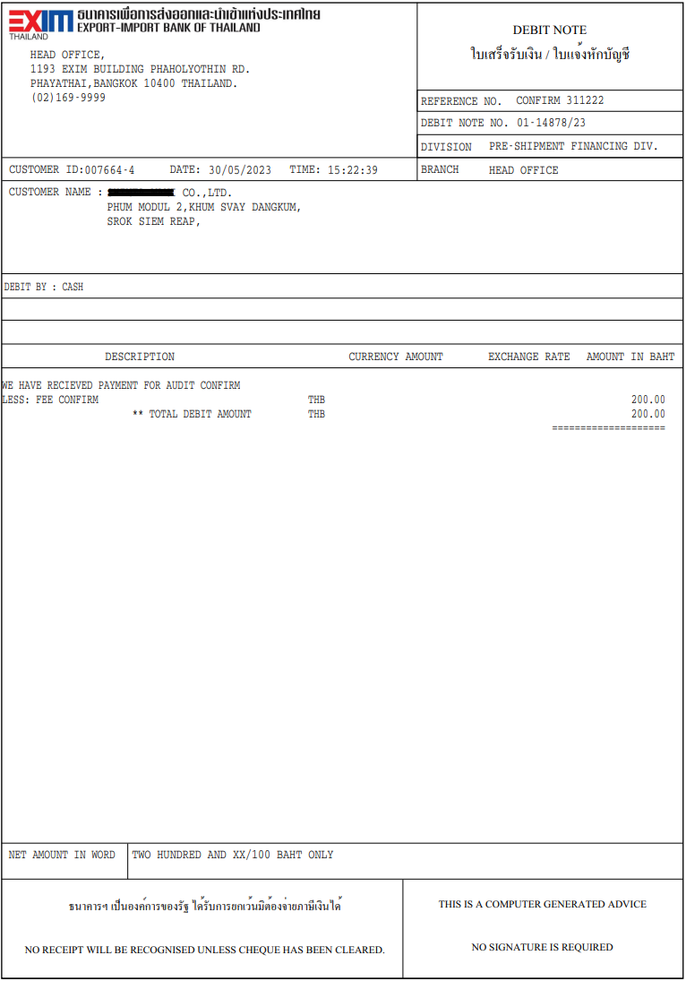

##### TD Payout

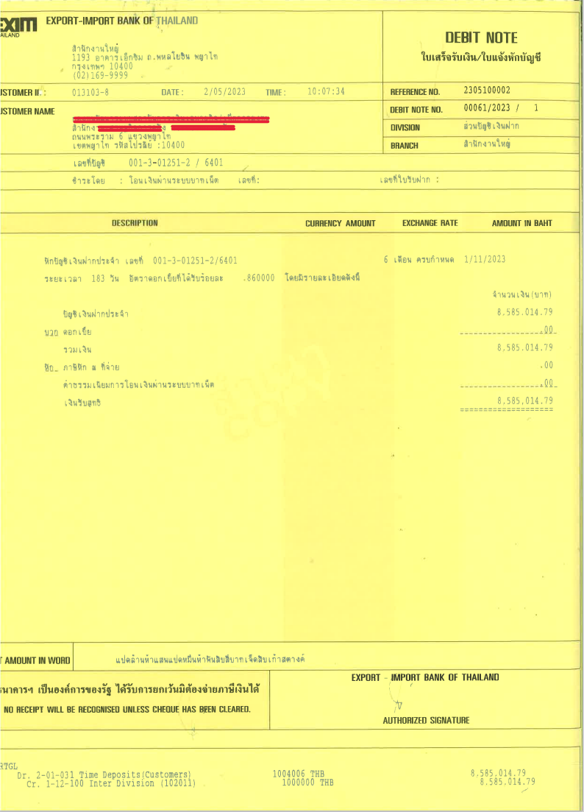

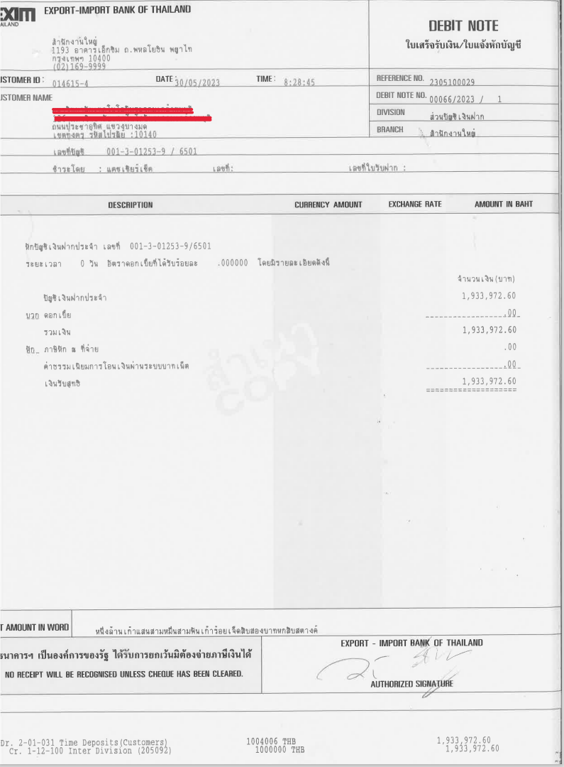

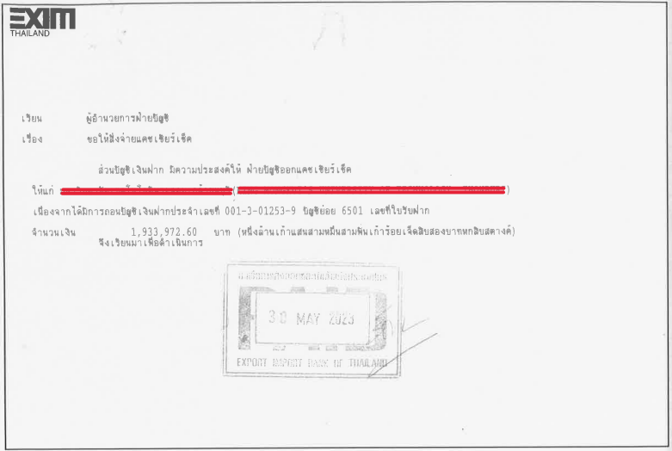

##### CASA Account transfer

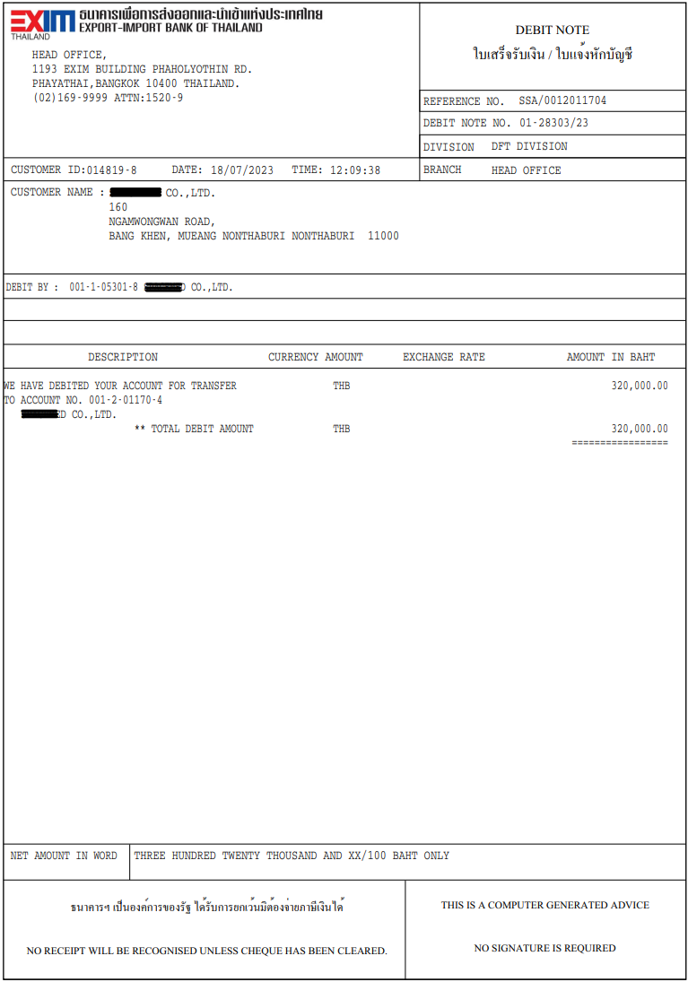

##### Overdraft interest

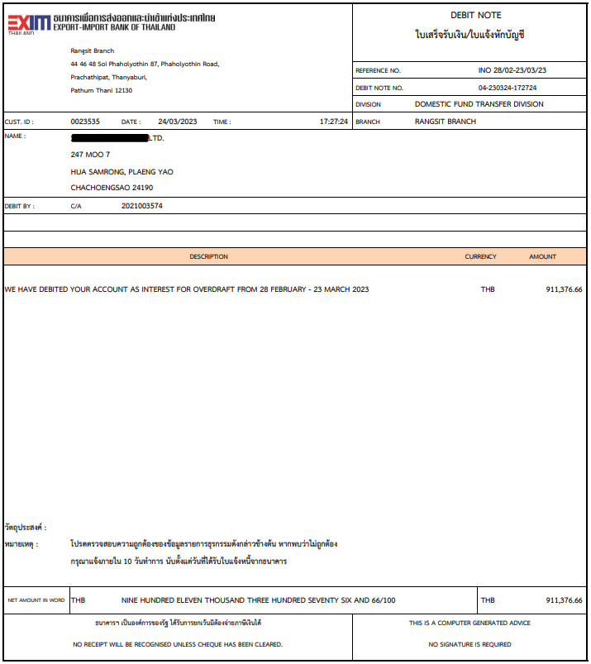

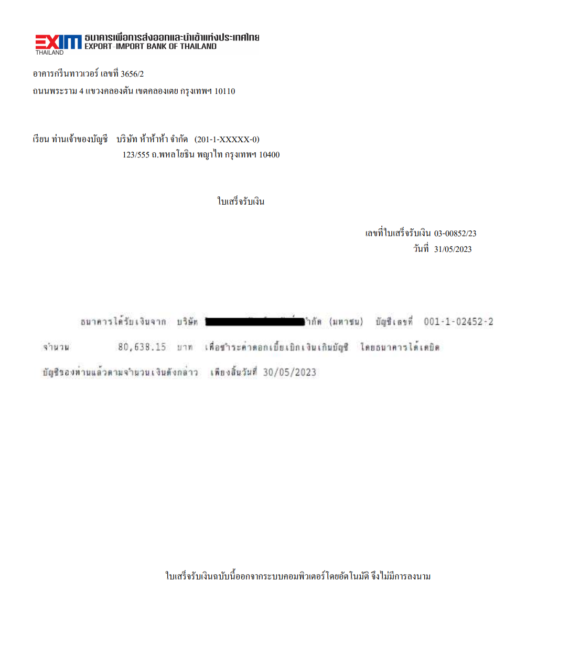

##### Withdraw from saving account and issue cashier cheque

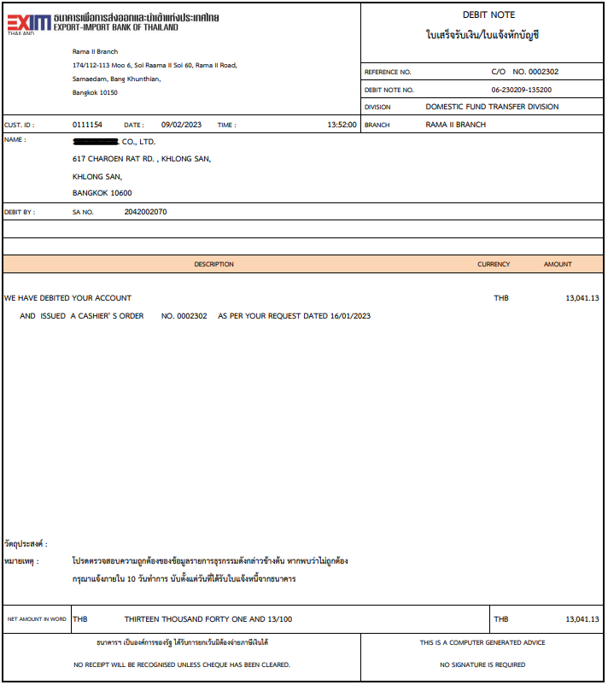

##### Close account and the rest of the money is bank income

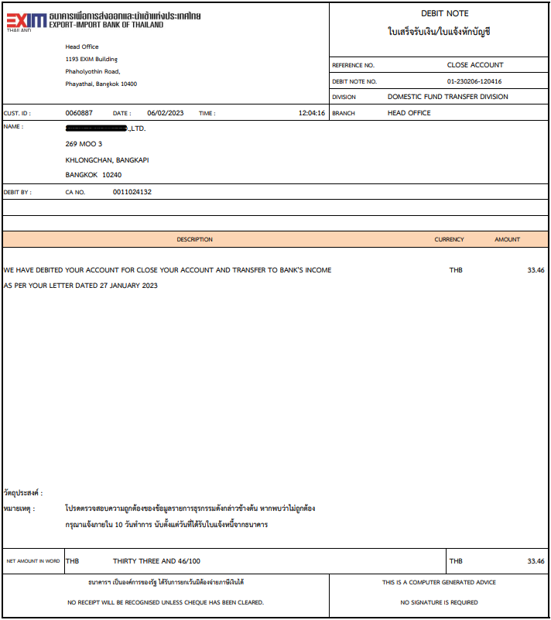

##### Close account and issue cashier cheque

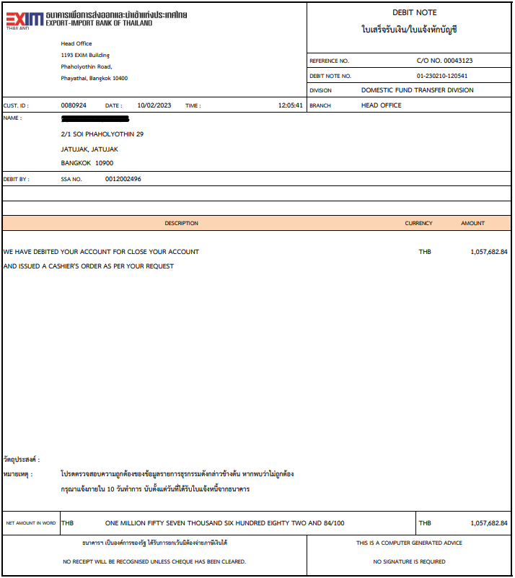

##### Customer request to issue unclear cheque

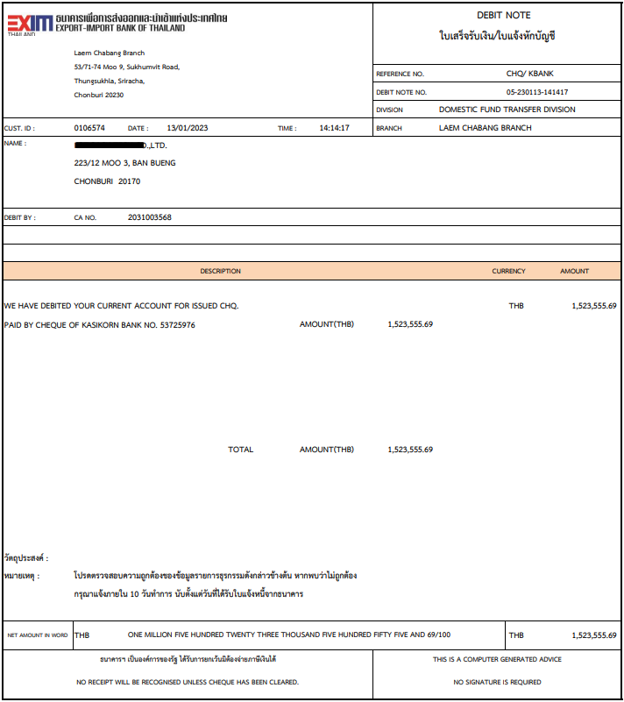

##### Close account and issue unclear cheque

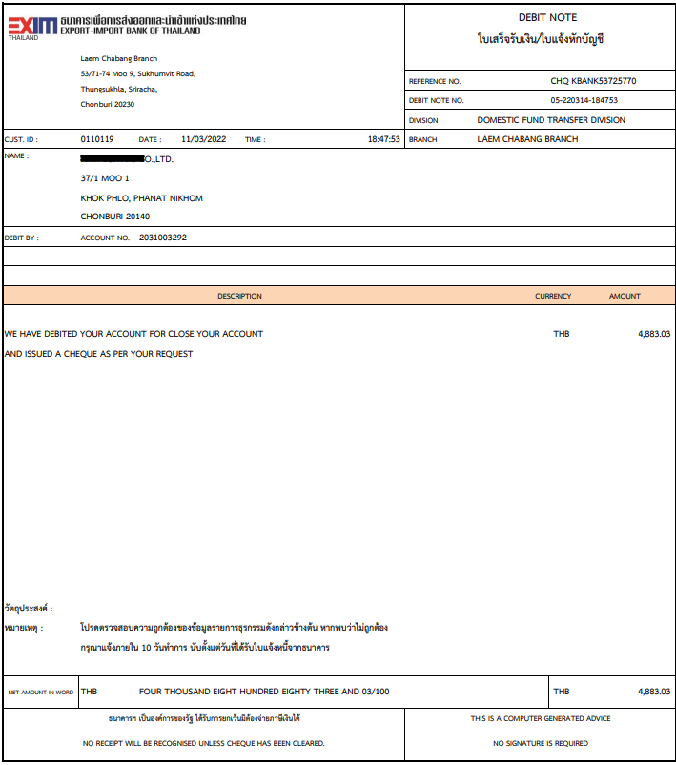

##### Freeze account and issue cashier cheque

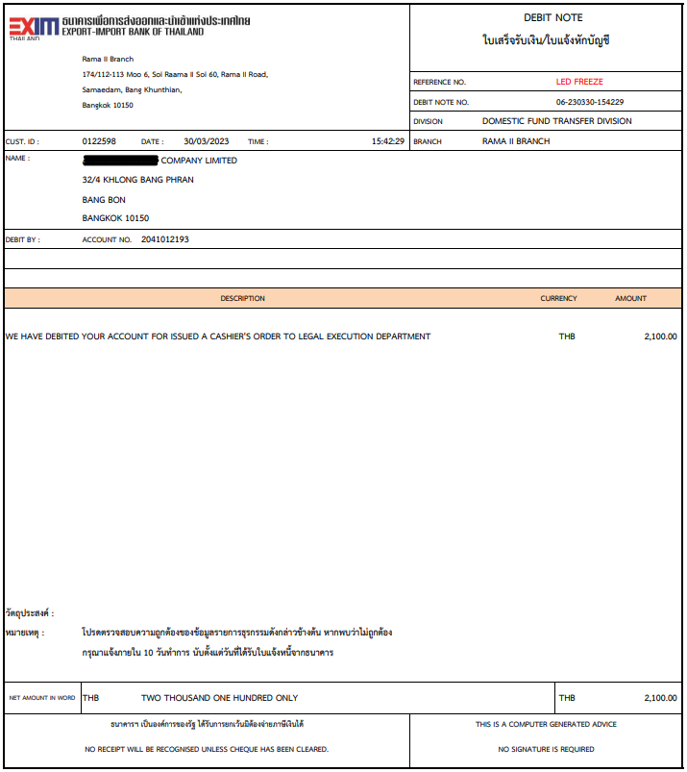

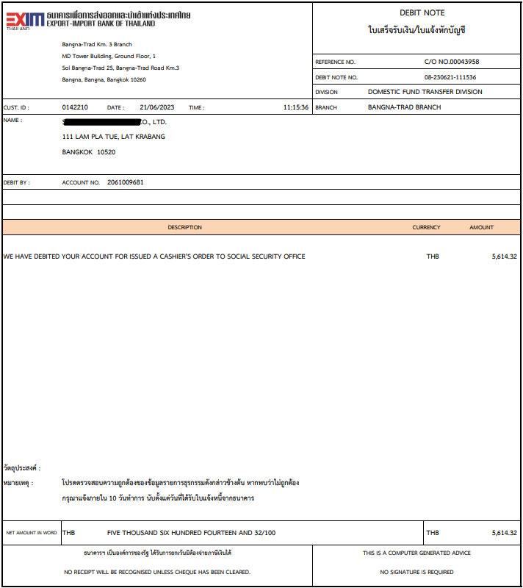

##### Dormant account fees

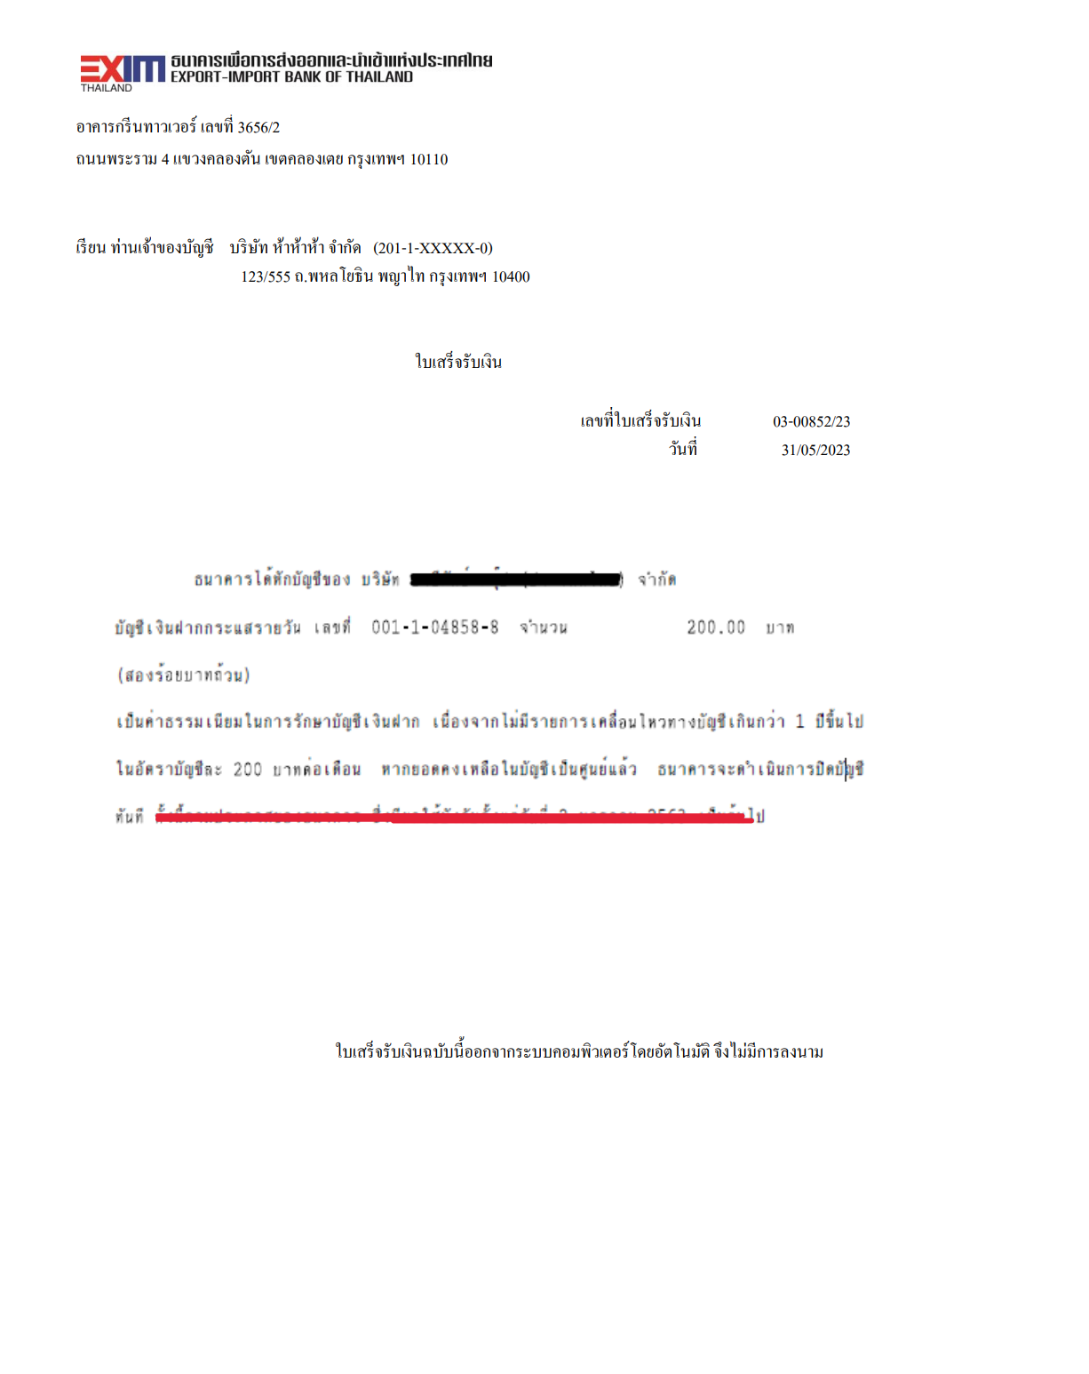

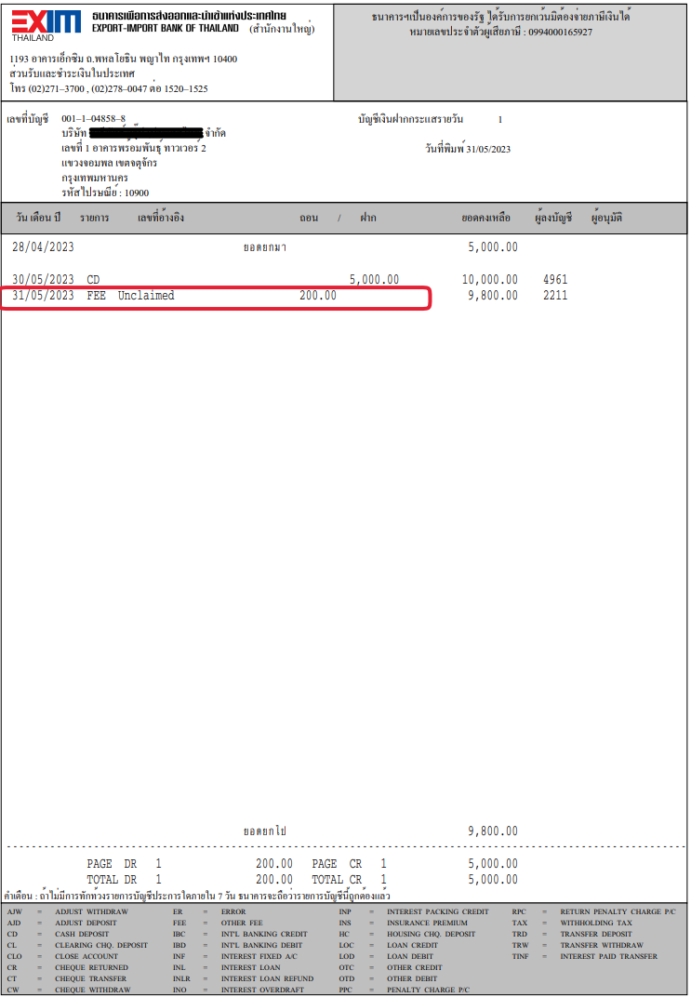

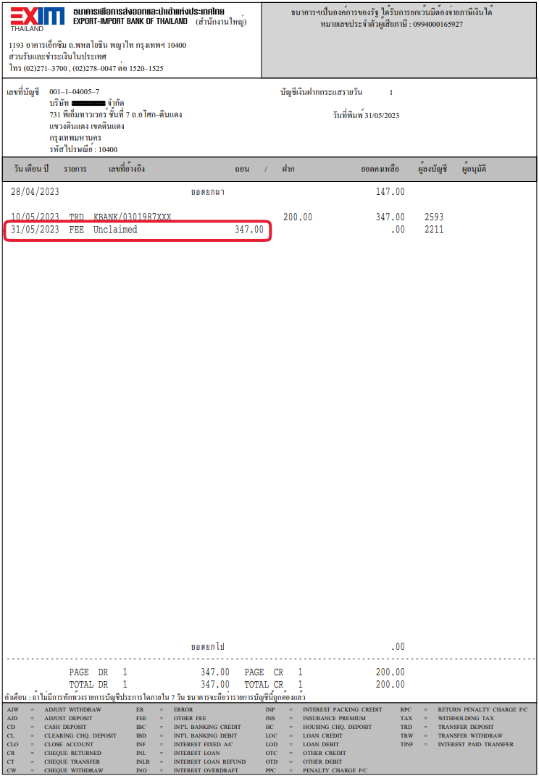

#### Credit note

##### Outward clearing cheque

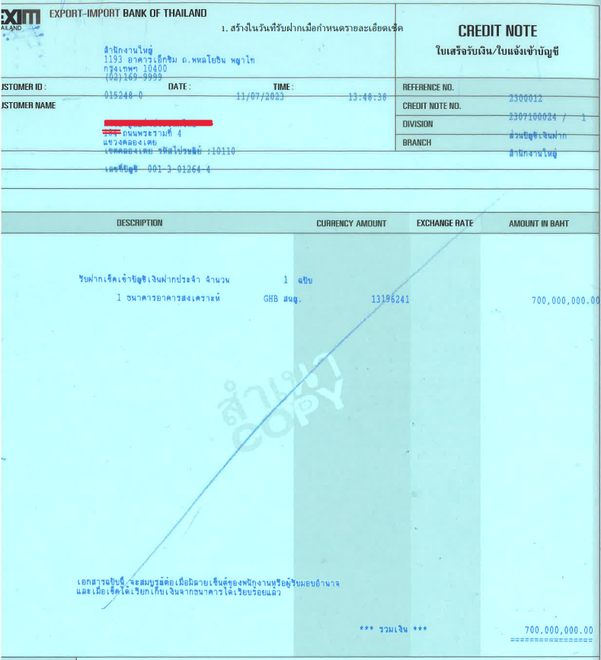

##### Interest payable

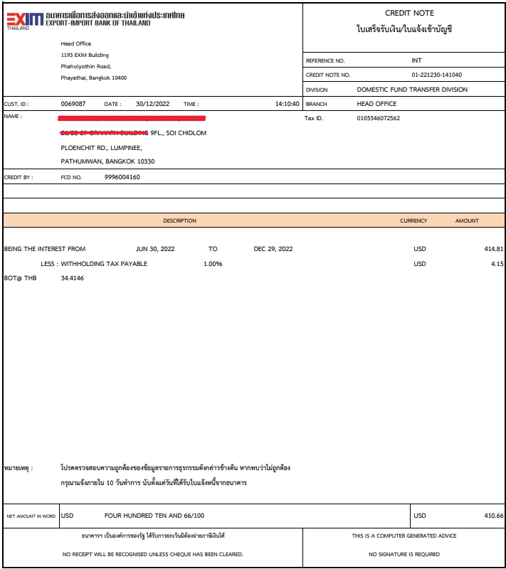

##### Incoming fund transfer

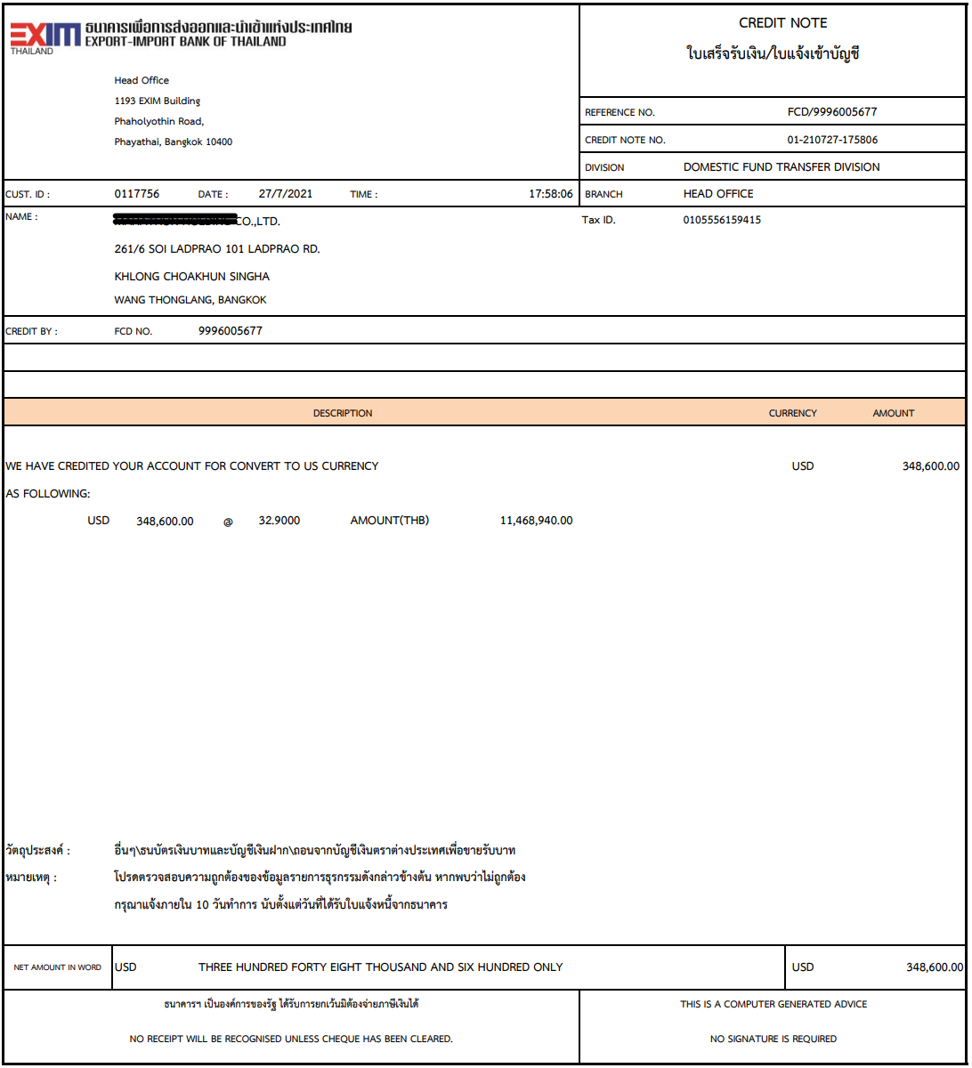

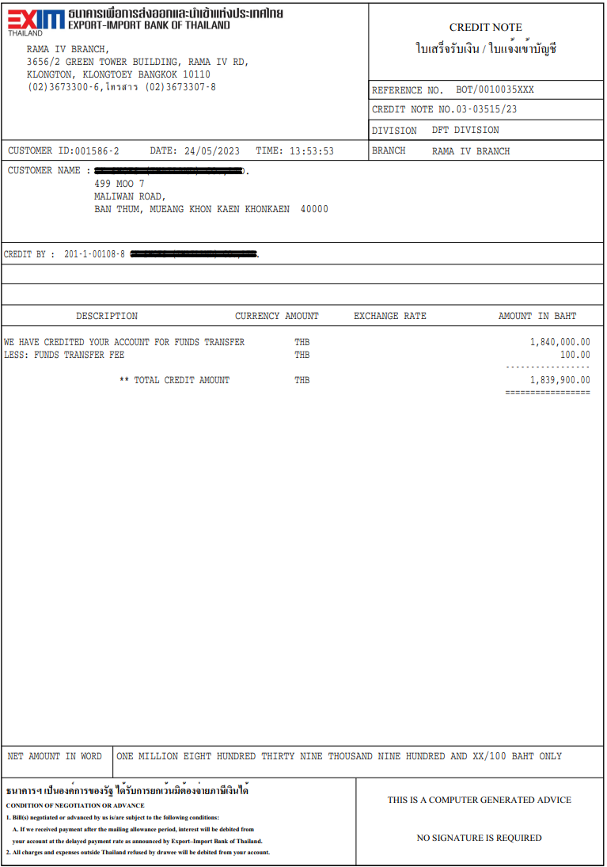

##### TD Placement

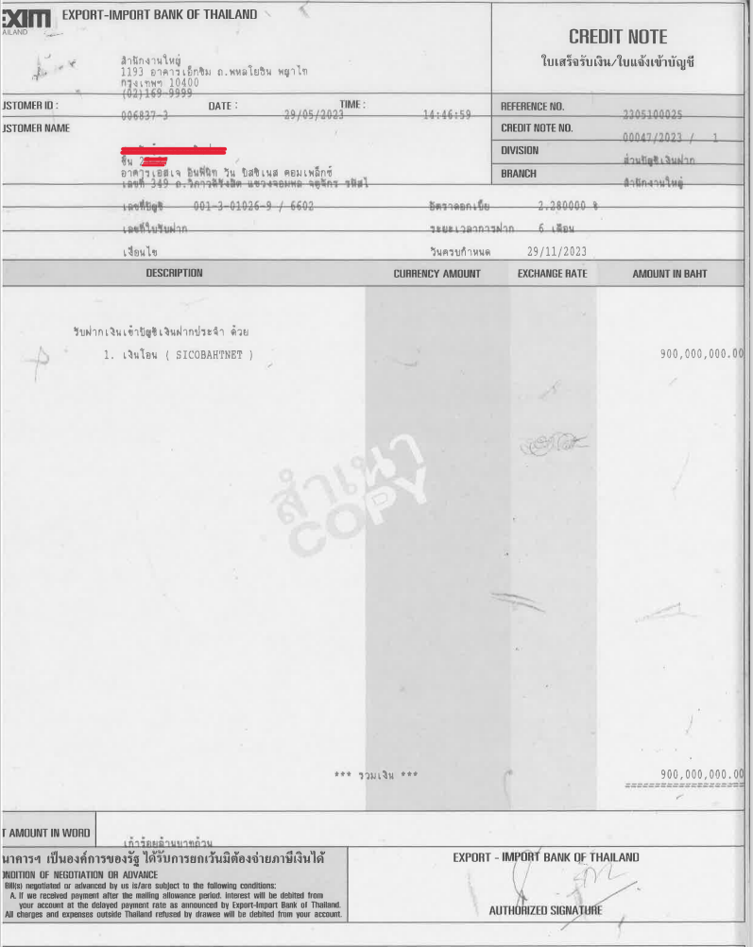

##### Fees refund

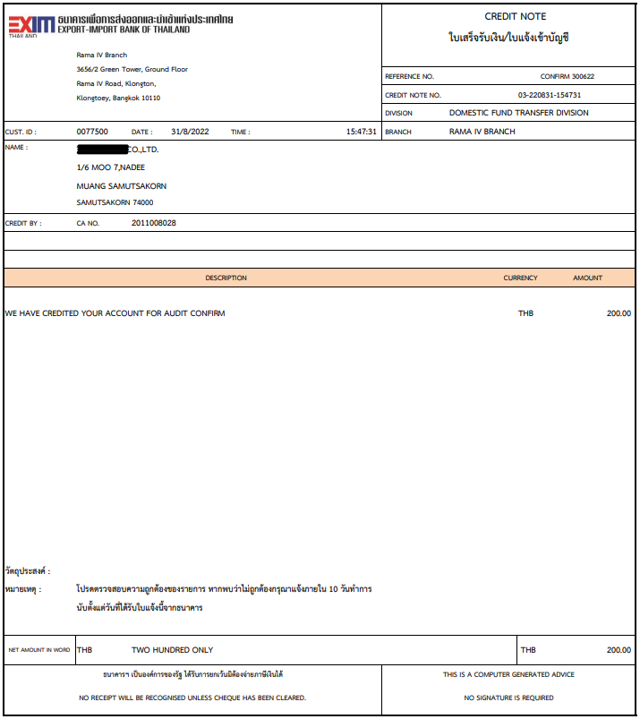

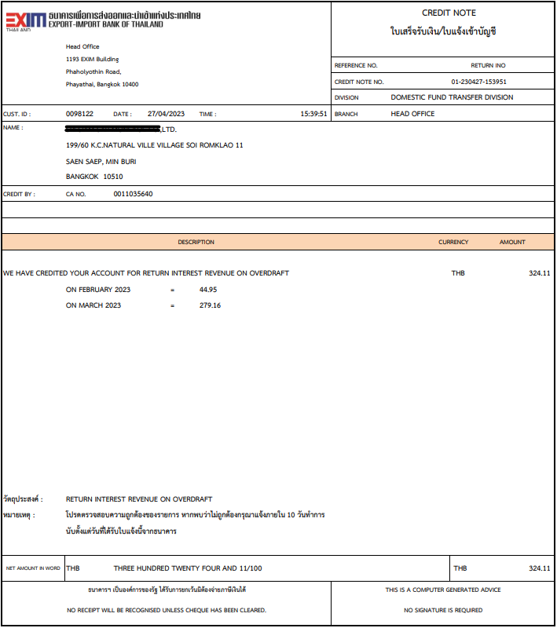

### Menu Modification

Not Applicable

### Screen Layout and Data Sheet

Not Applicable

### Business Rule / Business Logic

* Debit note printing when the following transaction occur:
* Internal fund transfer
* Outgoing fund transfer
* Outgoing direct credit
* Cheque book sell
* Cheque collection fees (Cross zone cheque)
* Confirmation fees
* TD payout
* Transfer
* Manual overdraft interest
* Withdraw money and payout by cheque
* Closed account and the rest of the money is bank income
* Closed account and payout by cheque
* Issue unclear cheque
* Closed account and payout by unclear cheque
* Feezed account and issue cahier cheque
* Dormant fees
* Overdraft interest
* Credit note printing when the following transaction occur:
* Outward clearing cheque
* Interest payment FCY
* Incoming fund transfer
* Fees refund
* Overdraft interest refund

### To-be Process

The system retrieves the all transactions occur to print debit note and credit note which template can be changed.

|  |  |
| --- | --- |
| Paper size | A4 |
| Reprinting require | Yes |
| Searching criteria | Account no, Reference no, Date, Transaction type |

### File / API Layout and Data Sheet

* Debit note / Credit note send to e-Services

### Report Layout and Data Sheet

#### Debit note



#### Overdraft interest debit note



#### Dormant account fees debit note



#### Credit note



### Additional Impacts

Not Applicable.

## Account Opening Application Form

|  |  |
| --- | --- |
| DPS-68 สามารถสร้างและสั่งพิมพ์ข้อมูลบนแบบฟอร์มที่ธนาคารกำหนดได้ในระบบ เช่น แบบฟอร์มคำขอเปิดบัญชีเงินฝากและแบบฟอร์มอื่นที่เกี่ยวข้อง | Able to create and print forms specified by the bank in the system, such as the request form for opening a deposit account and other related forms. |

### Purpose

The purpose is to provide application form printing by account type.

### Background

### Supported Sample Transaction and Case from Customer

#### Current Application form

..\..\Deposit\ตัวอย่างคำขอเปิดบัญชี\ตัวอย่างคำขอเปิดบัญชีล่าสุด\คำขอเปิดบัญชีCA(รวม) (1).docx

Account type 1 : Current

#### Saving Application form

..\..\Deposit\ตัวอย่างคำขอเปิดบัญชี\ตัวอย่างคำขอเปิดบัญชีล่าสุด\คำขอเปิดบัญชีSA-สองภาษา เพิ่มมอบอำนาจ v1.doc

Account type 2 : Saving

#### FCD Application form

..\..\Deposit\ตัวอย่างคำขอเปิดบัญชี\ตัวอย่างคำขอเปิดบัญชีล่าสุด\คำขอเปิดบัญชีFCD-สองภาษา เพิ่มมอบอำนาจ v1 (2).doc

Account Type 6 : FCD

#### Special Saving form

..\..\Deposit\ตัวอย่างคำขอเปิดบัญชี\ตัวอย่างคำขอเปิดบัญชีล่าสุด\คำขอเปิดบัญชีเงินฝากSSA-สองภาษา เพิ่มมอบอำนาจหักบัญชี v1 (1).doc

Account type 2 : Saving

#### Customer Clearing Account form

..\..\Deposit\ตัวอย่างคำขอเปิดบัญชี\ตัวอย่างคำขอเปิดบัญชีล่าสุด\คำขอเปิดบัญชีClearing-สองภาษา เพิ่มมอบอำนาจหักโอนเงิน.doc

Account Type 4 : Customer clearing account

* TD Application form

..\..\Deposit\ตัวอย่างคำขอเปิดบัญชี\ตัวอย่างคำขอเปิดบัญชีล่าสุด\คำขอเปิดบัญชีเงินฝากประจำ(TD).doc

Account Type 3 : TD

* Thank you letter

..\..\Deposit\ตัวอย่างคำขอเปิดบัญชี\ตัวอย่างคำขอเปิดบัญชีล่าสุด\Letter of Thanks.docx

### Menu Modification

Not Applicable.

### Screen Layout and Data Sheet

Not Applicable.

### Business Rule / Business Logic

* Print Application form before approval, information to display in application form such as:
* Account number
* Account name
* Address
* Tel
* Customer name (English)
* Customer name (Thai)
* Print Thank you letter after approval, information to display in letter such as:
* Account name (English)
* Account name (Thai)
* Account type
* Account number
* Account branch
* Approved date

### To-be Process

The system retrieves the information from Account opening transaction to print Application form and Thank you letter.

|  |  |
| --- | --- |
| Paper size | A4 |
| Reprinting require | Yes |
| Searching criteria | Customer ID, Account no |

### File / API Layout and Data Sheet

* Thank letter send to e-Service
* Account number send to AS/400
* Account information send to Dataset
* Account number, Open date send to CRM

### Report Layout and Data Sheet

According to 5.3

### Additional Impacts

Not Applicable.

## Pre-Dormant Notification Letter

|  |  |
| --- | --- |
| DPS-69 บัญชีที่ไม่มีการเคลื่อนไหวติดต่อกัน 12 เดือน ให้แสดงข้อมูลบนหนังสือออกตามแบบฟอร์มที่ธนาคารกำหนด โดยเรียกรายงานตามประเภทบัญชีหรือทั้งหมดได้ | Accounts that have been inactive for 12 consecutive months shall show the information on the letter issued in accordance with the form prescribed by the bank. You can retrieve reports by account type or all. |

### Purpose

The purpose is to provide Notification letter of pre-dormant account that have been inactive for 12 months.

### Background

* + 1. EXIM Current Business Practice (as-is)
* As is report produced by AS/400.
* Auto-Generated after EOD

6.2.2 CBS9 Current Functionality

* Checking CBS9 report.

### Supported Sample Transaction and Case from Customer

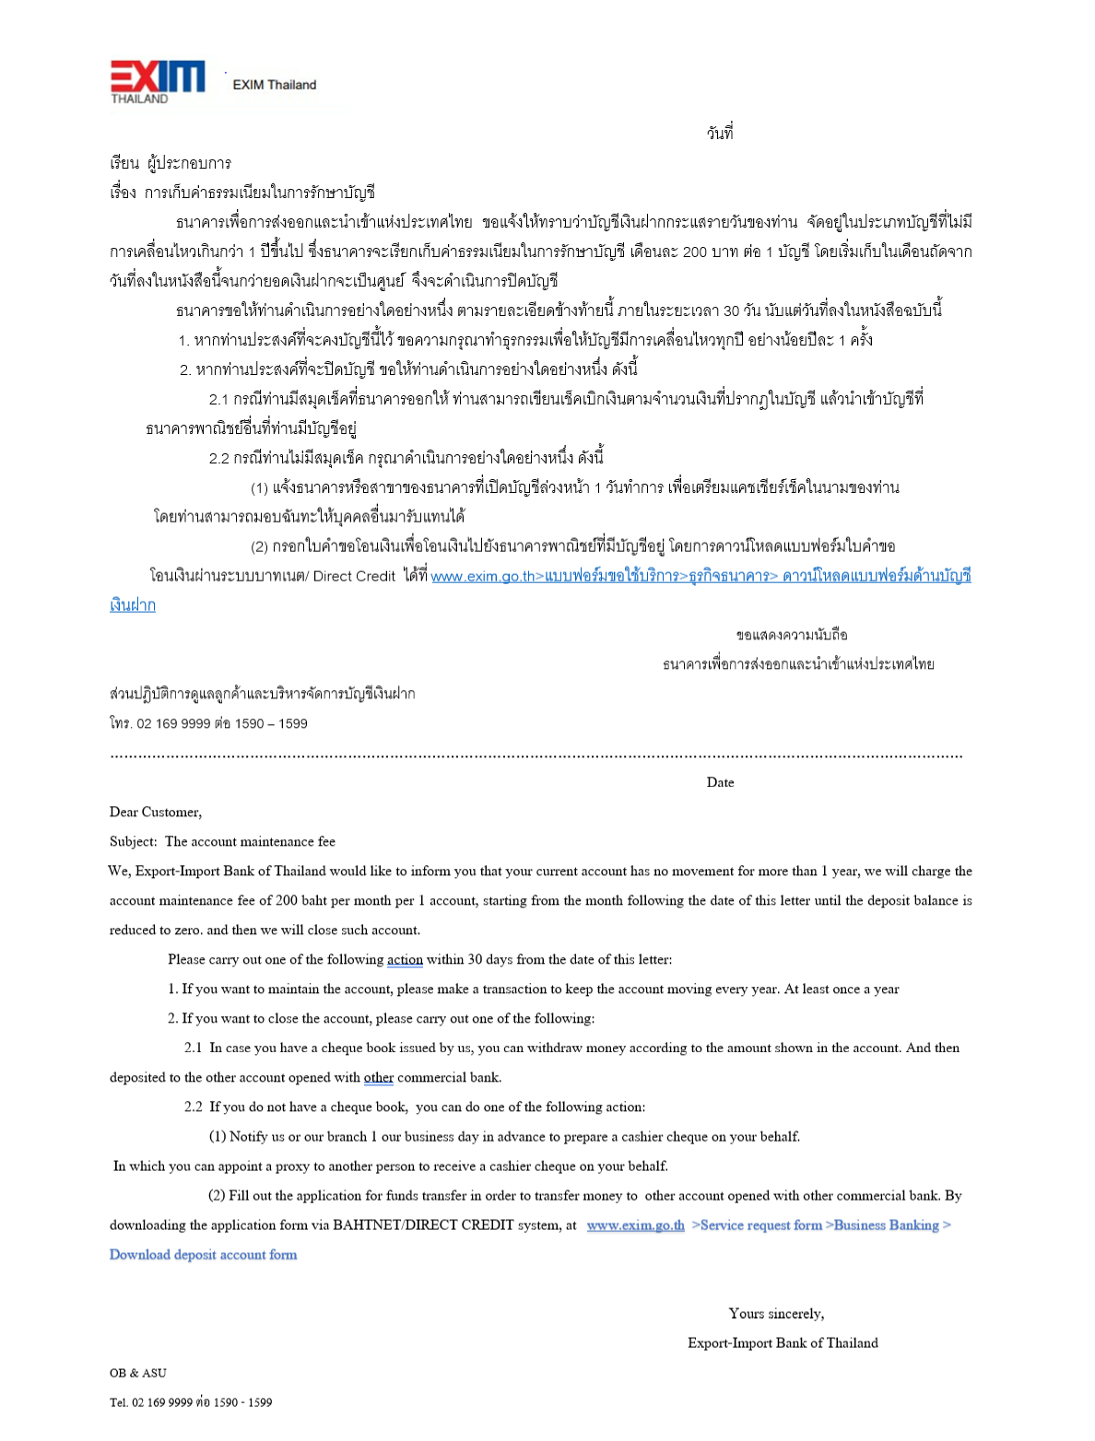

### Menu Modification

Not Applicable.

### Screen Layout and Data Sheet

Not Applicable.

### Business Rule / Business Logic

* Notification letter of pre-dormant account that have been inactive for 12 months.
* The letter format is provided in advice template.
* Reprinting require.
* Auto-Generate after EOD.

### To-be Process

Batch Will be sent based on the definition in Job Scheduler for Pre-dormant notification.

|  |  |
| --- | --- |
| Paper size | A4 |
| Reprinting require | Yes |
| Searching criteria | Account no, Date range |

### File / API Layout and Data Sheet

* Send to e-Service

### Report Layout and Data Sheet

According to 6.3

### Additional Impacts

Not Applicable.

## Time Deposit Certificate

|  |  |
| --- | --- |
| DPS-70 สามารถสร้างบัตรเงินฝาก ประเภทบัญชีเงินฝากประจำ ตามรูปแบบที่ธนาคารกำหนด | Able to create a deposit certificate time deposit account type according to the form specified by the bank |

### Purpose

The purpose is to create a certificate of deposit for customers which are type of time deposit account in each time they make a deposit.

### Background

7.2.1 EXIM Current Business Practice (as-is)

* Certificate provided by AS/400.
* Printing using preprinted form.

7.2.2 CBS9 Current Functionality

* CBS9 reports catalog support the “Term Deposit Confirmation”

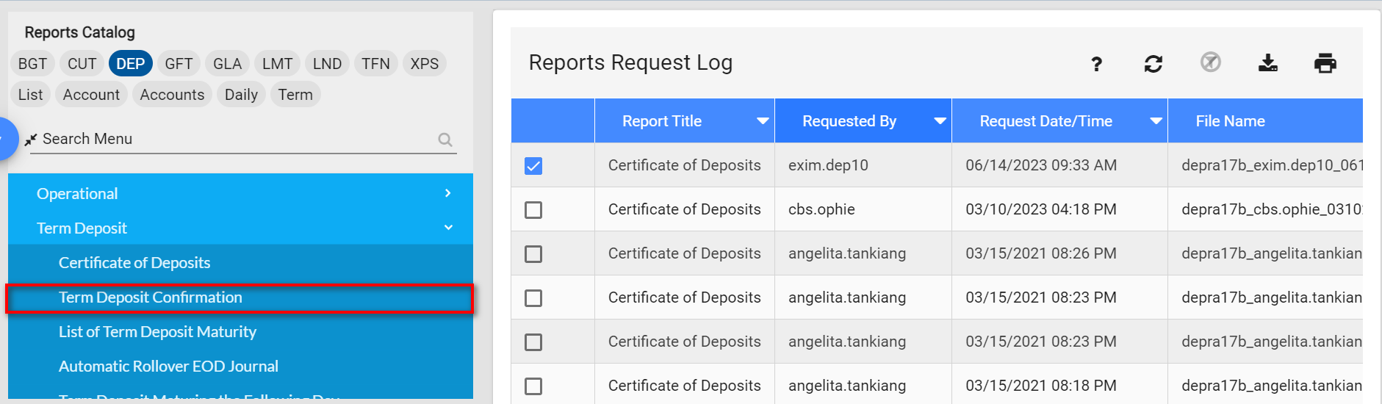

* Example layout

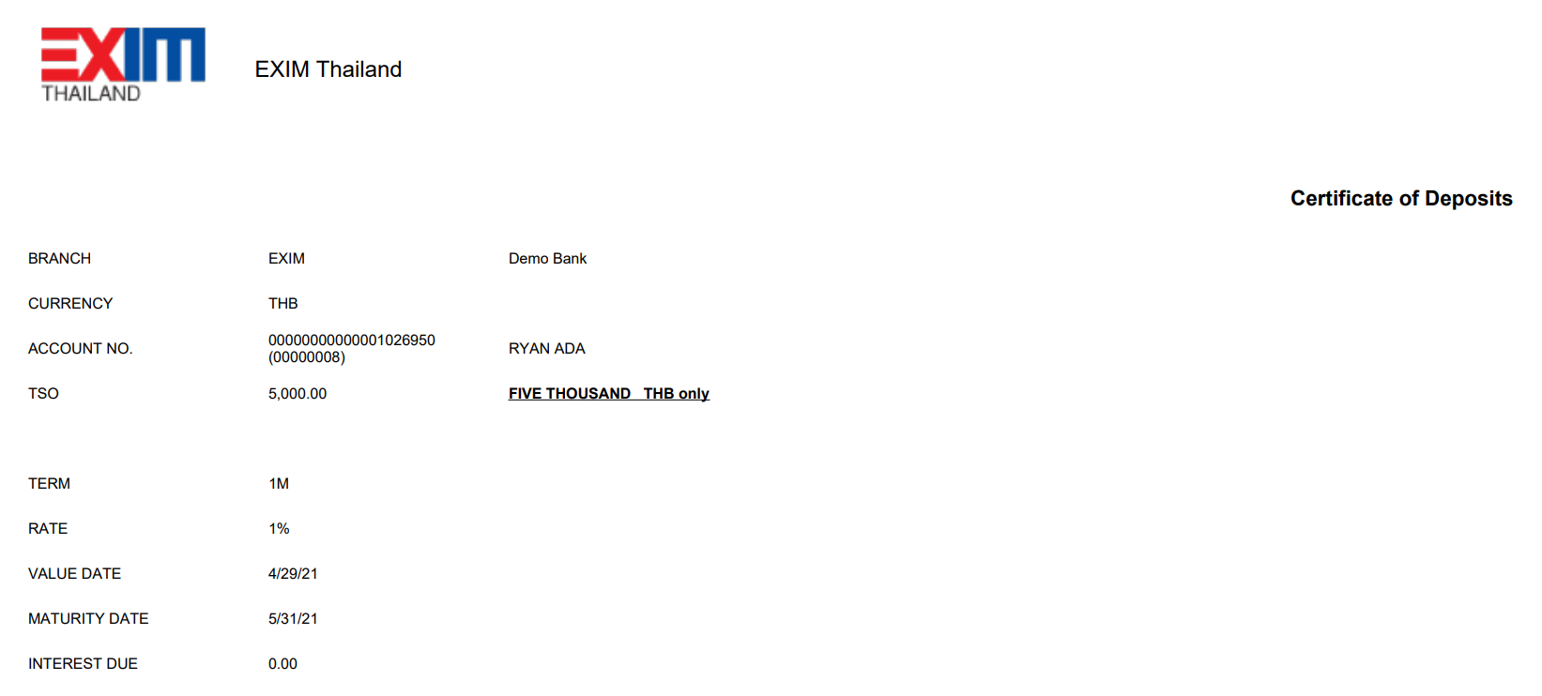

### Supported Sample Transaction and Case from Customer

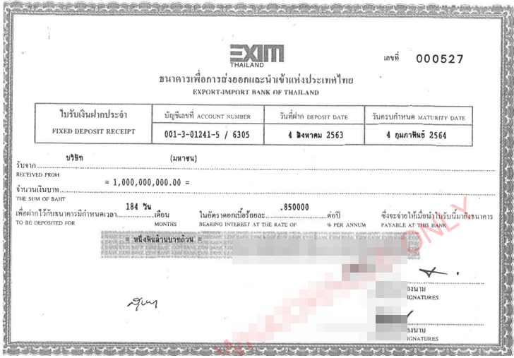

### Menu Modification

Not Applicable.

### Screen Layout and Data Sheet

Not Applicable.

### Business Rule / Business Logic

* Generate deposit certification for time deposit account once customers have money deposit in each time including rollover and renewal.
* Printing using blank paper.

### To-be Process

Print all the information on the blank paper

|  |  |
| --- | --- |
| Paper size | A4 |
| Reprinting require | Yes |
| Searching criteria | Account Number, Client Number, Date |

### File / API Layout and Data Sheet

Not Applicable.

### Report Layout and Data Sheet

|  |  |
| --- | --- |
| Report Field | Description |
| Certificate no. | Display Certificate no. |
| Account number | Display main account number / sub account number |
| Deposit date | Display deposit date |
| Maturity date | Display maturity date |
| Received from | Display account name |
| The sum of baht | Display amount |
| Gap period | Display gap period |
| Bearing interest at the rate of | Display interest rate |
| Thai letter amount | Display amount in Thai letter |



### Additional Impacts

Not Applicable.

## Non-Resident Report

|  |  |
| --- | --- |
| DPS-71 สามารถค้นหาและจัดทำรายงานสรุปยอดเงินฝากของบัญชีที่เป็นคนต่างชาติ (Non-Resident) เช่น รายงานสรุป Transaction รายวัน, รายงานเงินฝากในบัญชีเกินข้อกำหนดของธปท. | Able to search and prepare a summary of deposit balances of foreign accounts. (Non-resident) such as a daily transaction summary report, a report on deposits in accounts exceeding the BOT's requirements. |

### Purpose

The purpose is to provide Non-Resident account activity summary report.

### Background

* + 1. EXIM Current Business Practice (as-is)
* As is report produced by AS/400.
* Auto-Generated after EOD
* Daily report

8.2.2 CBS9 Current Functionality

* Checking CBS9 report.

### Supported Sample Transaction and Case from Customer

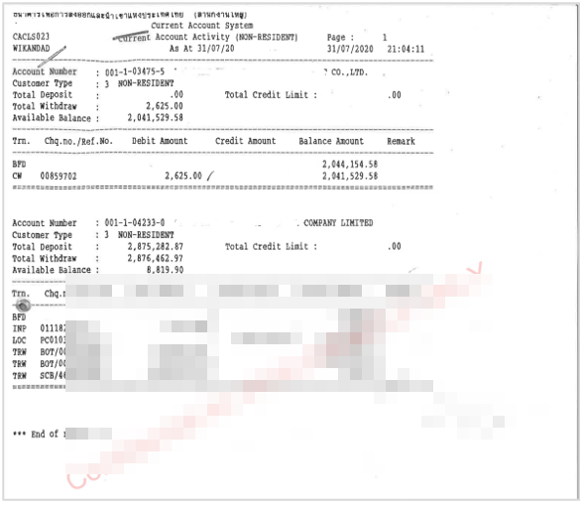

### Menu Modification

Not Applicable.

### Screen Layout and Data Sheet

Not Applicable.

### Business Rule / Business Logic

* Account type Non-Resident should define minimum balance = 200MB
* Online report.
* Require historical data.

### To-be Process

The system retrieves transaction from Non-resident account.

|  |  |
| --- | --- |
| Paper size | A4 |
| Reprinting require | Yes |
| Searching criteria | Client branch, Account type, Account no, Date range |

### File / API Layout and Data Sheet

* Send outstanding / transaction data to Dataset
* Refer to DEP-FS10 Interface.

### Report Layout and Data Sheet

|  |  |
| --- | --- |
| Report Field | Description |
| Header | |
| As At | Display as of date |
| Page | Display number of page |
| Printed date | Display printed date |
| Printed time | Display printed time |
| Printed by | Display user who login to system |
| Detail 1 | |
| Branch | Display branch name |
| Account Number | Display account number |
| Account Name | Display account name |
| Total Deposit | Display total deposit |
| Total Credit Limit | Display total credit limit |
| Total Withdrawal | Display total withdrawal |
| Available Balance | Display available balance |
| Detail 2 | |
| Txn. | Display Brough forward and movement transaction |
| Chq.No./Txn.No | Display cheque no/transaction no |
| Debit Amount | Display debit amount |
| Credit Amount | Display credit amount |
| Balance Amount | Display balance amount |
| Remark | Display remark |



### Additional Impacts

Not Applicable.

## Cheque Duty Fees Remittance Report

|  |  |
| --- | --- |
| DPS-72 สามารถสร้างรายงานนำส่งอากร (อส.4ก) เพื่อใช้ประกอบการนำส่งค่าอากรไปยังกรมสรรพากร โดยสามารถเรียกพิมพ์รายงานตามช่วงเวลาได้ โดยแบ่งตามประเภทเช็คดังนี้  1) เช็คธสน.  2) Cashier Cheque | Able to create a duty remittance report (Form Aor.Sor. 4 Kor) to support the submission of duties to the Revenue Department which can print reports at intervals Divided by type of check as follows:  1) Check the Bank of Thailand  2) Cashier Check |

### Purpose

The purpose is to provide cheque sell of Cheque books and Cashier cheque duty fees remittance report for EXIM to submit to Revenue department.

### Background

9.2.1 EXIM Current Business Practice (as-is)

* Cheque Duty Fees Remittance Report provided by AS/400.
* Online report
* The duty is 3 Baht Per 1 cheque.
* EXIM submits the report to the Revenue department twice a month.

e.g. June

1st submission with the information of the 1st – 15th

2nd submission with the information of the 16th – 30th

9.2.2 BDS Current Functionality

BDS module supported function Cheque sell of Cheque books and Cashier cheque.

The entries can be recorded as cheque sell fees and duties as shown in the table.

|  |  |  |
| --- | --- | --- |
| Type | Fees (Baht/Leave) | Duty (Baht/Leave) |
| Cheque book | 12 | 3 |
| Cashier cheque | 17 | 3 |

Therefore, new report will be collecting the Cheque Duty Fees Remittance transaction.

### Supported Sample Transaction and Case from Customer

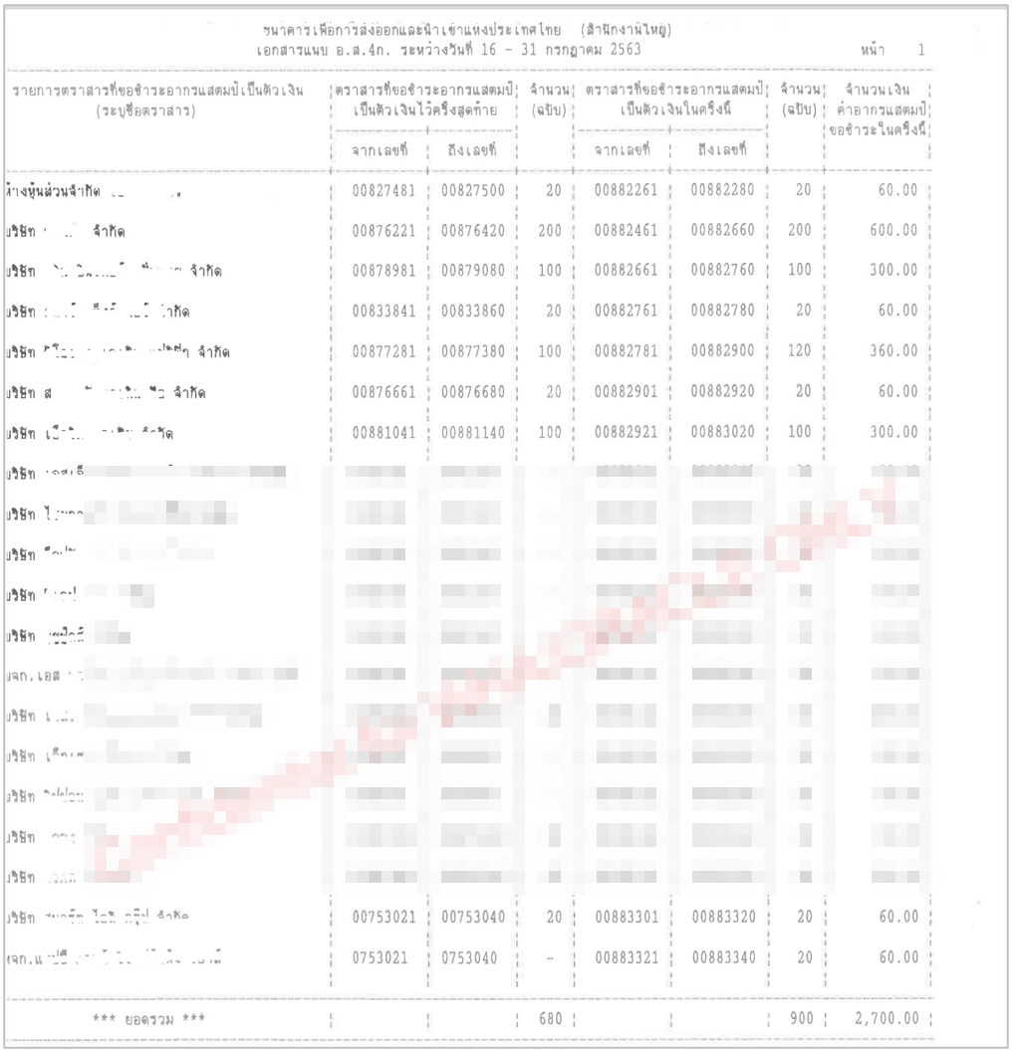

### Menu Modification

Not Applicable.

### Screen Layout and Data Sheet

Not Applicable.

### Business Rule / Business Logic

* System should be able to provide cheque sell of Cheque books and Cashier cheque duty fees remittance report and separate by client branch.
* Online report
* The duty is 3 Baht Per 1 cheque.
* EXIM submits the report to the Revenue department twice a month.

e.g. June

1st submission with the information of the 1st – 15th

2nd submission with the information of the 16th – 30th

### To-be Process

The system retrieves the duty fee from the cheque sell of Cheque books and Cashier cheque transaction which can be separated by client branch.

|  |  |
| --- | --- |
| Paper size | A4 |
| Reprinting require | Yes |
| Searching criteria | Client branch, Date range, Cheque type |

### File / API Layout and Data Sheet

Not Applicable.

### Report Layout and Data Sheet

|  |  |
| --- | --- |
| Report Field | Description |
| Header | |
| Branch | Display branch name |
| Date from____ To ___ | Display date from…to… depend on searching criteria |
| Page | Display number of page |
| Detail | |
| Account name | Display account name |
| Cheque no from …..to ….. | Display last purchased from cheque number to cheque number |
| Number of cheques | Display number of cheques for last purchased |
| Cheque no from …..to ….. | Display cheque purchased this time from cheque number to cheque number |
| Number of cheques | Display number of cheques for this time |
| Duty fees | Display duty fees amount |
| Total | Display summary of the last/ this time cheque items and fees amount |

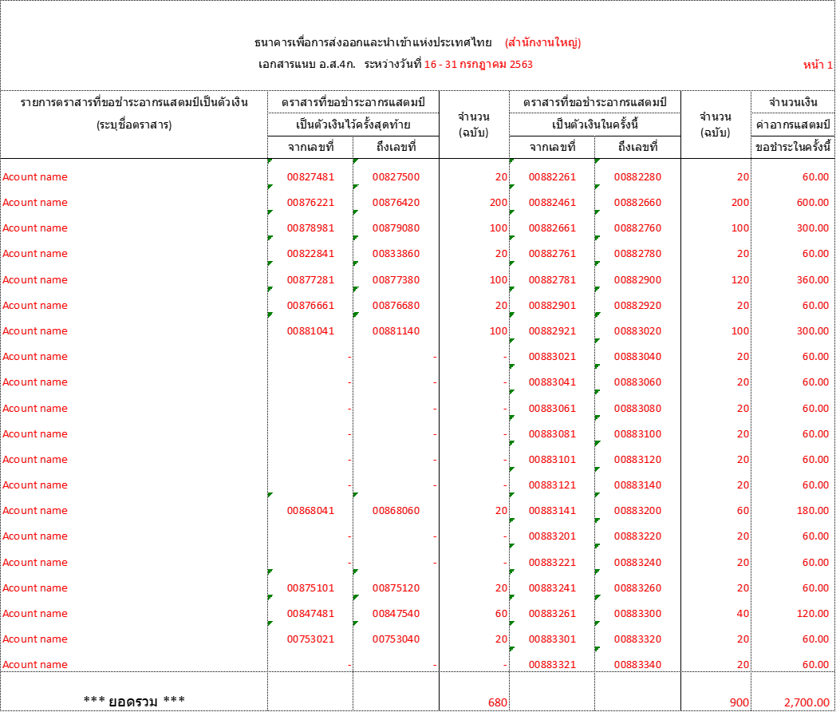

### Additional Impacts

Not Applicable

## Daily Summary Clearing Cheque Report

|  |  |
| --- | --- |
| DPS-73 สามารถทำสรุปรายงาน Cheque เเบบรายวัน เพื่อตรวจสอบสถานะต่าง ๆ ของ Cheque เช่น การกระทบยอด Cheque เป็นต้น | Able to generate summary cheque daily report to check various status of cheque, such as reconciliation of cheque, etc. |

### Purpose

The purpose is to provide a daily summary report of the other bank clearing cheques deposit.

### Background

10.2.1 EXIM Current Business Practice (as-is)

* Daily Summary Clearing Cheque Report provided by AS/400.
* Online report

10.2.2 BDS Current Functionality

* Checking CBS9 report.

### Supported Sample Transaction and Case from Customer

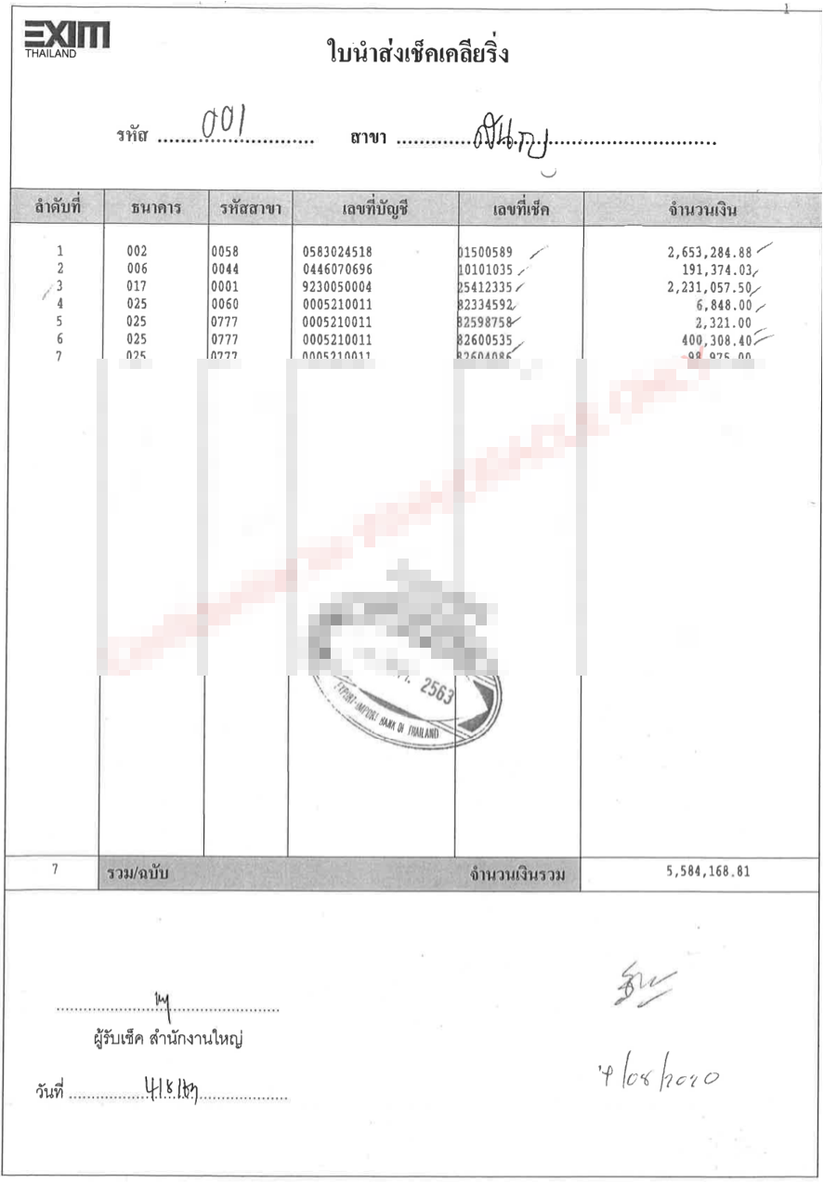

### Menu Modification

Not Applicable.

### Screen Layout and Data Sheet

Not Applicable.

### Business Rule / Business Logic

* System should be able to provide Daily Summary Clearing Cheque Report and separate by client branch.
* Online report

### To-be Process

The system retrieves the Collected Cheque and Multiple Clearing Cheque Deposit transaction which can be separated by client branch.

|  |  |
| --- | --- |
| Paper size | A4 |
| Reprinting require | Yes |
| Searching criteria | Branch code, Transaction Date range, Account no, Cheque no, Account type |

### File / API Layout and Data Sheet

Not Applicable

### Report Layout and Data Sheet

| Report Field | Description |
| --- | --- |
| Header | |
| รหัส (Branch code) | EXIM customer branch code |
| สาขา (Branch name) | EXIM customer branch name |
| Transaction Date From ……To….. | Display date from…to… depend on searching criteria |
| Page | Display number of page |
| Printed date | Display printed date |
| Printed time | Display printed time |
| Printed by | Display user who login to system |
| Detail | |
| Account type | Display account type |
| ลำดับที่ (No.) | Display sequential of transaction |
| Customer Account | Display EXIM customer account |
| Customer Name | Display customer name |
| Transaction Date | Display transaction date |
| Cheque Date | Display cheque date |
| ธนาคาร (Bank) | Display bank cheque |
| รหัสสาขา (Branch) | Display branch under bank cheque |
| เลขที่บัญชี (Account Number) | Display cheque account number |
| เลขที่เช็ค (Cheque Number) | Display cheque number |
| จำนวนเงิน (Amount) | Display amount |
| Total | Display total number of cheque and total amount |



### Additional Impacts

Not Applicable.

## Post Cheque Report

|  |  |
| --- | --- |
| DPS-74 สร้างรายงานเช็คที่ Post ได้ | Able to create a Post cheque report |

### Purpose

The purpose is to provide Post Cheque Report only successful processed from ICAS.

### Background

11.2.1 EXIM Current Business Practice (as-is)

* Post Cheque Report provided by AS/400.
* Online report

11.2.2 CBS9 Current Functionality

* Checking CBS9 report.

### Supported Sample Transaction and Case from Customer

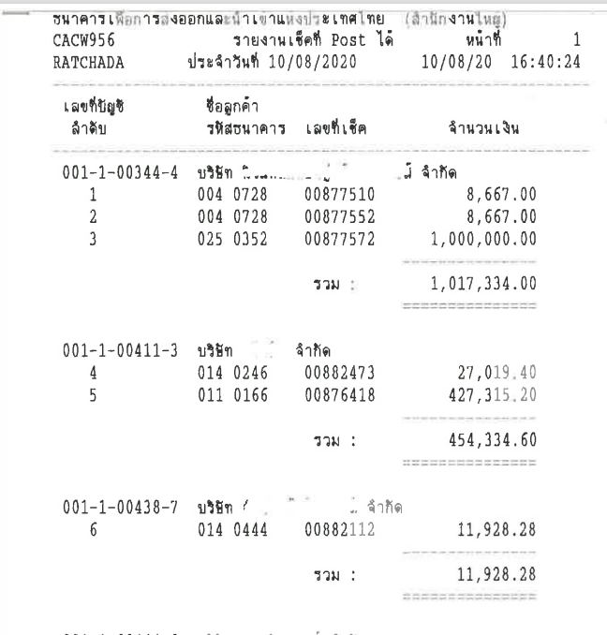

### Menu Modification

Not Applicable.

### Screen Layout and Data Sheet

Not Applicable.

### Business Rule / Business Logic

* System provide Post Cheque Report and separate by client branch which successful processed transaction in CBS9 from ICAS.
* Online report
* The report will be update when transaction process have been completed.

### To-be Process

The system retrieves the successful processed transaction in CBS9 from ICAS which can be separated by client branch.

|  |  |
| --- | --- |
| Paper size | A4 |
| Reprinting require | Yes |
| Searching criteria | Branch code, Account no, Date range, Cheque no |

### File / API Layout and Data Sheet

Not Applicable.

### Report Layout and Data Sheet

| Report Field | Description |
| --- | --- |
| Header | | |
| Transaction Date | Display date from…to… depend on searching criteria |
| Page | Display number of page |
| Printed date | Display printed date |
| Printed time | Display printed time |
| Printed by | Display user who login to system |
| Detail | | |
| สาขา (Branch name) | Display EXIM customer branch |
| เลขที่บัญชี (Account number) | Display account number |
| ชื่อลูกค้า (Account name) | Display account name |
| ลำดับ (No.) | Display sequential of transaction |
| รหัสธนาคาร (Bank) | Display sending bank |
| รหัสสาขา (Branch) | Display sending branch of bank |
| เลขที่เช็ค (Cheque number) | Display cheque number |
| จำนวนเงิน (Amount) | Display cheque amount |
| รวม (Total) | Displays the total amount of each account number |
| รวมทั้งหมด (Grand total) | Display grand total number of cheques and amount |



### Additional Impacts

Not Applicable.

## Not Post Cheque Report

|  |  |
| --- | --- |
| DPS-75 สร้างรายงานเช็คที่ไม่สามารถ Post Auto | Able to create a unauto post cheque report |

### Purpose

The purpose is to provide Post Cheque Report only unsuccessful processed from ICAS.

### Background

12.2.1 EXIM Current Business Practice (as-is)

* Not Post Cheque Report provided by AS/400.
* Online report

12.2.2 CBS9 Current Functionality

* Checking CBS9 report.

### Supported Sample Transaction and Case from Customer

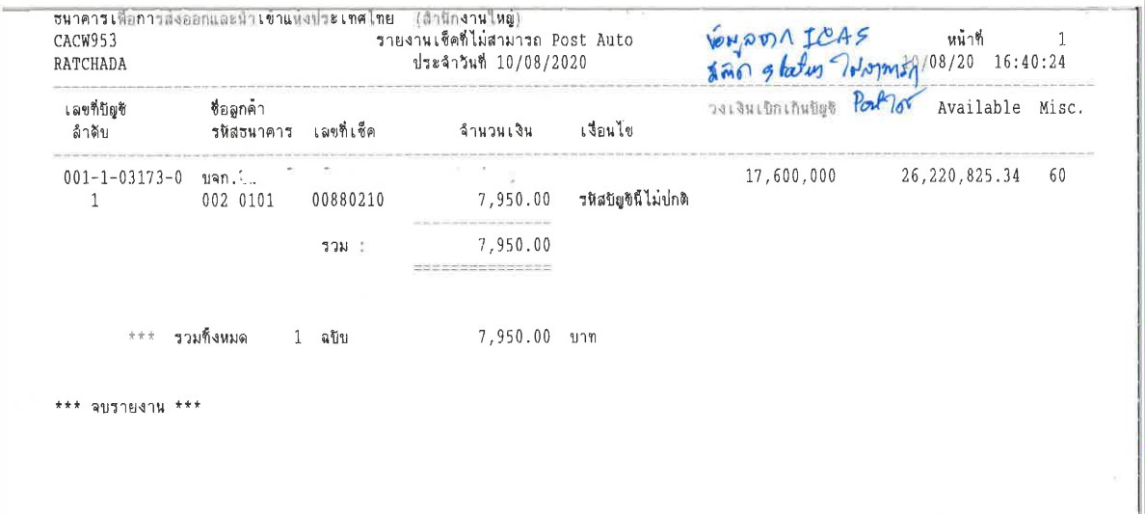

### Menu Modification

Not Applicable

### Screen Layout and Data Sheet

Not Applicable.

### Business Rule / Business Logic

* System provide Not Post Cheque Report and separate by client branch which unsuccessful processed transaction in CBS9 from ICAS.
* Online report
* The report will be update when transaction process have been completed.

### To-be Process

The system retrieves the unsuccessful processed transaction in CBS9 from ICAS which can be separated by client branch.

|  |  |
| --- | --- |
| Paper size | A4 |
| Reprinting require | Yes |
| Searching criteria | Branch code, Account no, Date range, Cheque no |

### File / API Layout and Data Sheet

Not Applicable.

### Report Layout and Data Sheet

| Report Field | Description |
| --- | --- |
| Header | | |
| Transaction Date | Display date from…to… depend on searching criteria |
| Page | Display number of page |
| Printed date | Display printed date |
| Printed time | Display printed time |
| Printed by | Display user who login to system |
| Detail | | |
| สาขา (Branch) | Display EXIM customer branch |
| เลขที่บัญชี (Account number) | Display account number |
| ชื่อลูกค้า (Account name) | Display account name |
| ลำดับ (No.) | Display sequential of transaction |
| รหัสธนาคาร (Bank) | Display sending bank |
| รหัสสาขา (Branch) | Display sending branch of bank |
| เลขที่เช็ค (Cheque number) | Display cheque number |
| จำนวนเงิน (Amount) | Display cheque amount |
| เงื่อนไข (Reason) | Display not post reason, Ex. Dormant account |
| วงเงิน OD (Limit OD Amount) | Display Limit OD amount |
| จำนวนเงินคงค้าง (Available) | Displays amount outstanding balance |
| เงื่อนไขการระงับบัญชี (Restraint) | Displays Restraint code |
| รวม (Total) | Displays the total amount of each account number |
| รวมทั้งหมด (Grand total) | Display grand total number of cheques and amount |



Add the items below to the report as well.

* วงเงิน OD (Limit OD Amount)
* จำนวนเงินคงค้าง (Available)
* เงื่อนไขการระงับบัญชี (Restraint)

### Additional Impacts

Not Applicable.

## Return Cheque Report

|  |  |
| --- | --- |
| DPS-76 สร้างรายงานเช็คคืน | Able to create a return cheque report |
| DPS-77 สามารถเรียกรายงานเช็คคืนตามช่วงเวลาและ/หรือลูกค้าที่กำหนดได้ | Return cheque reports can be retrieved at specified intervals and/or customers. |

### Purpose

The purpose is to provide Return Cheque Report from ICAS.

### Background

12.2.1 EXIM Current Business Practice (as-is)

* Return Cheque Report provided by AS/400.
* Online report

12.2.2 CBS9 Current Functionality

* Checking CBS9 report.

### Supported Sample Transaction and Case from Customer

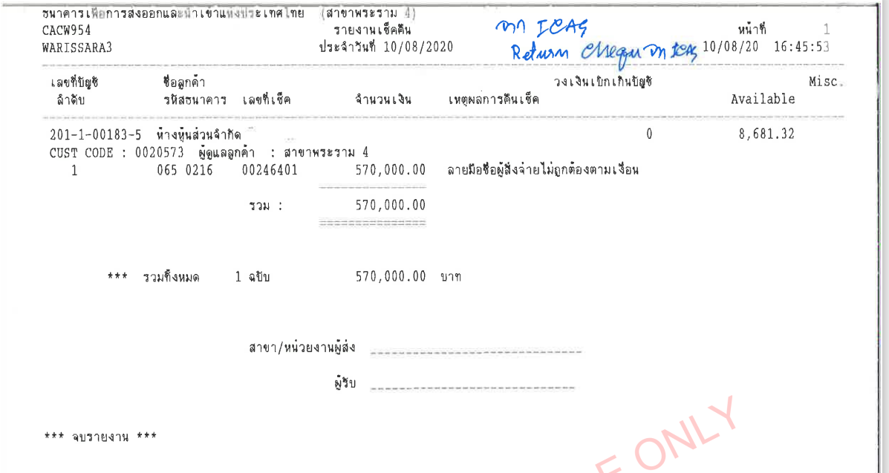

### Menu Modification

Not Applicable.

### Screen Layout and Data Sheet

Not Applicable.

### Business Rule / Business Logic

* System provide Return Cheque Report and separate by client branch which return cheque processed transaction in CBS9 from ICAS.
* Online report
* The report will be update when transaction process have been completed.

### To-be Process

The system retrieves the Cheque returned transaction which can be separated by client branch.

|  |  |
| --- | --- |
| Paper size | A4 |
| Reprinting require | Yes |
| Searching criteria | Branch code, Account no, Date range, Cheque no, Reason |

### File / API Layout and Data Sheet

Not Applicable.

### Report Layout and Data Sheet

| Report Field | Description |
| --- | --- |
| Header | | |
| Transaction Date | Display date from…to… depend on searching criteria |
| Page | Display number of page |
| Printed date | Display printed date |
| Printed time | Display printed time |
| Printed by | Display user who login to system |
| Detail | | |
| สาขา (Branch) | Display EXIM customer branch |
| เลขที่บัญชี (Account number) | Display account number |
| ชื่อลูกค้า (Account name) | Display account name |
| ลำดับ (No.) | Display sequential of transaction |
| รหัสธนาคาร (Bank) | Display sending bank |
| รหัสสาขา (Branch) | Display sending branch of bank |
| เลขที่เช็ค (Cheque number) | Display cheque number |
| จำนวนเงิน (Amount) | Display cheque amount |
| เหตุผลการคืนเช็ค (Reason) | Display return cheque reason, Ex. The payer’s signature is incorrect |
| วงเงิน OD (Limit OD Amount) | Display Limit OD amount |
| จำนวนเงินคงค้าง (Available) | Displays amount outstanding balance |
| เงื่อนไขการระงับบัญชี (Restraint) | Displays Restraint code |
| รวม (Total) | Displays the total amount of each account number |
| รวมทั้งหมด (Grand total) | Display grand total number of cheques and amount |



Add the items below to the report as well.

* วงเงิน OD (Limit OD Amount)
* จำนวนเงินคงค้าง (Available)
* เงื่อนไขการระงับบัญชี (Restraint)

### Additional Impacts

Not Applicable.

## Cash Deposit Report >= 2 Million

|  |  |
| --- | --- |
| DPS-78 ระบบสามารถสร้างรายงานสำหรับการฝากเงินตั้งแต่ 2 ล้านบาทขึ้นไปได้ ตามช่วงระยะเวลาที่กำหนด | The system can generate reports for deposit of 2 million baht or more according to the specified period. |

### Purpose

The purpose is to provide report for Cash deposit transaction of greater than or equal to 2 million baht.

### Background

13.2.1 EXIM Current Business Practice (as-is)

* Cash Deposit Report provided by AS/400.
* Auto-Generated after EOD
* Daily report

13.2.2 CBS9 Current Functionality

* Checking CBS9 report.

### Supported Sample Transaction and Case from Customer

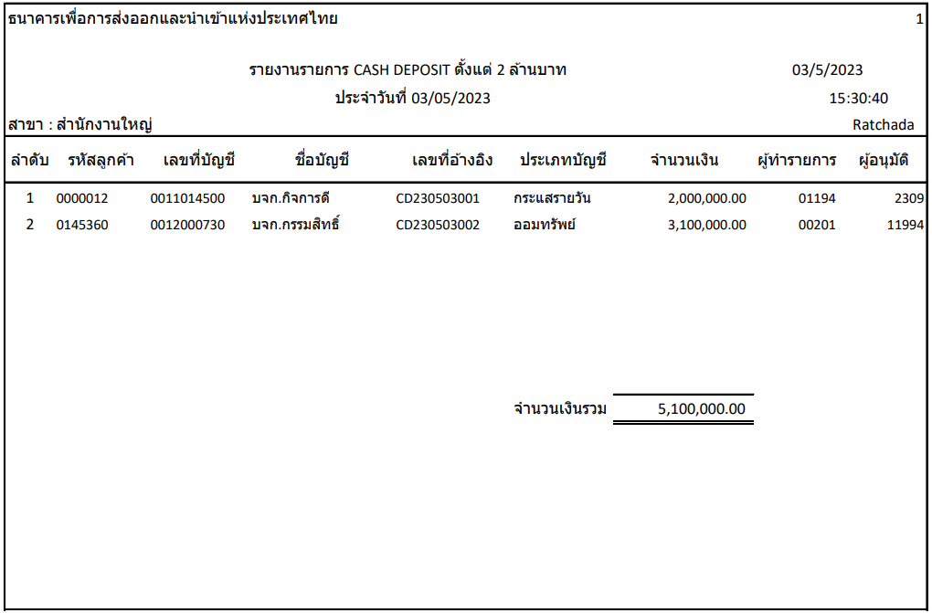

### Menu Modification

Not Applicable.

### Screen Layout and Data Sheet

Not Applicable.

### Business Rule / Business Logic

* Cash deposit transaction of greater than or equal to 2 million baht.
* Auto-Generated after EOD
* Reprinting require
* Daily report

### To-be Process

The system retrieves the Cash deposit transaction of greater than or equal to 2 million baht which can be separated by client branch.

|  |  |
| --- | --- |
| Paper size | A4 |
| Reprinting require | Yes |
| Searching criteria | Branch, Account type, Account no, Account name, Date range |

### File / API Layout and Data Sheet

Not Applicable.

### Report Layout and Data Sheet

| Report Field | Description |
| --- | --- |
| Header | | |
| Date From……… To …………. | Display date from…to… depend on searching criteria |
| Page | Display number of page |
| Printed date | Display printed date |
| Printed time | Display printed time |
| Printed by | Display user who login to system |
| Detail | | |
| สาขา (Branch) | Display EXIM customer branch |
| ลำดับ (No.) | Display sequential of transaction |
| รหัสลูกค้า (Customer ID) | Display customer ID |
| เลขที่บัญชี (Account number) | Display account number |
| ชื่อบัญชี (Account name) | Display account name |
| เลขที่อ้างอิง (Transaction number) | Display transaction number |
| วันที่ (Transaction date) | Display transaction date |
| ประเภทบัญชี (Account type) | Display account type |
| จำนวนเงิน (Amount) | Display amount |
| ผู้ทำรายการ (Maker) | Display maker |
| ผู้อนุมัติ (Checker) | Display checker |
| จำนวนเงินรวม (Total) | Display Summary total amount |



### Additional Impacts

Not Applicable

## Deposit Transaction more than 1 time

|  |  |
| --- | --- |
| DPS-79 ระบบสามารถสร้างรายงานการฝากเงินมากกว่า 1 ครั้งในวันเดียวกันต่อ 1 บัญชีได้ | The system can generate report for deposit more than 1 time per 1 account on the same day. |

### Purpose

The purpose is to provide report for deposit transaction of more than 1 time per 1 account on the same day.

### Background

15.2.1 EXIM Current Business Practice (as-is)

* Cash Deposit Report provided by AS/400.
* Auto-Generated after EOD
* Daily

15.2.2 CBS9 Current Functionality

* Checking CBS9 report.

### Supported Sample Transaction and Case from Customer

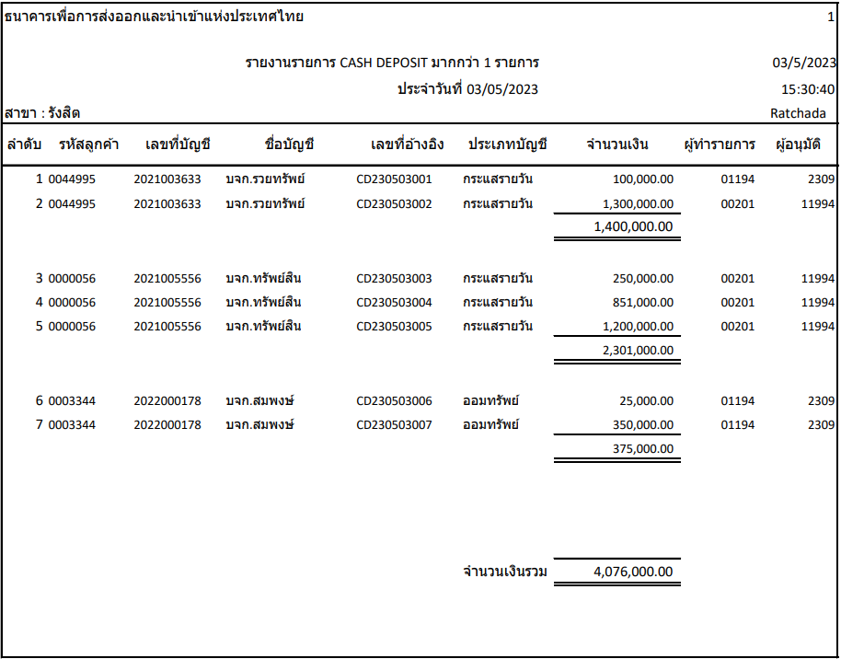

### Menu Modification

Not Applicable.

### Screen Layout and Data Sheet

Not Applicable.

### Business Rule / Business Logic

* Deposit transaction of more than 1 time per 1 account on the same day.
* Able to search by transaction
* Online report

### To-be Process

The system retrieves the deposit transaction of more than 1 time per 1 account on the same day which can be separated by client branch.

|  |  |
| --- | --- |
| Paper size | A4 |
| Reprinting require | Yes |
| Searching criteria | Account type, Account no, Account name, Date range, Transaction type |

### File / API Layout and Data Sheet

Not Applicable.

### Report Layout and Data Sheet

| Report Field | Description |
| --- | --- |
| Header | | |
| Date From……… To …………. | Display date from…to… depend on searching criteria |
| Page | Display number of page |
| Printed date | Display printed date |
| Printed time | Display printed time |
| Printed by | Display user who login to system |
| Detail | | |
| สาขา (Branch) | Display EXIM customer branch |
| ลำดับ (No.) | Display sequential of transaction |
| รหัสลูกค้า (Customer ID) | Display customer ID |
| เลขที่บัญชี (Account number) | Display account number |
| ชื่อบัญชี (Account name) | Display account name |
| เลขที่อ้างอิง (Transaction number) | Display transaction number |
| วันที่ (Transaction date) | Display transaction date |
| ประเภทบัญชี (Account type) | Display account type |
| จำนวนเงิน (Amount) | Display amount |
| ผู้ทำรายการ (Maker) | Display maker |
| ผู้อนุมัติ (Checker) | Display checker |
| รวม (Total) | Displays the total amount of each account number |
| รวมทั้งหมด (Grand total) | Display grand total number of cheques and amount |



### Additional Impacts

Not Applicable.

## Overdraft / Accrued / Saving Interest Report

|  |  |
| --- | --- |
| DPS-80 สามารถสร้างรายงานดอกเบี้ยค้างรับ/ค้างจ่าย, รายงานดอกเบี้ยรับ/ดอกเบี้ยจ่าย โดยสามารถเรียกรายงานของทุกบัญชีหรือแยกตามประเภทบัญชี, สกุลเงิน, สาขา ได้ ในรูปแบบ Online โดยเลือกเงื่อนไขข้อมูลได้ตามที่ธนาคารกำหนด | Able to generate accrued interest / accrued reports, interest income / interest reports, can retrieve reports of all accounts or classified by account type, currency, branch. in near real-times |

### Purpose

The purpose is to provide report for Overdraft interest, Accrued interest, Saving interest and TD interest.

### Background

* + 1. EXIM Current Business Practice (as-is)
* As is report produced by AS/400.
* Online report

16.2.2 CBS9 Current Functionality

* Checking CBS9 report.

### Supported Sample Transaction and Case from Customer

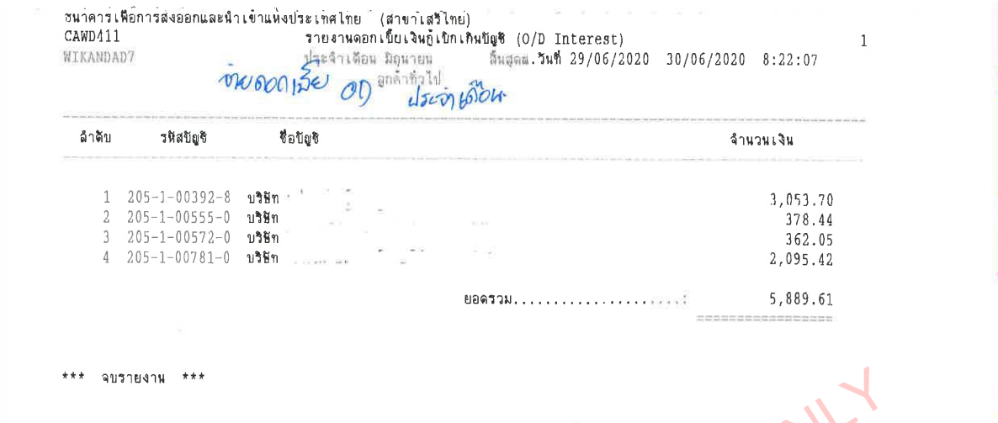

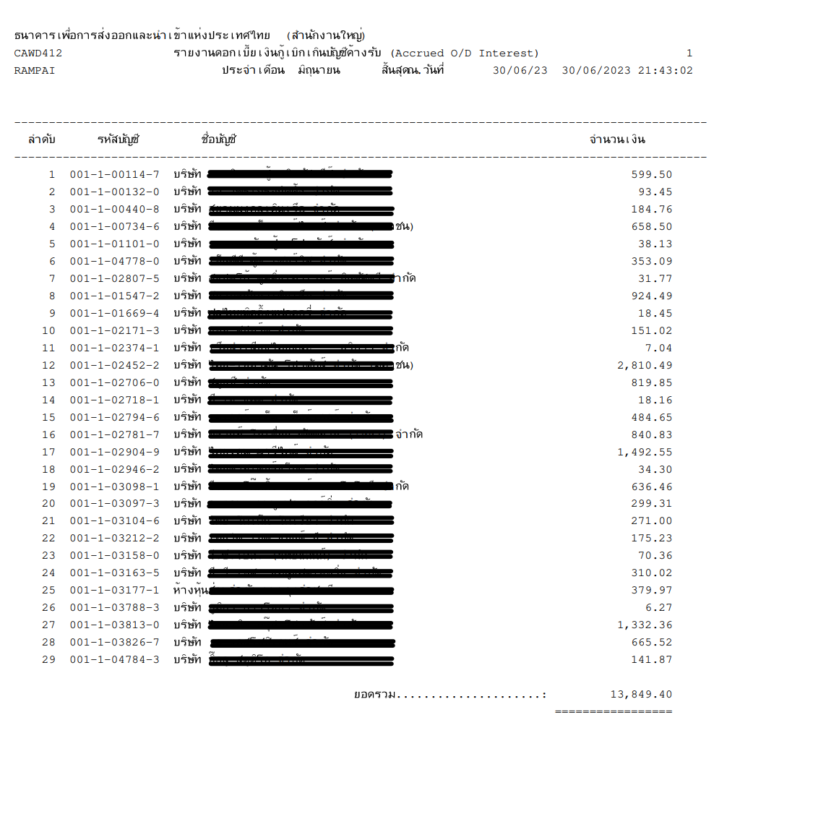

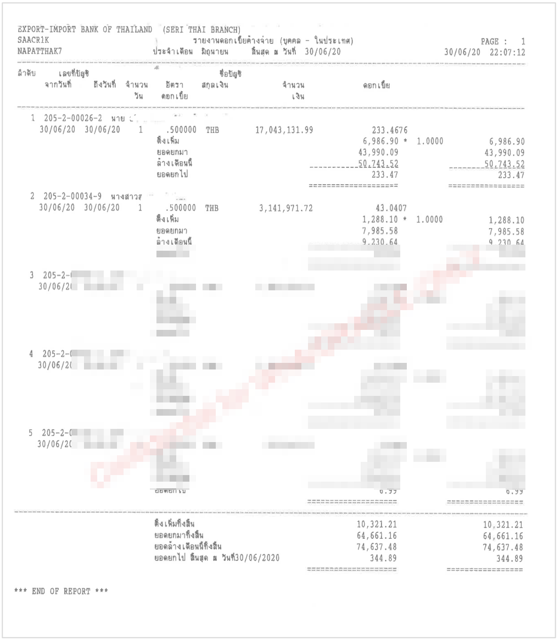

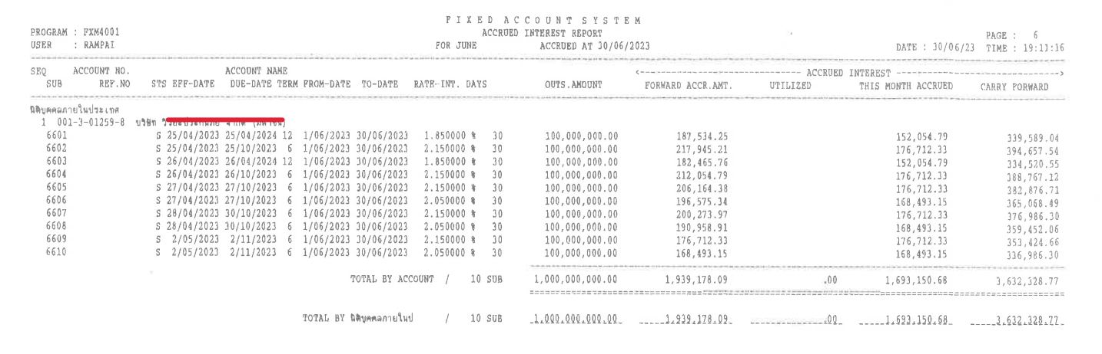

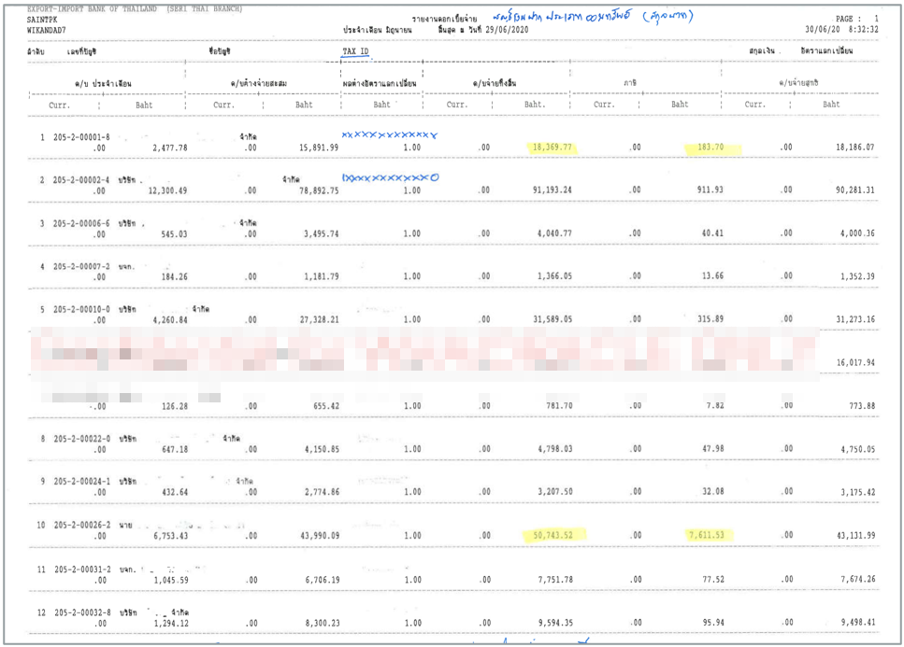

### Menu Modification

Not Applicable.

### Screen Layout and Data Sheet

Not Applicable.

### Business Rule / Business Logic

* Overdraft interest will debit to account on last working day of the month.
* Accrued interest will calculate accumulated daily.
* Saving interest will credit to account on last working day of June and December or when closing account.
* TD interest will process on maturity date.
* Online report.
* Require historical data.

### To-be Process

The system retrieves the Overdraft / Accrued / Saving / TD interest transaction which can be separated by client branch.

|  |  |
| --- | --- |
| Paper size | A4 |
| Reprinting require | Yes |
| Searching criteria | Branch code, Date, Account type, Currency, Account no, Account name |

### File / API Layout and Data Sheet

Not Applicable.

### Report Layout and Data Sheet

#### Overdraft interest report



#### Accrued interest report



Example Accrued OD and TD report shown as exemplified in “16.3 Supported Sample Transaction and Case from Customer”

#### Interest payable report



### Additional Impacts

Not Applicable.

## Statement

|  |  |
| --- | --- |
| DPS-81 สามารถเรียกดู และสั่งพิมพ์รายการเคลื่อนไหวในบัญชี (Statement) รายบัญชี ทุกประเภทบัญชี ตามช่วงเวลาได้ เช่น ประจำวัน, รายเดือน และย้อนหลังได้ กรณีเงินฝากประจำสามารถสร้างและเรียกได้แบบเป็นรายบัญชีและบัญชีย่อยได้ | Able to view and print a list of transaction movements (Statement) for each account according to a period of time, such as daily, monthly and past. |
| DPS-83 สามารถออก Statement ประจำเดือนเพื่อส่งให้ลูกค้า โดยสามารถกำหนดเงื่อนไขการเรียกข้อมูลได้ เช่น เฉพาะบัญชีที่เคลื่อนไหว หรือบัญชีทั้งหมดเป็นต้น โดยสามารถสั่งพิมพ์ทั้งหมดหรือเป็นกลุ่มได้อย่างต่อเนื่อง | Able to issue monthly statement to send to customers You can set retrieval conditions, for example, only active accounts. or all accounts etc. All or batch can be printed continuously. |
| DPS-84 สามารถออก Statement ประจำเดือน 6 และ 12 โดยสร้างทุกบัญชีลูกค้า (รวมบัญชีที่ไม่เคลื่อนไหว) สำหรับบัญชีลูกค้าทุกประเภท | Able to issue 6 and 12 monthly statements by creating every customer account (including dormant accounts) for all customer accounts |
| DEP-21 รองรับการพิมพ์ Statement ได้ทั้ง รายวัน รายสัปดาห์ รายเดือน โดยเชื่อมต่อกับ E-Service | Statements which can be printed on daily, weekly and monthly frequency. Interface with e-Service. |

### Purpose

The purpose is to provide account statement for all account type daily, weekly and monthly.

### Background

* + 1. EXIM Current Business Practice (as-is)
* As is report produced by AS/400.
* Auto-Generated after EOD
* Daily, Weekly and Monthly

17.2.2 CBS9 Current Functionality

* Checking CBS9 report.

### Supported Sample Transaction and Case from Customer

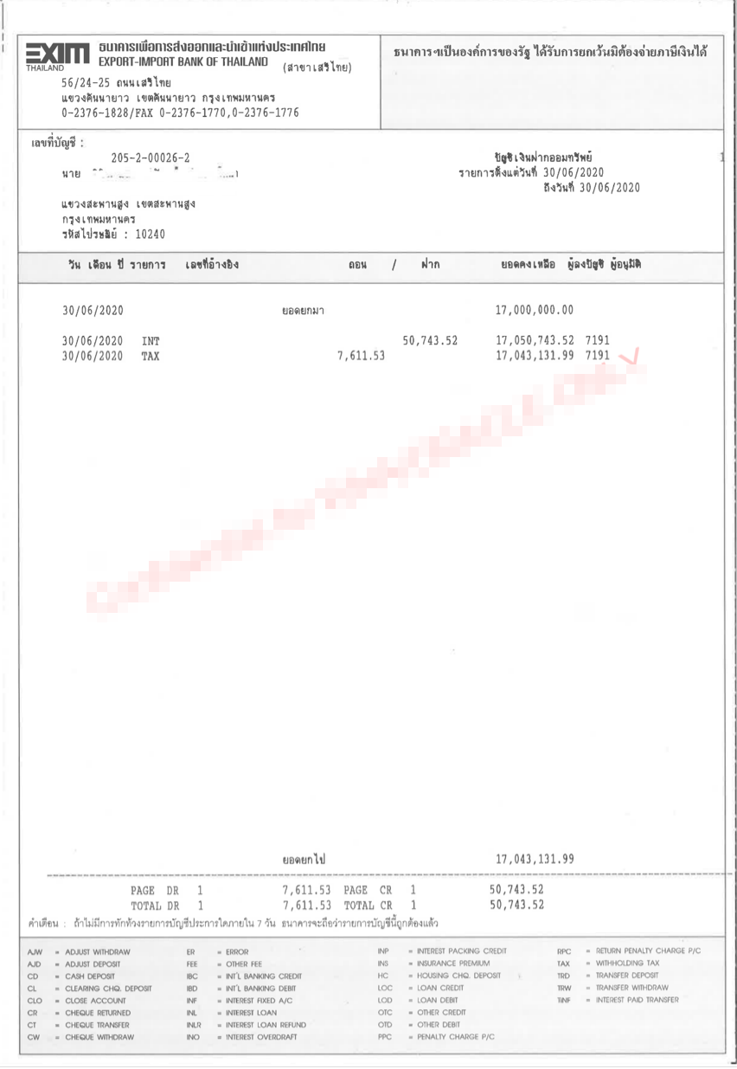

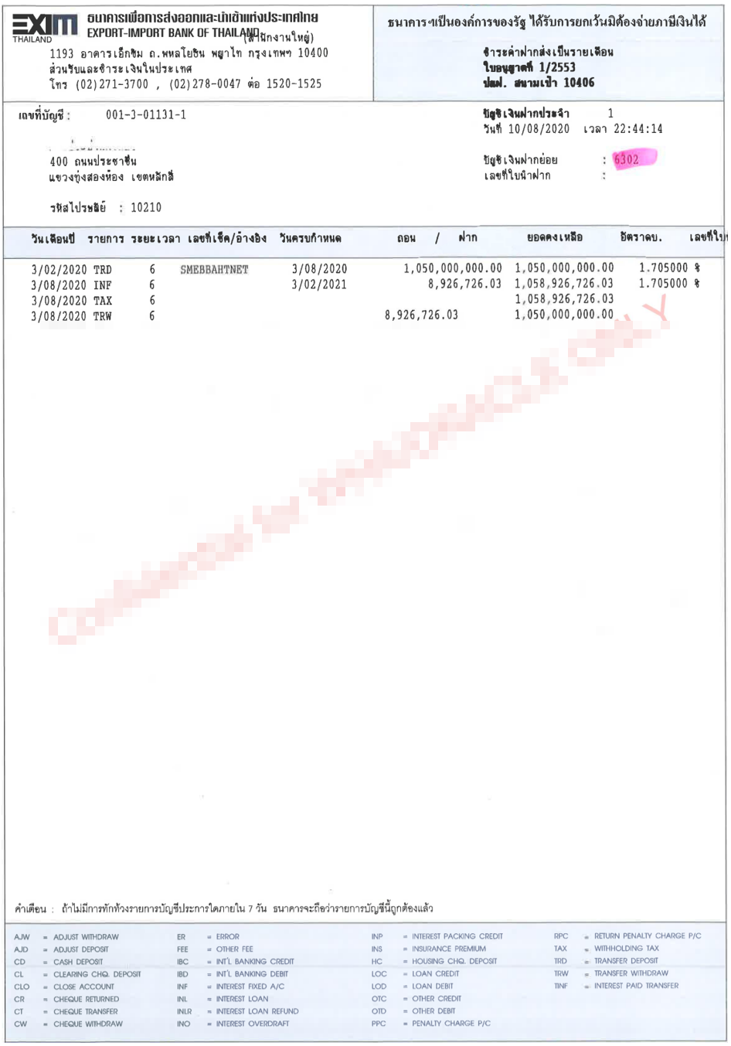

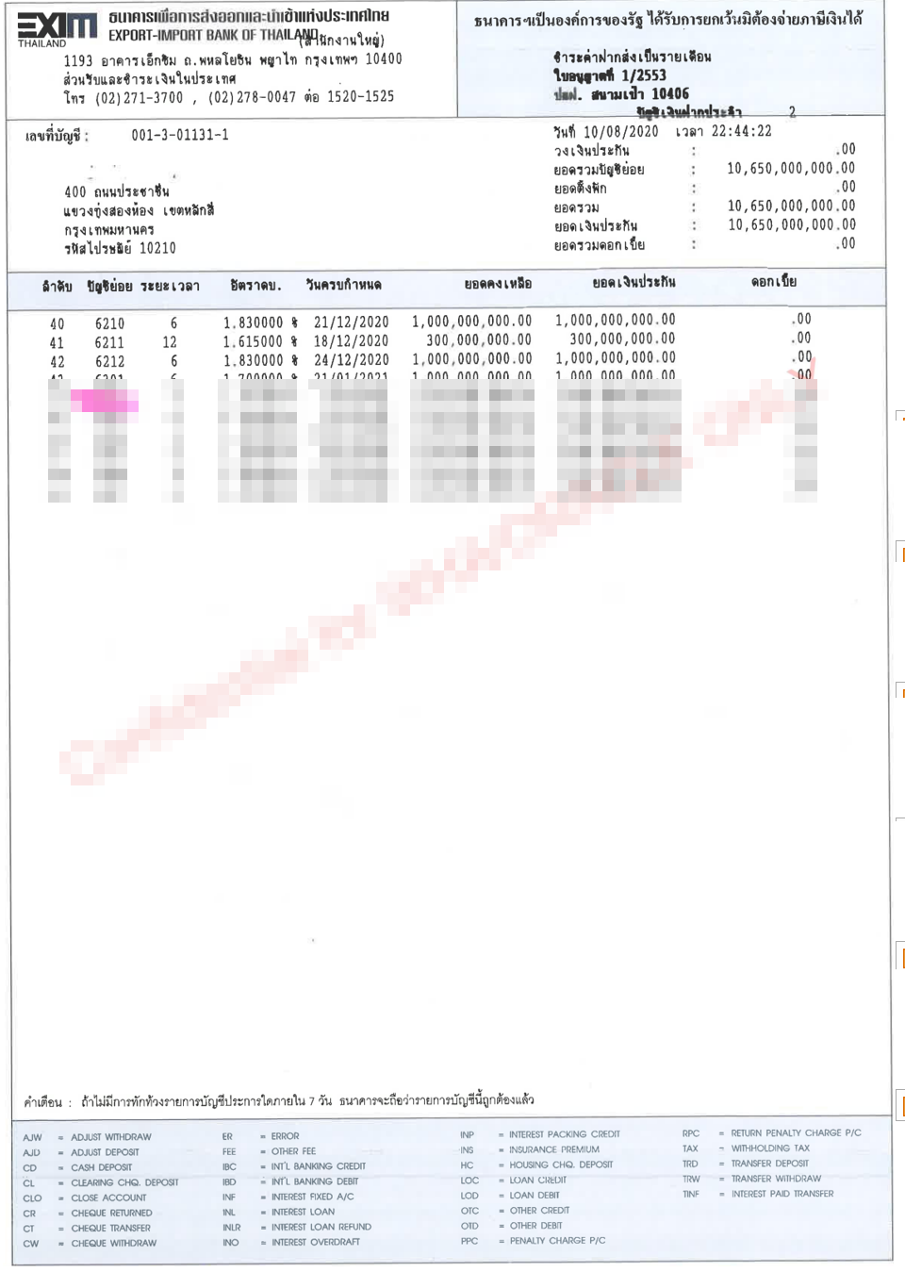

### Menu Modification

Not Applicable.

### Screen Layout and Data Sheet

Not Applicable.

### Business Rule / Business Logic

* Account statement shows all transaction separated by account type.
* Auto-Generated after EOD.
* Daily, Weekly and Monthly.
* Incase of TD Account : Individual statement needs to be generated for each TD Account and consolidated statement to be generated based on Account Group No.

### To-be Process

The system retrieves the transactions to shown in account statement which can be separated by client branch and account type.

|  |  |
| --- | --- |
| Paper size | A4 |
| Reprinting require | Yes |
| Searching criteria | Account type, Account no, Date range |

### File / API Layout and Data Sheet

* Send to e-Service

### Report Layout and Data Sheet

#### CA/SA

| Report Field | Description |
| --- | --- |
| Header | | |
| Branch name | Display customer branch |
| Branch address | Display branch address |
| Account number | Display account number |
| Account name | Display account name |
| Account type | Display account type |
| Customer address | Display customer address |
| Date From……… To …………. | Display date |
| Detail | | |
| วัน เดือน ปี (Transaction date) | Display transaction date (The First line Display brought forward value and the end of each page display carry forward value) |
| รายการ (Transaction) | Display transaction code |
| เลขที่อ้างอิง (Transaction No.) | Display transaction number |
| ถอน (Withdrawal) | Display withdrawal transaction amount |
| ฝาก (Deposit) | Display deposit transaction amount |
| ยอดคงเหลือ (Outstanding) | Display outstanding amount |
| ผู้ลงบัญชี (Maker) | Display maker |
| ผู้อนุมัติ (Checker) | Display checker |
| สรุปรายการและจำนวนเงินของรายการถอน/ฝากแต่ละหน้า (Total Transaction item and amount debit and credit) | Display summary item and amount debit /credit each page |
| สรุปรายการและจำนวนเงินรวมรายการถอน/ฝาก (Grand total transaction item and amount debit/credit at the last page) | Display Grand total items and amount debit/credit at the last page. |



#### TD by sub-account

| Report Field | Description |
| --- | --- |
| Header | | |
| Branch name | Display customer branch |
| Branch address | Display branch address |
| Account number | Display account number |
| Account name | Display account name |
| Account type | Display account type |
| Customer address | Display customer address |
| Date - Time | Display date -Time |
| TD account | Display TD sub-account |
| Detail | | |
| วัน เดือน ปี (Transaction date) | Display transaction date |
| รายการ (Transaction) | Display transaction code |
| ระยะเวลา (Term) | Display term |
| เลขที่เช็ค/อ้างอิง (Cheque No./Transaction No.) | Display cheque number/transaction number |
| วันครบกำหนด (Maturity date) | Display maturity date |
| ถอน (Withdrawal) | Display withdrawal transaction amount |
| ฝาก (Deposit) | Display deposit transaction amount |
| ยอดคงเหลือ (Outstanding) | Display outstanding amount |
| อัตราดอกเบี้ย (Interest rate) | Display interest rate |



#### TD by consolidates

| Report Field | Description |
| --- | --- |
| Header | | |
| Branch name | Display customer branch |
| Branch address | Display branch address |
| Account number | Display account number |
| Account name | Display account name |
| Account type | Display account type |
| Customer address | Display customer address |
| Date - Time | Display date -Time |
| วงเงินประกัน () |  |
| ยอดรวมบัญชีย่อย (Sub-account total) |  |
| ยอดตั้งพัก (Accrued amount) |  |
| ยอดรวม (Total) |  |
| ยอดเงินประกัน () |  |
| ยอดรวมดอกเบี้ย (Interest total) |  |
| Detail | | |
| ลำดับ (No.) | Display sequential of transaction |
| บัญชีย่อย (Sub-account) | Display transaction date |
| ระยะเวลา (Term) | Display term |
| อัตราดอกเบี้ย (Interest rate) | Display interest rate |
| วันครบกำหนด (Maturity date) | Display maturity date |
| ยอดคงเหลือ (Outstanding) | Display outstanding amount |
| ยอดเงินประกัน () | Display |
| ดอกเบี้ย (Interest) | Display interest |



### Additional Impacts

Not Applicable.

## List of top 20 Customer by transaction amount

|  |  |
| --- | --- |
| DPS-82 สามารถสรุปรายงานของยอดธุรกรรมตามความต้องการของผู้ใช้งานระบบโดยไม่ต้องอาศัยฝ่ายปฏิบัติการเทคโนโลยีสารสนเทศ ข้อมูลที่ต้องการ เช่น สาขา, Customer ID, ชื่อลูกค้า, เลขที่บัญชี, ประเภทบัญชี, Term, Currency, Amount | Able to summarize reports of transaction amount according to the needs of system users without the need for information technology operations. Required information such as branch, Customer ID, customer name, account number, Term, Currency, Amount. |

### Purpose

The purpose is to provide list of top customers by transaction amount.

### Background

* + 1. EXIM Current Business Practice (as-is)
* As is report produced by AS/400.
* Auto-Generated by IT team.
* Monthly report.

18.2.2 CBS9 Current Functionality

* Checking CBS9 report.

### Supported Sample Transaction and Case from Customer

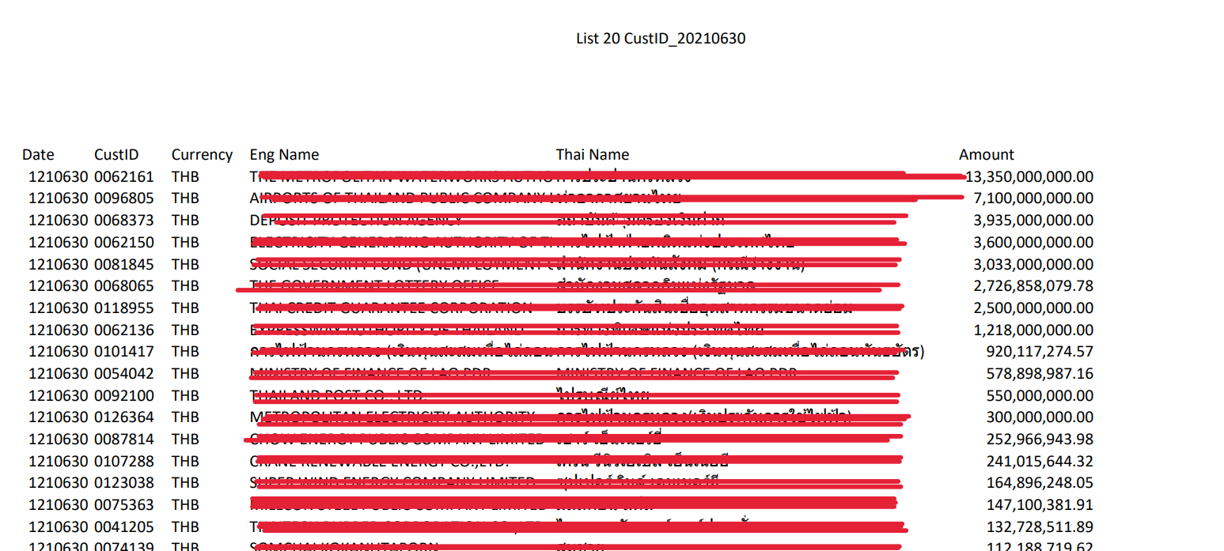

### Menu Modification

Not Applicable.

### Screen Layout and Data Sheet

Not Applicable.

### Business Rule / Business Logic

* List of top X transaction amount by customer ID and consolidate with all account type.
* FCD account should convert to THB by mid rate.
* Require historical data.

### To-be Process

The system retrieves list of top customer by outstanding balance with consolidate from all account type.

|  |  |
| --- | --- |
| Paper size | A4 |
| Reprinting require | Yes |
| Searching criteria | Date, Customer ID, Currency |

### File / API Layout and Data Sheet

Not Applicable.

### Report Layout and Data Sheet

#### List 20 CusID

|  |  |
| --- | --- |
| Report Field | Description |
| Header | |
| As At | Display as of date |
| Page | Display number of page |
| Printed date | Display printed date |
| Printed time | Display printed time |
| Printed by | Display user who login to system |
| Detail | |
| Date | Display date |
| Customer ID | Display customer ID |
| Currency | Display currency |
| English Name | Display customer name (English name) |
| Thai Name | Display customer name (Thai name) |
| Amount | Display amount |



#### ข้อมูลบัญชีลูกค้าเพื่อจัดทำงบการเงิน

**จำแนกตามประเภทเงินฝาก**

|  |  |
| --- | --- |
|  | 31 ธันวาคม 2565 |
| จ่ายคืนเมื่อทวงถาม (Current Account) | 2,035,517,752.58 |
| จ่ายคืนเมื่อทวงถาม (O/D) | 112,795,957.35 |
| จ่ายคืนเมื่อทวงถาม (FCD) แยกตามสกุลเงิน |  |
| USD(01) | 54,511,814.88 |
| JPY(04) | 137,879,524.21 |
| AUD(08) | 612,131.73 |
| EUR(18) | 1,640,097.78 |
| ออมทรัพย์(THB) | 7,227,428,305.17 |
| จ่ายคืนเมื่อสิ้นระยะเวลา |  |
| - ไม่ถึง 6 เดือน ( 3 เดือน ) THB | 1,716,000,000.00 |
| - 6 เดือนไม่ถึง 1 ปี ( 6 เดือน ) THB | 30,787,370,033.86 |
| - 1 ปีขึ้นไป ( 12 เดือน รวมที่ยังเป็น Term )THB | 6,561,111,762.17 |
| รวม |  |

**จำแนกตามระยะเวลาที่เหลือของสัญญารับฝากเงิน**

**For TD**

|  |  |
| --- | --- |
|  | 31 ธันวาคม 2565 |
| ไม่เกิน 1 ปี * THB | 39,064,481,796.03 |
| เกิน 1 ปี | 0.00 |

**จำแนกตามสกุลเงินและถิ่นที่อยู่ของผู้ฝาก**

**1. เงินรับฝากจากลูกค้า**

หน่วย : บาท

|  |  |  |  |
| --- | --- | --- | --- |
|  | 31 ธันวาคม 2565 | | |
| ในประเทศ | ต่างประเทศ | รวม |
| เงินบาท (ca,sa,fcd,fixed) |  |  |  |
| Fixed (THB) | 39,064,481,796.03 | 0.0 | 39,064,481,796.03 |
| CA(THB) | 2,033,200,329.31 | 440,822.67 | 2,033,641,151.98 |
| SA(THB) | 6,648,301,638.00 | 577,106,198.08 | 7,225,407,836.08 |
| USD(01) | 40,889,267.10 | 11,318,604.19 | 52,207,871.29 |
| JPY(04) | 137,879,524.21 | 0.00 | 137,879,524.21 |
| AUD(08) | 1.27 | 612,130.46 | 612,131.73 |
| EUR(18) | 1,326,580.20 | 0.00 | 1,326,580.20 |
| รวม |  |  |  |

ต่างประเทศ คือ Non resident

**2. เงินรับฝากระหว่างธนาคาร**

**(บัญชีประเภท Nostro account)**

หน่วย : บาท

|  |  |  |  |
| --- | --- | --- | --- |
|  | 31 ธันวาคม 2565 | | |
| ในประเทศ | ต่างประเทศ | รวม |
| เงินบาท (ca,sa,fix) |  |  |  |
| Fixed(THB) | 0.00 | 0.00 | 0.00 |
| CA(THB) | 1,876,600.60 | 0.00 | 1,876,600.60 |
| SA(THB) | 0.00 | 2,020,469.09 | 2,020,469.09 |
| USD(01) | 141.04 | 2,303,802.55 | 2,303,943.59 |
| JPY(04) | 0.00 | 0.00 | 0.00 |
| AUD(08) | 0.00 | 0.00 | 0.00 |
| EUR(18) | 0.00 | 313,517.58 | 313,517.58 |
| รวม |  |  |  |

### Additional Impacts

Not Applicable.

## Account Balance Report

|  |  |
| --- | --- |
| DPS-85 สร้างรายงานยอดเงินฝากคงเหลือในบัญชี แยกตามประเภทบัญชี รูปแบบ เป็น All Account และสามารถ Search Criteria ตามประเภทลูกค้า เช่น ประเภทลูกค้าบุคคลธรรมดา, นิติบุคคล, Non-Resident เป็นต้น | Generate account balance report Classified by account type, formatted as All Account, and able to define Search criteria according to customer type such as individual customers, Non-resident juristic persons, etc. |

### Purpose

The purpose is to provide list of account balance report by account type.

### Background

* + 1. EXIM Current Business Practice (as-is)
* As is report produced by AS/400.
* Auto-Generated after EOD
* Daily and Monthly

19.2.2 CBS9 Current Functionality

* Checking CBS9 report.
* Check for previous date criteria

### Supported Sample Transaction and Case from Customer

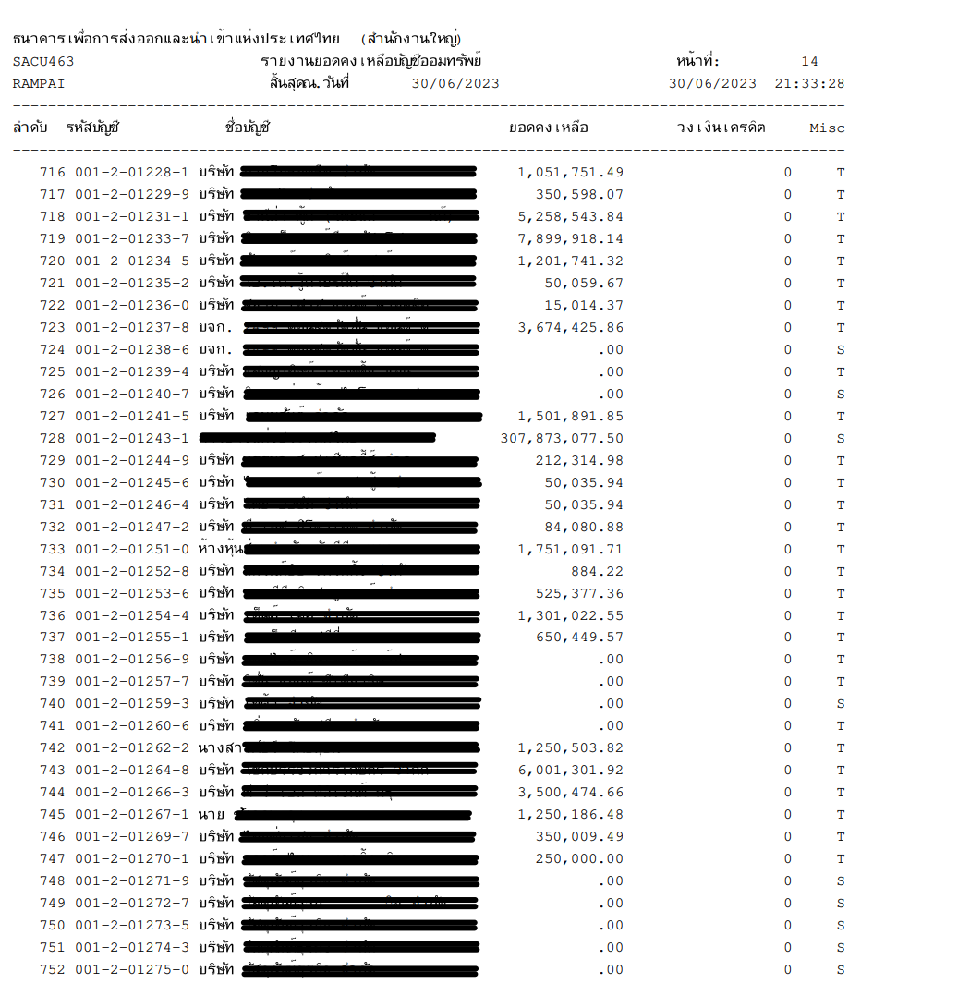

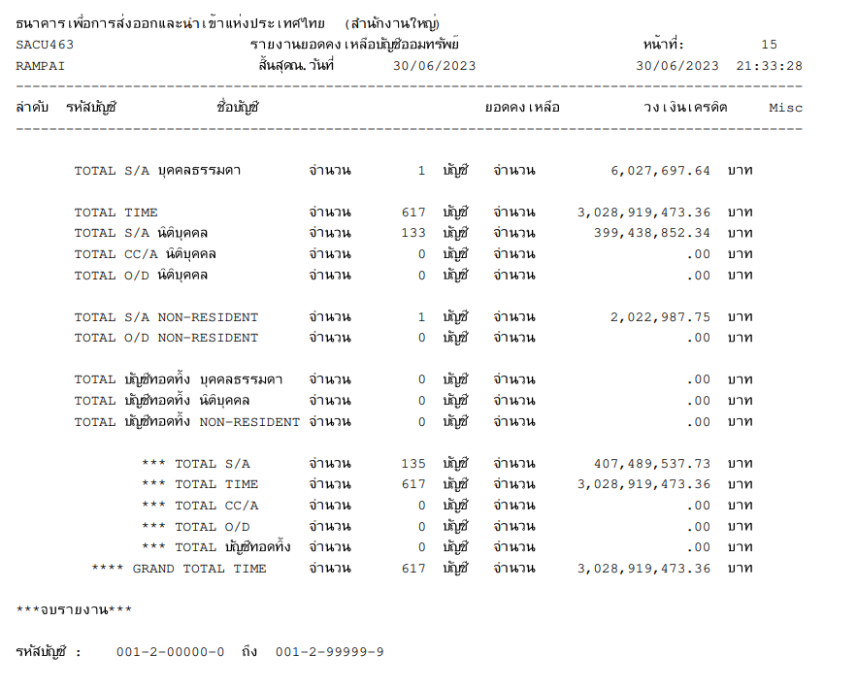

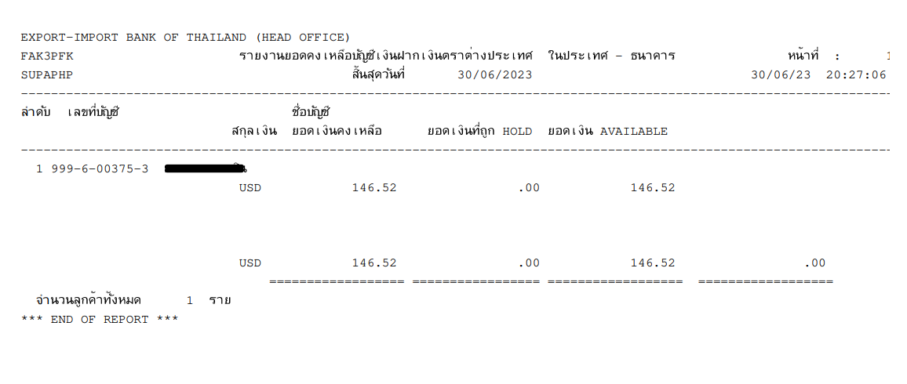

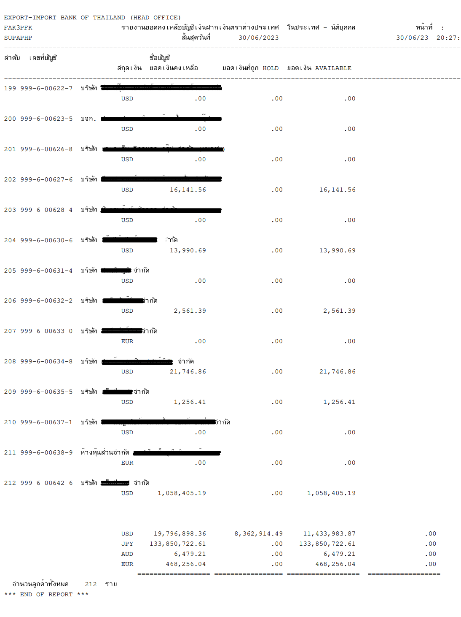

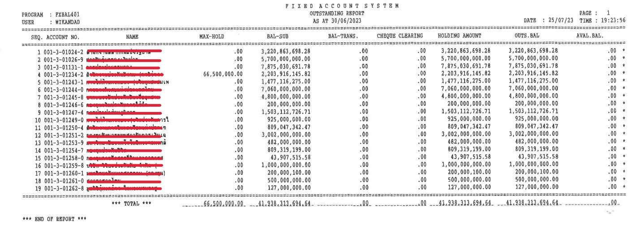

### Menu Modification

Not Applicable.

### Screen Layout and Data Sheet

Not Applicable.

### Business Rule / Business Logic

* System generates list of account balance report by account type.
* Auto-Generated after EOD .
* Daily and Monthly.
* Require historical data.

### To-be Process

The system retrieves the account balance by account type which can be separated by client branch.

|  |  |
| --- | --- |
| Paper size | A4 |
| Searching criteria | Branch code, Account type, Date |

### File / API Layout and Data Sheet

Not Applicable.

### Report Layout and Data Sheet

|  |  |
| --- | --- |
| Report Field | Description |
| Header | |
| As At | Display as of date |
| Page | Display number of page |
| Printed date | Display printed date |
| Printed time | Display printed time |
| Printed by | Display user who login to system |
| Detail | |
| สาขา (Branch) | Display customer branch |
| ประเภทบัญชี (Account type) | Display account type |
| ลำดับ (No.) | Display sequential of transaction |
| รหัสบัญชี (Account number) | Display account number |
| ชื่อบัญชี (Account name) | Display account name |
| ยอดคงเหลือ (Account balance) | Display account balance |
| วงเงินเครดิต (Credit limits) | Display credit limits |
| Misc | Display misc |
| Summary | Display summary |

Example FCD and TD report shown as exemplified in “19.3 Supported Sample Transaction and Case from Customer”



### Additional Impacts

Not Applicable.

## Overdraft Account Report

|  |  |
| --- | --- |
| DPS-86 สร้างรายงานบัญชีกระแสรายวันที่เป็นหนี้เบิกเกินบัญชี รูปแบบเป็น All Account | Generate overdraft account report formatted as All Account |

### Purpose

The purpose is to provide Overdraft report with limits and without limits.

### Background

* + 1. EXIM Current Business Practice (as-is)
* As is report produced by AS/400.
* Auto-Generated after EOD
* Daily and Monthly

20.2.2 CBS9 Current Functionality

* Checking CBS9 report.

### Supported Sample Transaction and Case from Customer

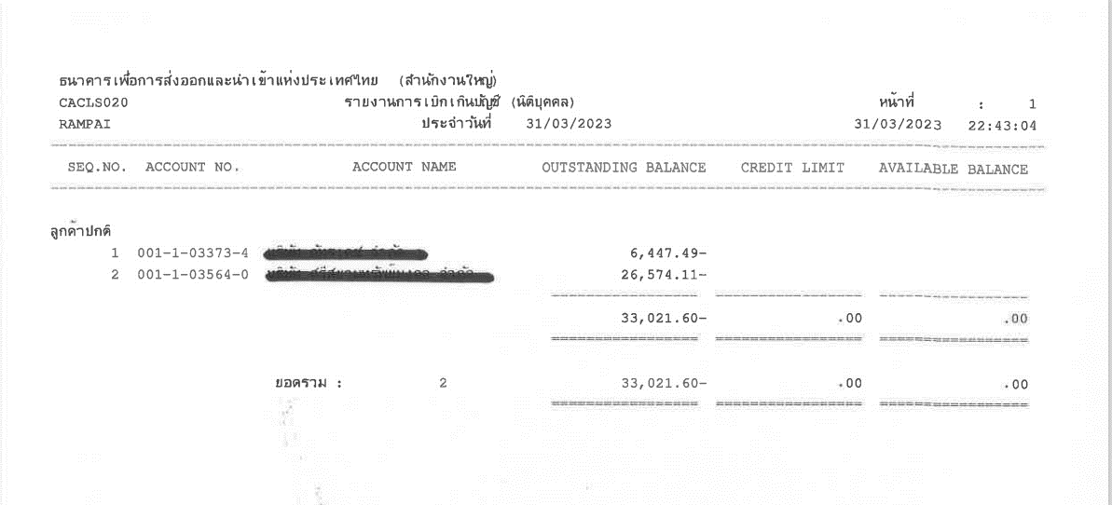

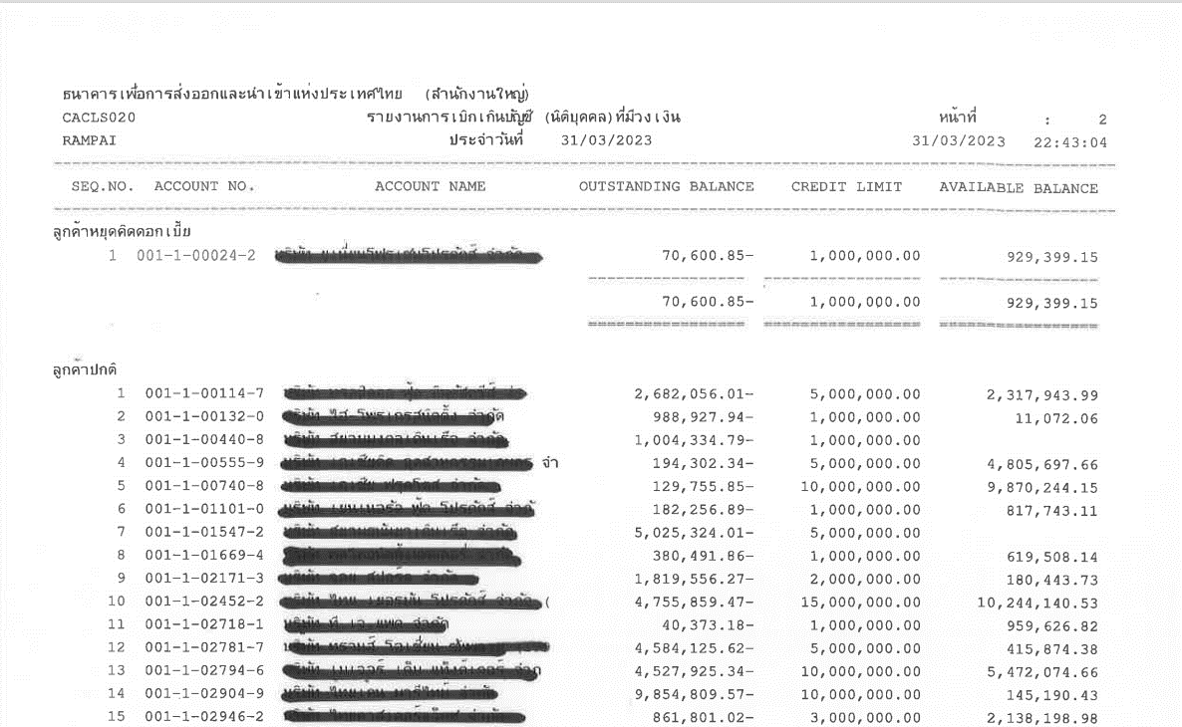

### Menu Modification

Not Applicable.

### Screen Layout and Data Sheet

Not Applicable.

### Business Rule / Business Logic

* System provide Overdraft report with limits and without limits.
* With limit, there are 2 groups : customers stop interest and regular customers
* Auto-Generated after EOD.
* Require historical data.

### To-be Process

The system retrieves the Overdraft outstanding balance with limits and without limits which can be separated by client branch and account type.

|  |  |
| --- | --- |
| Paper size | A4 |
| Reprinting require | Yes |
| Searching criteria | Branch code, Account type, Date, Account No. |

### File / API Layout and Data Sheet

Not Applicable.

### Report Layout and Data Sheet

#### Overdraft without limit

| Report Field | Description |
| --- | --- |
| Header | | |
| As At | Display as of date |
| Page | Display number of page |
| Printed date | Display printed date |
| Printed time | Display printed time |
| Printed by | Display user who login to system |
| Detail | | |
| Branch | Display customer branch |
| Account type | Display account type |
| SEQ No. | Display sequential of transaction |
| Account No. | Display account number |
| Account Name | Display account name |
| Outstanding Balance | Display outstanding balance |
| Credit Limit | Display credit limit  In case of short OD, do not show credit limit amount. |
| Available Balance | Display available balance |
| Total | Display total balance of each group |
| Grand total | Display grand total consolidate all |



#### With limit

| Report Field | Description |
| --- | --- |
| Header | | |
| As At | Display as of date |
| Page | Display number of page |
| Printed date | Display printed date |
| Printed time | Display printed time |
| Printed by | Display user who login to system |
| Detail | | |
| Branch | Display customer branch |
| Account type | Display account type |
| SEQ No. | Display sequential of transaction |
| Account No. | Display account number |
| Account Name | Display account name |
| Outstanding Balance | Display outstanding balance |
| Credit Limit | Display credit limit |
| Available Balance | Display available balance |
| Total | Display total balance of each group |
| Grand total | Display grand total consolidate all |



### Additional Impacts

Not Applicable.

## Overdraft Account Summary Report

|  |  |
| --- | --- |
| DPS-87 กรณีบัญชีเป็นหนี้เบิกเกินบัญชี ตั้งแต่ 3 เดือน หรือ 90 วัน ระบบสามารถสร้างรายงานเฉพาะบัญชีตามเงื่อนไขนี้ ได้ | In case of the account is overdraft from 3 months or 90 days, the system can generate a report for only the account under this condition. |

### Purpose

The purpose is to provide Overdraft outstanding summary report.

### Background

* + 1. EXIM Current Business Practice (as-is)
* As is report produced by AS/400.
* Online report.

21.2.2 CBS9 Current Functionality

* Checking CBS9 report.

### Supported Sample Transaction and Case from Customer

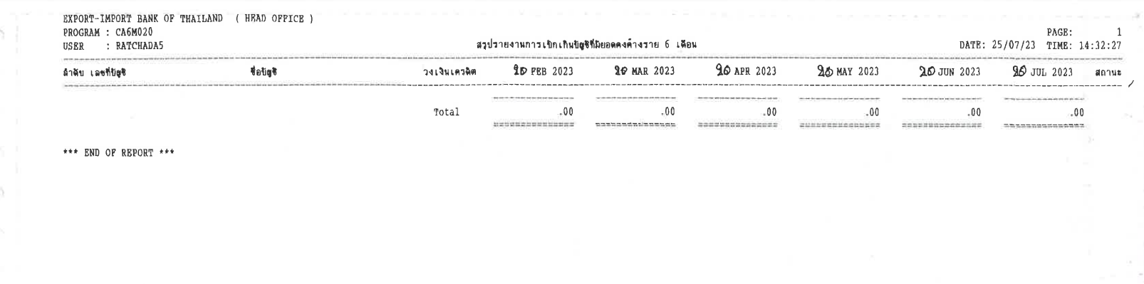

### Menu Modification

Not Applicable.

### Screen Layout and Data Sheet

Not Applicable.

### Business Rule / Business Logic

* System provide Overdraft outstanding summary of 6 months report.
* Online report.
* Require historical data.

### To-be Process

The system retrieves the Overdraft balance with limits and without limits which can be separated by client branch and account type.

|  |  |
| --- | --- |
| Paper size | A4 |
| Reprinting require | Yes |
| Searching criteria | Branch code, Account type, Date, Account No. |

### File / API Layout and Data Sheet

Not Applicable.

### Report Layout and Data Sheet

#### Overdraft without limit



### Additional Impacts

Not Applicable.

## Inactive Account Report

|  |  |
| --- | --- |
| DPS-88 ระบบสามารถสร้างและเรียกดูรายงานบัญชีที่ Inactive โดยสามารถกำหนดเงื่อนไขในช่วงระยะเวลาที่กำหนดได้ในระบบ และสามารถสั่งพิมพ์ออกมาเป็นรูปแบบไฟล์นามสกุล .Txt หรือ .CSV ได้ | The system can generate and retrieve reports on Inactive accounts. Conditions can be set for a specified period of time in the system. and can be printed out as a file extension of .Txt or .CSV |

### Purpose

The purpose is to provide Inactive account report.

### Background

* + 1. EXIM Current Business Practice (as-is)
* As is report produced by AS/400.
* Online, On request

22.2.2 CBS9 Current Functionality

* Checking CBS9 report.

### Supported Sample Transaction and Case from Customer

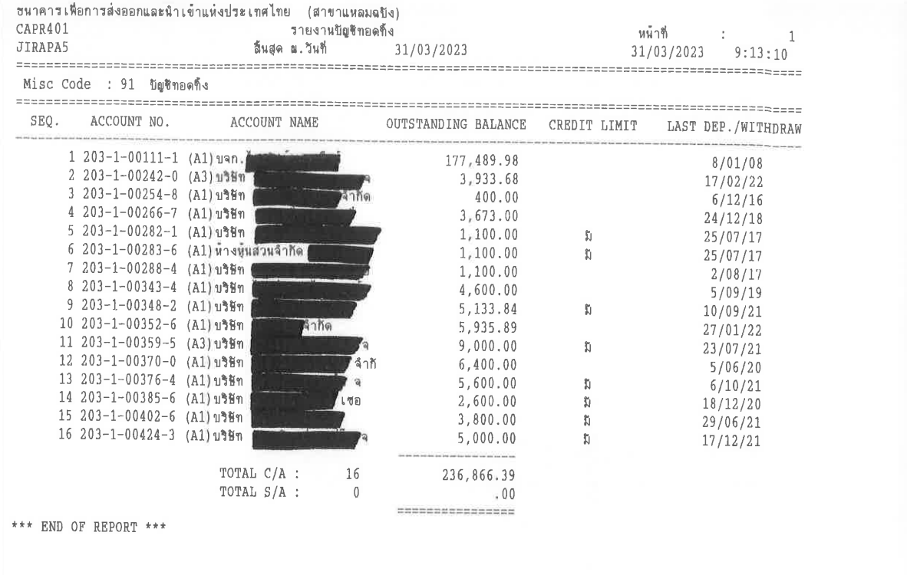

Dormant account

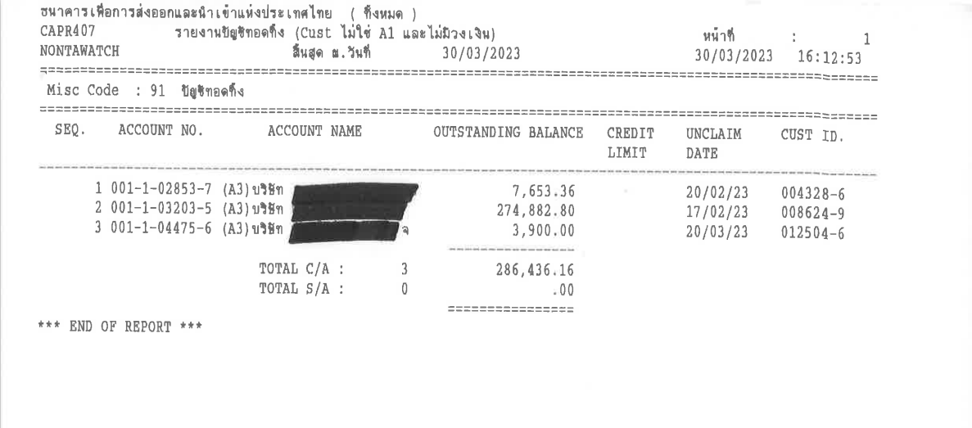

### Menu Modification

Not Applicable.

### Screen Layout and Data Sheet

Not Applicable.

### Business Rule / Business Logic

* Create 2 reports on EOD Process with all dormant account and dormant account with include AMLO rating exclude A1 and without limit. (All Credit limit of the customer).
* Online report.
* Require historical data.

### To-be Process

The system retrieves dormant account and dormant account which is without limit and AMLO rating exclude A1.

|  |  |
| --- | --- |
| Paper size | A4 |
| Reprinting require | Yes |
| Searching criteria | Branch code, Date, Account No., Restraint code, Account type |

### File / API Layout and Data Sheet

Not Applicable.

### Report Layout and Data Sheet

#### Inactive account with all credit limits and without limits (Dormant account)

| Report Field | Description |
| --- | --- |
| Header | | |
| As At | Display as of date |
| Page | Display number of page |
| Printed date | Display printed date |
| Printed time | Display printed time |
| Printed by | Display user who login to system |
| Detail | | |
| Branch | Display customer branch |
| Misc Code | Display Restraint |
| SEQ NO. | Display sequential of transaction |
| Account NO. | Display account number |
| AMLO Rating | Display AMLO rating |
| Account Name | Display account name |
| Outstanding Balance | Display outstanding balance |
| Credit Limit | Display credit limit / no credit limit |
| Last DEP./WITHDRAW | Display date of last deposit/withdraw |
| Total C/A | Display total number of current account and total outstanding balance |
| Total S/A | Display total number of saving account and total outstanding balance |



#### Inactive account without limit

| Report Field | Description |
| --- | --- |
| Header | | |
| As At | Display as of date |
| Page | Display number of page |
| Printed date | Display printed date |
| Printed time | Display printed time |
| Printed by | Display user who login to system |
| Detail | | |
| Branch | Display customer branch |
| Misc Code | Display Restraint |
| SEQ NO. | Display sequential of transaction |
| Account NO. | Display account number |
| AMLO Rating | Display AMLO rating |
| Account Name | Display account name |
| Outstanding Balance | Display outstanding balance |
| Credit Limit | Display credit limit (no limit) |
| Last DEP./WITHDRAW | Display date of last deposit/withdraw |
| Total C/A | Display total number of current account and total outstanding balance |
| Total S/A | Display total number of saving account and total outstanding balance |



### Additional Impacts

Not Applicable.

## 50 bis Withholding Tax

|  |  |
| --- | --- |
| DPS-89 สามารถออกใบภาษีหัก ณ ที่จ่ายเมื่อมีการหักภาษีจากดอกเบี้ย เช่น WHT, 50ทวิ | Able to issue withholding tax slip when tax is deducted from interest, eg WHT, 50bis. |

### Purpose

The purpose is to provide 50 bis Withholding tax when tax is deducted from interest payable.

### Background

* + 1. EXIM Current Business Practice (as-is)
* As is report produced by AS/400.
* Auto- Generated Monthly

23.2.2 CBS9 Current Functionality

* System supports interest tax deduction.
* 50 bis Withholding tax form will be create to new form.

### Supported Sample Transaction and Case from Customer

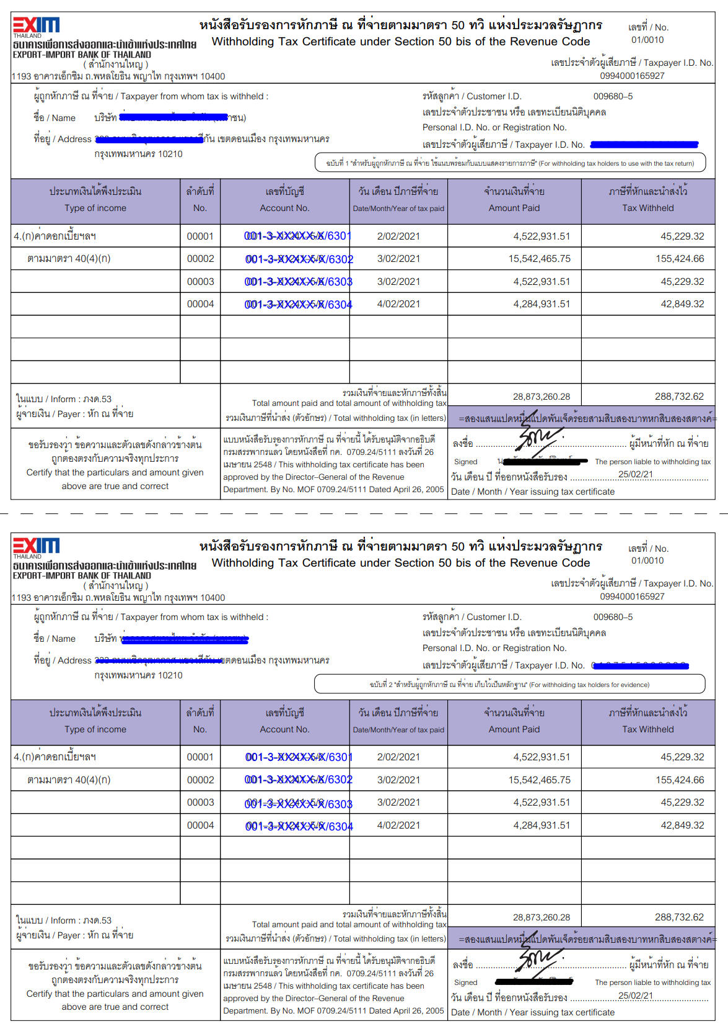

### Menu Modification

Not Applicable.

### Screen Layout and Data Sheet

Not Applicable.

### Business Rule / Business Logic

* System generates 50 bis Withholding tax when tax is deducted from interest payable and also placed with authorize e-signatured.
* Auto-Generate monthly
* Separate by account number
* Reprinting require

### To-be Process

Create new form for 50 bis Withholding tax and collect tax of the credit interest of account.

|  |  |
| --- | --- |
| Paper size | A4 |
| Reprinting require | Yes |
| Searching criteria | Customer ID, Account no, Date range |

### File / API Layout and Data Sheet

* Send to e-Services.

### Report Layout and Data Sheet

| Report Field | Description |
| --- | --- |
| Header | | |
| Branch name | Display customer branch |
| Branch address | Display branch address |
| เลขที่ / No. | Display Running No. Ex. Customer HO : 01/0001 , Cust Rm4 : 03/0001 etc. |
| Taxpayer ID | Display EXIM tax ID |
| Name | Display taxpayer name |
| Taxpayer address | Display taxpayer address |
| Customer ID | Display customer ID |
| Taxpayer ID | Display customer tax ID |
| Detail | | |
| Type of income | Display type of income (Interest) |
| No | Display sequential of transaction |
| Account no | Display account number  If TD account should display both main account number and sub-account |
| Date/Month/Year of tax paid | Display date of tax deduction |
| Amount paid | Display amount paid  Amount paid for FCY account , EXIM will check how to convert |
| Tax withheld | Display tax withheld |
| Total amount paid and tax withheld | Display amount paid / total tax withheld and amount in Thai letter |
| Date/Month/Year issuing tax certificate | Display date issuing |



### Additional Impacts

Not Applicable.

## PND Withholding Tax

|  |  |
| --- | --- |
| DPS-90 สามารถสร้างรายงานแสดงข้อมูลดอกเบี้ยและภาษีหัก ณ ที่จ่าย เพื่อนำส่งจำนวนเงินภาษี เช่น ภงด. 2, ภงด.2ก. ภงด 53 เป็นต้น | Able to generate a report showing interest and withholding tax information to submit tax amounts such as PND. 2, PND. 2A, PND. 53, etc. |

### Purpose

The purpose is to provide withholding tax information to submit tax amounts such as PND. 2, PND. 2A, PND. 53.

### Background

* + 1. EXIM Current Business Practice (as-is)
* As is report produced by AS/400.
* Auto- Generated Monthly

24.2.2 CBS9 Current Functionality

* Checking CBS9 report.

### Supported Sample Transaction and Case from Customer

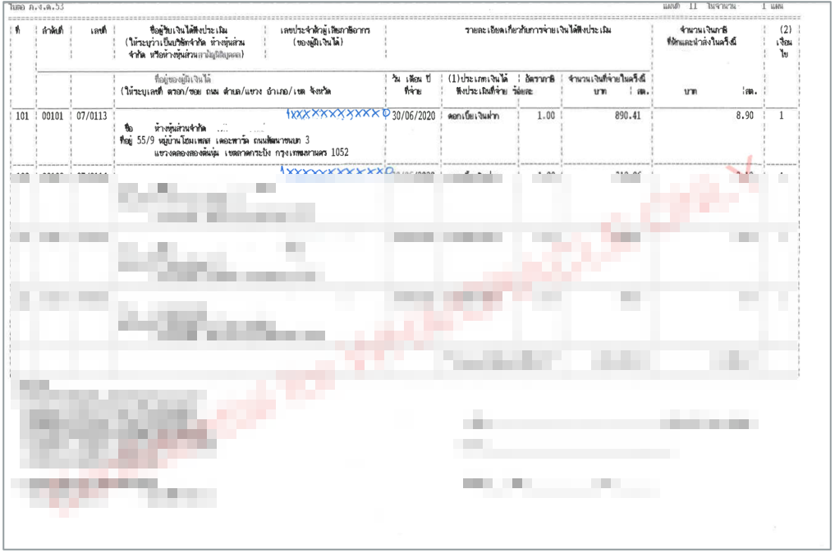

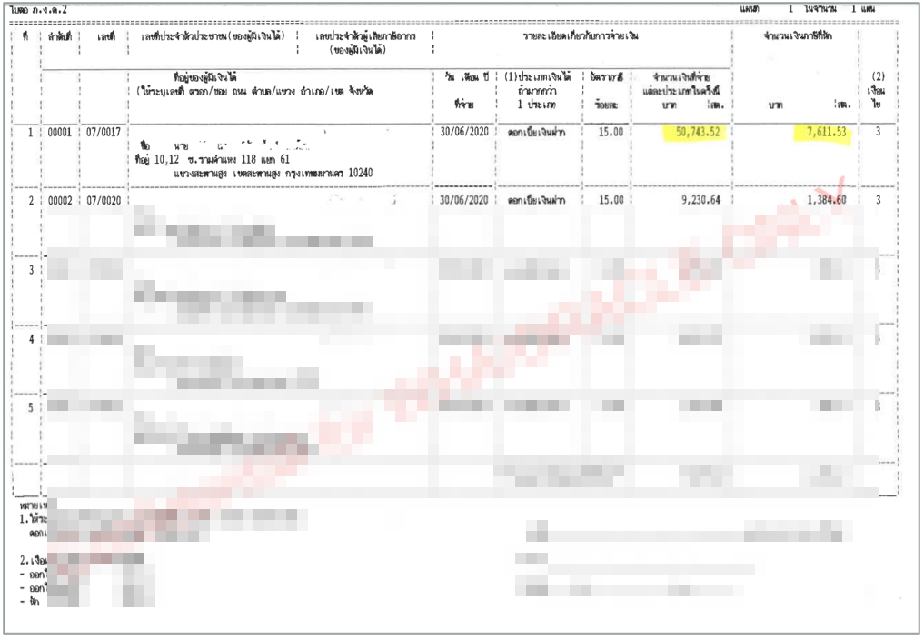

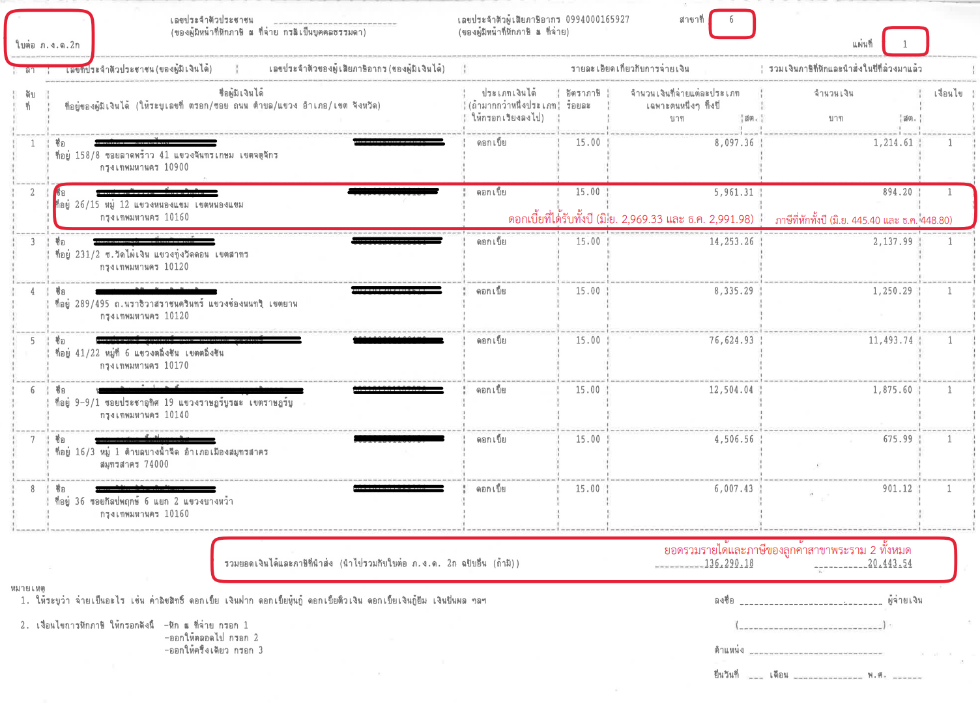

### Menu Modification

Not Applicable.

### Screen Layout and Data Sheet

Not Applicable.

### Business Rule / Business Logic

* System generates PND. 2, PND. 2A, PND. 53.
* Auto-Generate monthly
* Separate by report type : PND. 2, PND. 2A, PND. 53.
* Reprinting require

### To-be Process

Create new form for PND. 2, PND. 2A, PND. 53.

|  |  |
| --- | --- |
| Paper size | A4 |
| Reprinting require | Yes |
| Searching criteria | Customer ID, Account no, Date, Account type |

### File / API Layout and Data Sheet

Not Applicable.

### Report Layout and Data Sheet

#### Corporate (PND. 53)



#### Individual (PND. 2)



#### Summary (PND. 2A)



### Additional Impacts

Not Applicable.

## Withholding tax

|  |  |
| --- | --- |
| DPS-91 สามารถสร้างรายงานนำส่งภาษีหัก ณ ที่จ่ายเพื่อใช้ประกอบการนำส่งค่าภาษีไปยังกรมสรรพากร โดยสามารถเรียกพิมพ์รายงานตามช่วงเวลาได้ | Able to generate withholding tax remittance report to support tax remittance to the Revenue Department which can print reports at intervals |

### Purpose

The purpose is to provide withholding tax report for revenue department.

### Background

* + 1. EXIM Current Business Practice (as-is)
* As is report produced by AS/400.
* Auto- Generated Monthly

25.2.2 CBS9 Current Functionality

* Checking CBS9 report.

### Supported Sample Transaction and Case from Customer

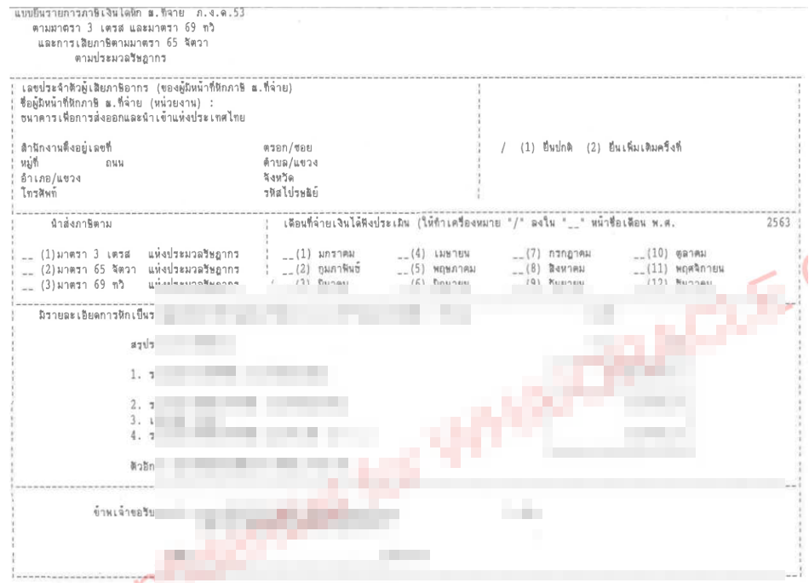

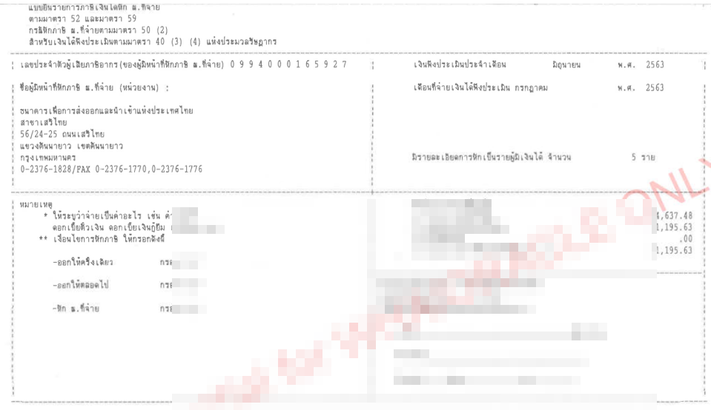

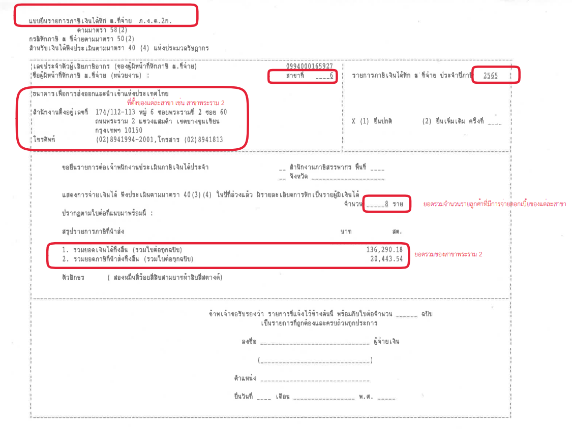

### Menu Modification

Not Applicable.

### Screen Layout and Data Sheet

Not Applicable.

### Business Rule / Business Logic

* Auto-Generate monthly
* Separate by report type : Corporate (PND. 53), Individual (PND. 2), PND. 2A.
* Summary interest payment and tax separate of each report by branch.
* Reprinting require

### To-be Process

Create withholding tax report for revenue department.

|  |  |
| --- | --- |
| Paper size | A4 |
| Reprinting require | Yes |
| Searching criteria | Customer ID, Account type, Date |

### File / API Layout and Data Sheet

### Report Layout and Data Sheet

#### Corporate



#### Individual



### Additional Impacts

Not Applicable.

## Tax of Interest text file

|  |  |
| --- | --- |
| DPS-92 สามารถสร้างข้อมูลภาษีจากการจ่ายดอกเบี้ย ตามรูปแบบ ที่กรมสรรพากรกำหนด เช่น Text File และสามารถนำข้อมูลไป Upload เข้าระบบของสรรพากร โดยสามารถแยกตามประเภทลูกค้าได้ เช่น ภงด 2 ภงด 2 ก หรือ ภงด 53 เป็นต้น  อ้างอิงการสร้างข้อมูลภาษี ตาม Tax/Localization Function G-67 | Can support the creation of tax information from interest payment according to the format specified by the Revenue Department such as Text File and can be uploaded into the revenue system which can be classified by customer type, such as PND 2, PND 2 Gor, or PND 53, etc.' Refer to tax data generation according to Tax/Localization Function G-67. |

### Purpose

The purpose is to provide tax information of interest by text file format.

### Background

### Supported Sample Transaction and Case from Customer

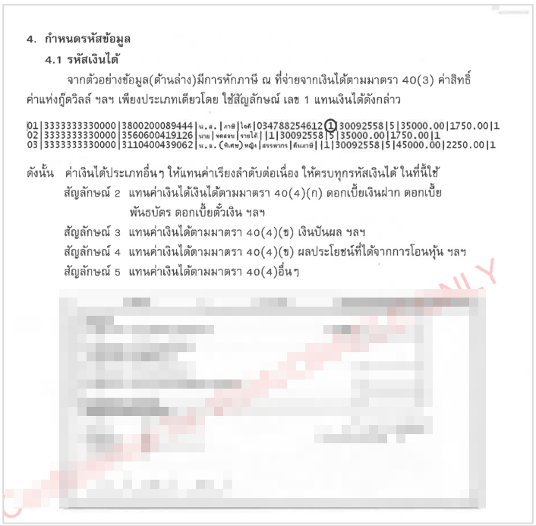

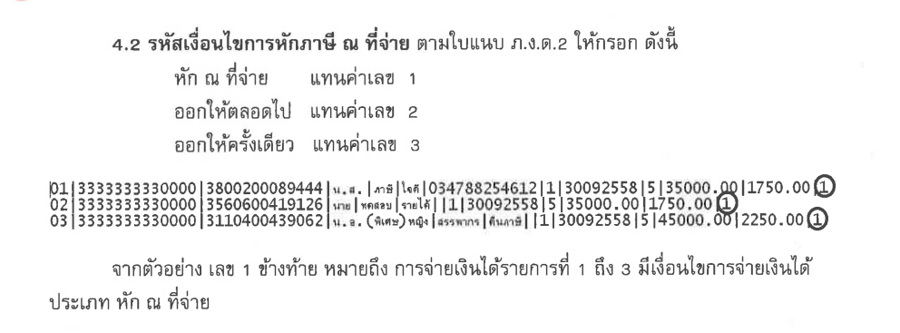

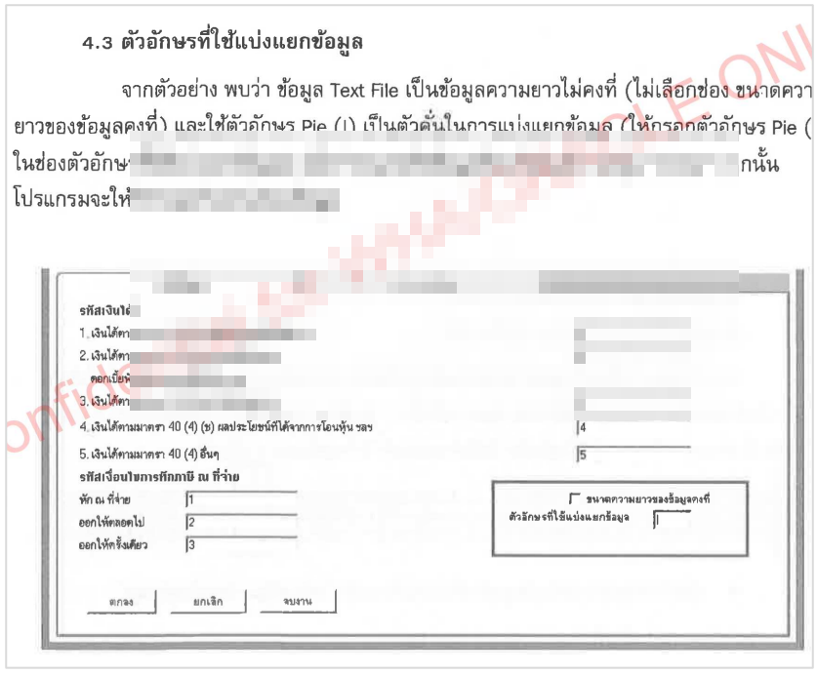

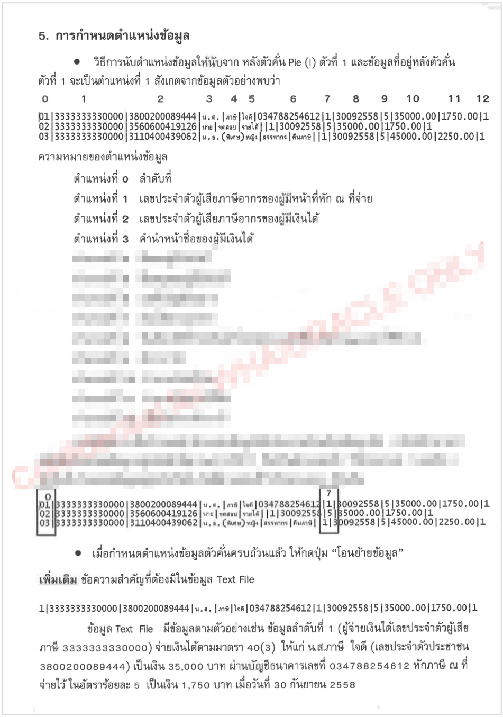

### Menu Modification

Not Applicable.

### Screen Layout and Data Sheet

Not Applicable.

### Business Rule / Business Logic

* System generates PND. 2, PND. 2, PND. 53. In text file with the format of revenue department.
* Auto-Generate monthly
* Separate by account number

### To-be Process

Convert the report of PND. 2, PND. 2, PND. 53. to text file.

### File / API Layout and Data Sheet

Not Applicable.

### Report Layout and Data Sheet

Not Applicable.

### Additional Impacts

Not Applicable.

## Overdraft Limit Report

|  |  |
| --- | --- |
| DPS-93 สร้างรายงานวงเงินเบิกเกินบัญชี รูปแบบเป็น All Account โดยแสดงข้อมูลอย่างน้อย เช่น จำนวนเงินตามวงเงิน ยอดเงินเบิกเกินบัญชีใช้ไป และจำนวนเงินคงค้างตามวงเงิน เป็นต้น | Create an overdraft limit report, formatted as All Account, showing at least information such as the limit amount. Overdraft balance used and the outstanding amount according to the limit, etc. |

### Purpose

The purpose is to provide Overdraft report to display limits amount, usage amount and limits outstanding.

### Background

* + 1. EXIM Current Business Practice (as-is)
* As is report produced by AS/400.
* Auto-Generated after EOD
* Daily report

27.2.2 CBS9 Current Functionality

* Checking CBS9 report.

### Supported Sample Transaction and Case from Customer

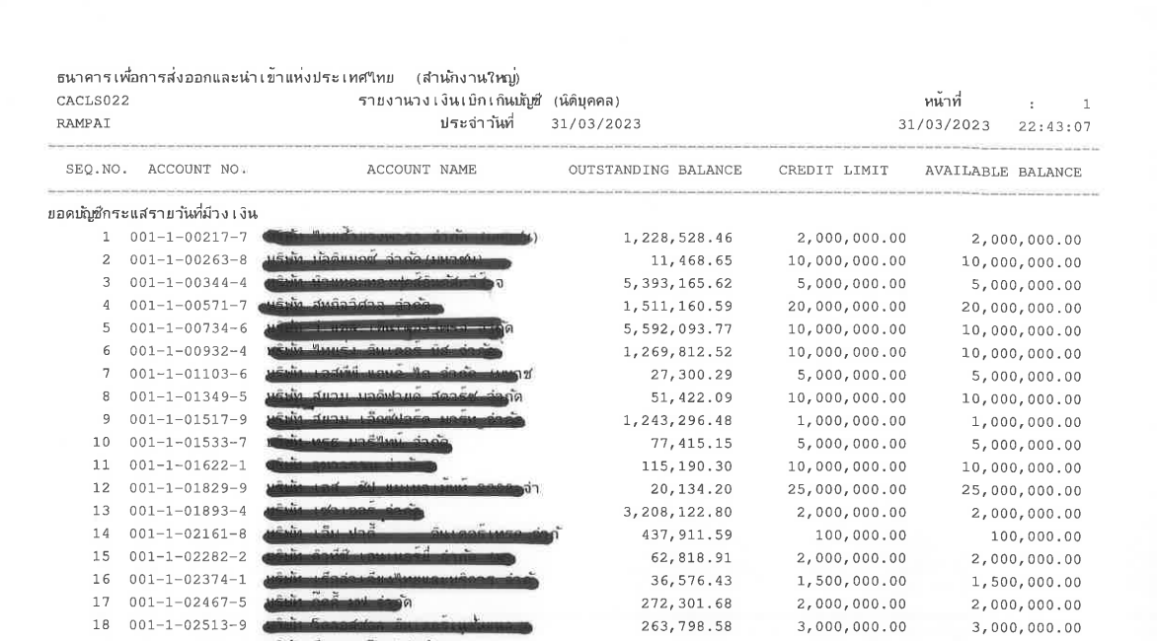

### Menu Modification

Not Applicable.

### Screen Layout and Data Sheet

Not Applicable.

### Business Rule / Business Logic

* Auto-Generated after EOD
* Require historical data
* Exclude short OD

### To-be Process

The system retrieves limits amount, usage amount and limits outstanding for all account.

|  |  |
| --- | --- |
| Paper size | A4 |
| Reprinting require | Yes |
| Searching criteria | Client branch, Date, Account type, Account no |

### File / API Layout and Data Sheet

Not Applicable.

### Report Layout and Data Sheet

| Report Field | Description |
| --- | --- |
| Header | | |
| As At | Display as of date |
| Page | Display number of page |
| Printed date | Display printed date |
| Printed time | Display printed time |
| Printed by | Display user who login to system |
| Detail | | |
| Branch | Display customer branch |
| Account type | Display account type |
| SEQ | Display sequential of transaction |
| Account NO. | Display account number |
| Account Name | Display account name |
| Outstanding Balance | Display outstanding balance |
| Credit Limit | Display credit limit |
| Available Balance | Display available balance |
| Total | Display total balance of each group |
| Grand total | Display grand total consolidate all |



### Additional Impacts

Not Applicable.

## Account Opening Report

|  |  |
| --- | --- |
| DPS-94 สามารถสร้างรายงานต่าง ๆ ที่เกี่ยวข้อง เช่น ปริมาณการเปิดบัญชีตามประเภทบัญชี และรายพนักงาน, รายงานบัญชีที่ไม่มีวงเงินสินเชื่อ | Able to generate various related report such as account opening by account type and marketing, report for accounts without credit limit |

### Purpose

The purpose of this report to support account opening and account without limits.

### Background

* + 1. EXIM Current Business Practice (as-is)
* As is report produced by AS/400.
* Online report

28.2.2 CBS9 Current Functionality

* Checking CBS9 report.
* Account opening report by account type
* Account closure report

### Supported Sample Transaction and Case from Customer

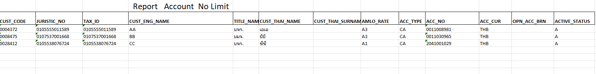

Limit : Customer level

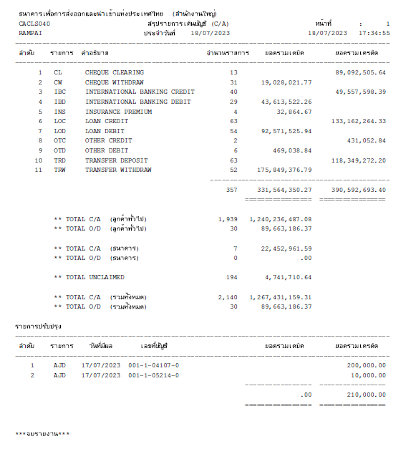

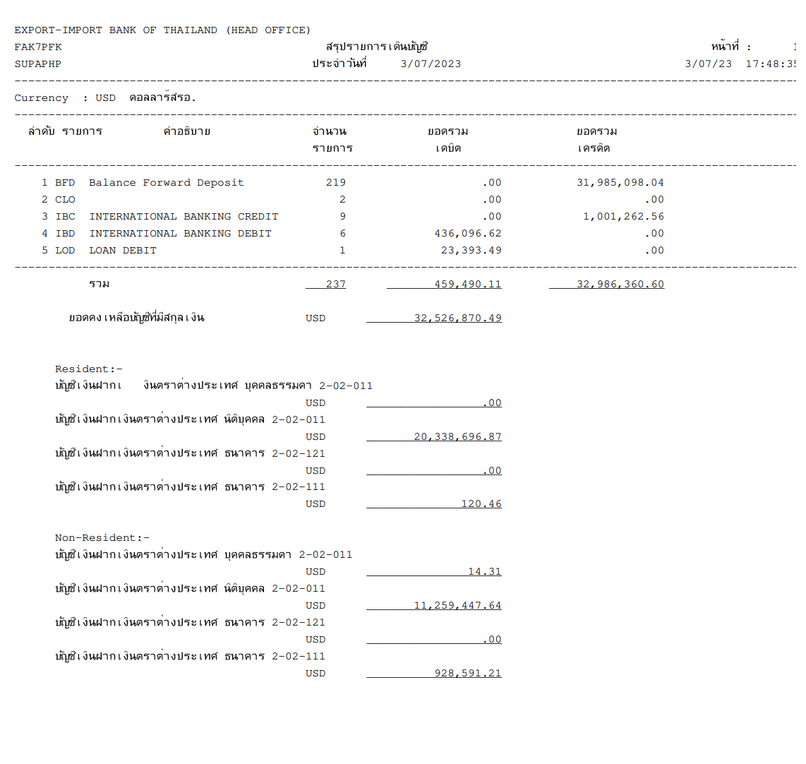

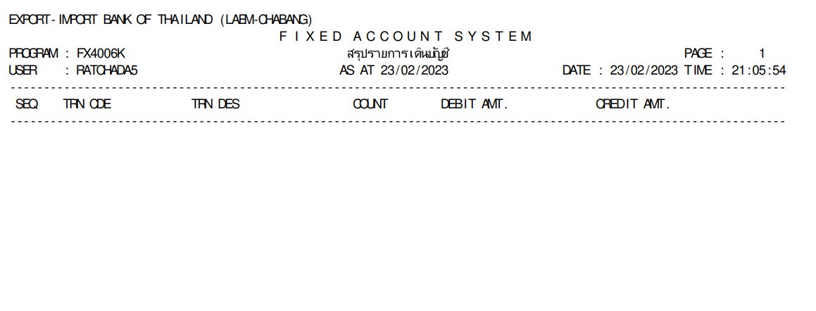

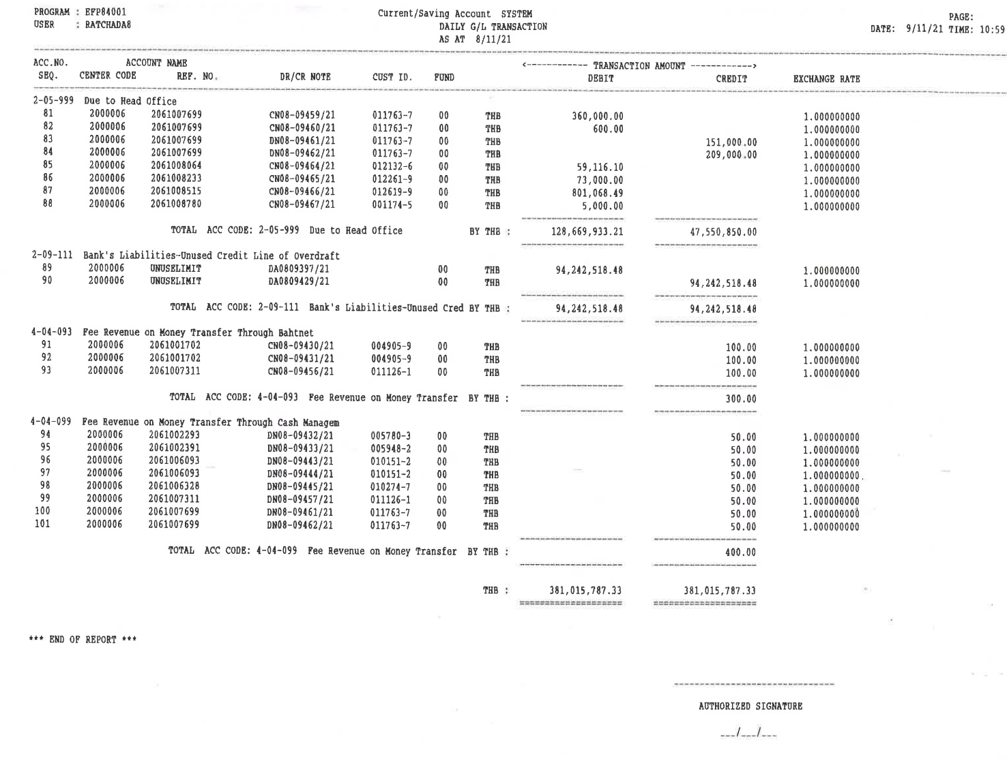

### Menu Modification

Not Applicable.

### Screen Layout and Data Sheet

Not Applicable.

### Business Rule / Business Logic

* System provide Account No Limit report by customer level.
* System provide summary of account statement by account type and separate by currency.
* System provide summary of account statement by fixed account.
* System provide daily G/L transaction.
* System provide daily summary transaction.
* Online report.
* Require historical data.

### To-be Process

The system retrieves the list of account opening, account closure and account without limit and provide report refer to “28.6 Business Rule / Business Logic.

|  |  |
| --- | --- |
| Paper size | A4 |
| Reprinting require | Yes |
| Searching criteria | Branch code, Account type, Date range, Account no, Currency |

### File / API Layout and Data Sheet

Not Applicable.

### Report Layout and Data Sheet

#### Opened accounts report

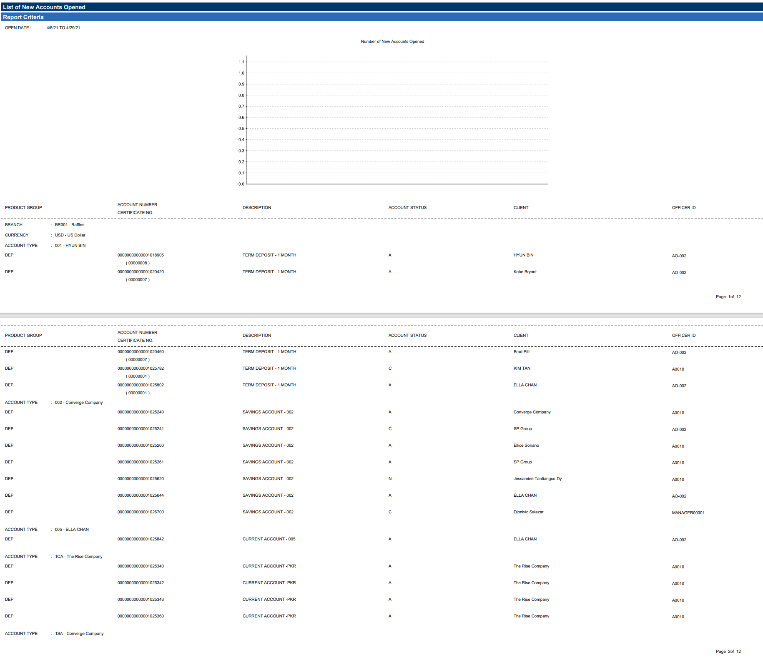

#### Closed accounts report

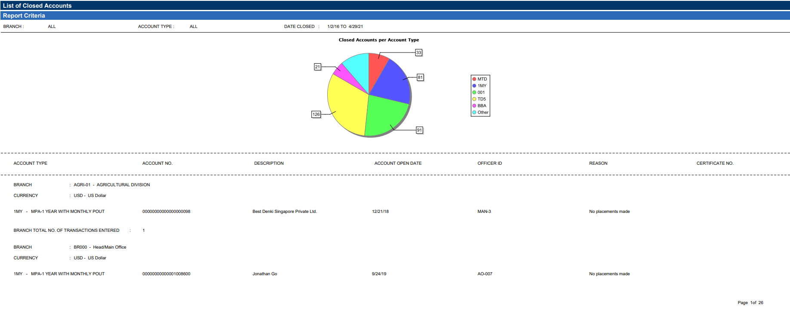

#### report for accounts without credit limit

| Report Field | Description |
| --- | --- |
| Header | | |
| As At | Display as of date |
| Page | Display number of page |
| Printed date | Display printed date |
| Printed time | Display printed time |
| Printed by | Display user who login to system |
| Detail | | |
| Customer ID | Display customer ID |
| Juristic Number | Display ID card number |
| Tax ID | Display tax ID |
| English Name | Display customer name (English) |
| Title | Display title |
| Thai Name | Display customer (Thai name) |
| AMLO Rating | Display AMLO rating |
| Account Type | Display account type |
| Currency | Display currency |
| Status | Display account status |



#### 28.9.4 Others report

* System provides summary of account statement by account type separate by currency.
* System provides summary of account statement by fixed account.
* System provides daily G/L transaction.
* System provides daily summary transaction.

### Additional Impacts

Not Applicable.

## Pre-Dormant Report

|  |  |
| --- | --- |
| DPS-95 ระบบสามารถออกรายงานบัญชีที่ไม่มีการเคลื่อนไหวติดต่อกัน 12 เดือน เป็น .csv หรือ Text file และสามารถตั้งค่าจำนวนเดือนเป็น Parameter ได้ | The system can issue a 12-month inactivity report as a .csv or a text file, and the number of months can be set as a parameter. |

### Purpose

The purpose of this report to provide 12 months inactive account.

### Background

* + 1. EXIM Current Business Practice (as-is)
* As is report produced by AS/400.
* Auto-Generated after EOD
* Daily report

29.2.2 CBS9 Current Functionality

* Checking CBS9 report.

### Supported Sample Transaction and Case from Customer

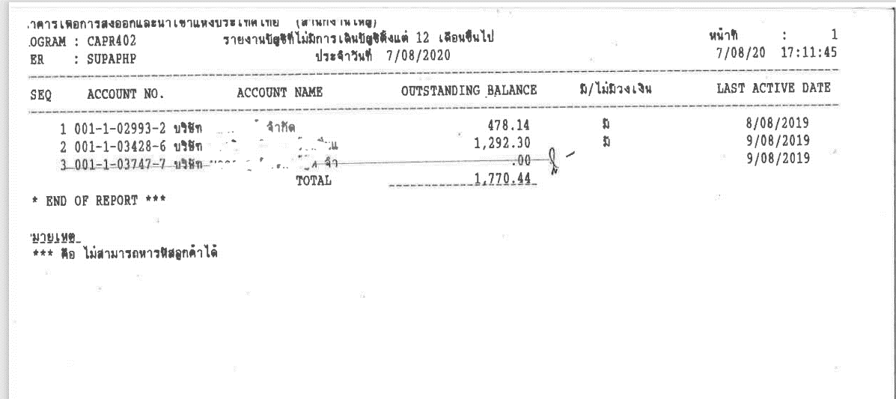

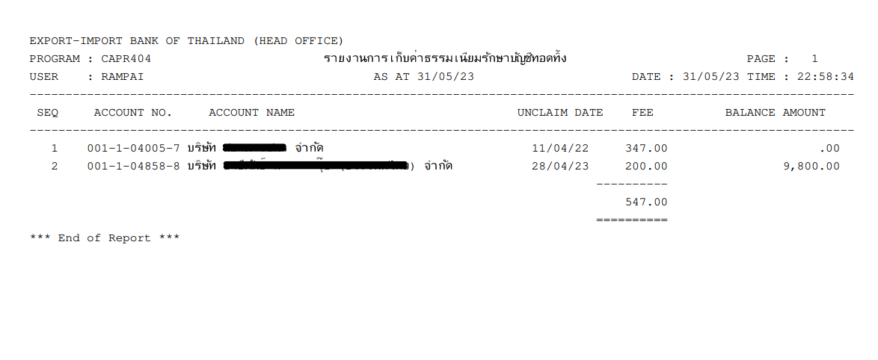

### Menu Modification

Not Applicable.

### Screen Layout and Data Sheet

Not Applicable.

### Business Rule / Business Logic

* System provide 12 months inactive account report base on notification letter of pre-dormant account.
* System provide dormant fees report by monthly.
* Auto-Generated after EOD.
* Require historical data.
* Reprinting require.

### To-be Process

The system retrieves 12 months inactive account report base on notification letter of pre-dormant account and provide dormant fees report by monthly which can be separated by client branch.

|  |  |
| --- | --- |
| Paper size | A4 |
| Reprinting require | Yes |
| Searching criteria | Branch code, Account type, Account no, Date range |

### File / API Layout and Data Sheet

Not Applicable.

### Report Layout and Data Sheet

#### Pre-dormant report

| Report Field | Description |
| --- | --- |
| Header | | |
| Transaction Date | Display date |
| Page | Display number of page |
| Printed date | Display printed time |
| Printed time | Display printed time |
| Printed by | Display user who login to system |
| Detail | | |
| SEQ | Display sequential of transaction |
| Account NO | Display account number |
| Account Name | Display account name |
| Outstanding Balance | Display outstanding balance |
| Limits | Display limit |
| Last Active Date | Display last active date |
| Total | Display total amount |



#### Dormant fees report

| Report Field | Description |
| --- | --- |
| Header | | |
| Transaction Date | Display date |
| Page | Display number of page |
| Printed date | Display printed time |
| Printed time | Display printed time |
| Printed by | Display user who login to system |
| Detail | | |
| SEQ | Display sequential of transaction |
| Account NO | Display account number |
| Account Name | Display account name |
| Dormant Date | Display Dormant date |
| Fee | Display Fee amount |
| Balance amount | Display Balance amount |
| Total | Display total fee amount |



### Additional Impacts

Not Applicable.

## Uncollected Service Charge Report

|  |  |
| --- | --- |
| DEP-04 รายงานสรุปประจำวันบัญชีเงินฝากสกุลเงินต่างประเทศ ในกรณีที่มียอดคงเหลือน้อยกว่าค่าธรรมเนียมการฝาก | Daily Summary Foreign Currency Report in case the balance is zero or the balance is less than the deposit fee |
| DEP-09 สืบเนื่องจาก DEP-04 ในกรณีที่มียอดเงินคงเหลือไม่พอให้หักค่าธรรมเนียมการฝากเงินให้รายงานแสดง 'Uncollection Amount' | According to DEP-04, in case of insufficient balance for deosit fee to be deducted, the report shall show 'Uncollection Amount' |

### Purpose

The purpose of this report is to support uncollected service charge amount of account.

### Background

* + 1. EXIM Current Business Practice (as-is)
* As is report produced by manually.
* Online report.
* Daily report.

29.2.2 CBS9 Current Functionality

* Checking CBS9 report.

### Supported Sample Transaction and Case from Customer

Not Applicable.

### Menu Modification

Not Applicable.

### Screen Layout and Data Sheet

Not Applicable.

### Business Rule / Business Logic

* Online report.
* Require historical data.
* Only uncollected transactions are listed.

### To-be Process

|  |  |
| --- | --- |
| Paper size | A4 |
| Reprinting require | Yes |
| Searching criteria | Branch code, Account type, Account no, Date range |

### File / API Layout and Data Sheet

Not Applicable.

### Report Layout and Data Sheet

| Report Field | Description |
| --- | --- |
| Header | | |
| As At | Display as of date |
| Page | Display number of page |
| Printed date | Display printed date |
| Printed time | Display printed time |
| Printed by | Display user who login to system |
| Detail | | |
| Customer ID | Display customer ID |
| Account No. | Display account number |
| Account Name | Display account name |
| Transaction type | Display transaction type |
| Transaction No. | Display transaction number |
| Currency | Display currency |
| Fee Accumulate | Display fee accumulate |
| Available Balance | Display available balance |
| Uncollected Amount | Display uncollected amount |
| Total amount | Display total amount |



### Additional Impacts

Not Applicable.

## Overdraft Projection Report

|  |  |
| --- | --- |
| DPS-25 มีช่องทางที่สามารถคำนวณดอกเบี้ย OD และดอกเบี้ยจ่าย แบบ Simulate ดอกเบี้ยล่วงหน้า โดยไม่ทำการบันทึกบัญชีได้ | There is a channel that can calculate interest, OD and interest expenses in a Simulate interest in advance without bookkeeping |

### Purpose

Projection accrual, OD interest and Interest expense for a specified period of time. For the interest projection can provide 2 ways of computation; compounding interest and simple interest.

### Background

* + 1. EXIM Current Business Practice (as-is)
* As is report produced by manually.
* Online report
* Daily report

30.2.2 CBS9 Current Functionality

* Checking CBS9 report.

### Supported Sample Transaction and Case from Customer

### Menu Modification

Not Applicable.

### Screen Layout and Data Sheet

Not Applicable.

### Business Rule / Business Logic

* Online report.
* System provide 2 ways of computation: compounding interest and simple interest.
* Summarize the balance on a monthly basis.

### To-be Process

System provide 2 ways of computation: compounding interest and simple interest.

|  |  |
| --- | --- |
| Paper size | A4 |
| Reprinting require | Yes |
| Searching criteria | Account no, Date |

### File / API Layout and Data Sheet

Not Applicable.

### Report Layout and Data Sheet

| Report Field | Description |
| --- | --- |
| Header | | |
| Account name | Display account name |
| Account No. | Display account number |
| Overdue start date | Display date overdue start date |
| Detail | | |
| Dd/mm/yyyy | Display date |
| Days | Display number of days |
| Interest rate | Display interest rate |
| Code | Display transaction code |
| Transaction | Display transaction description |
| Debtor | Display debit amount |
| Creditor | Display credit amount |
| Balance | Display balance amount |
| Base for interest calculation | Display base amount |

**Example 1 : OD Projection compounding interest computation**

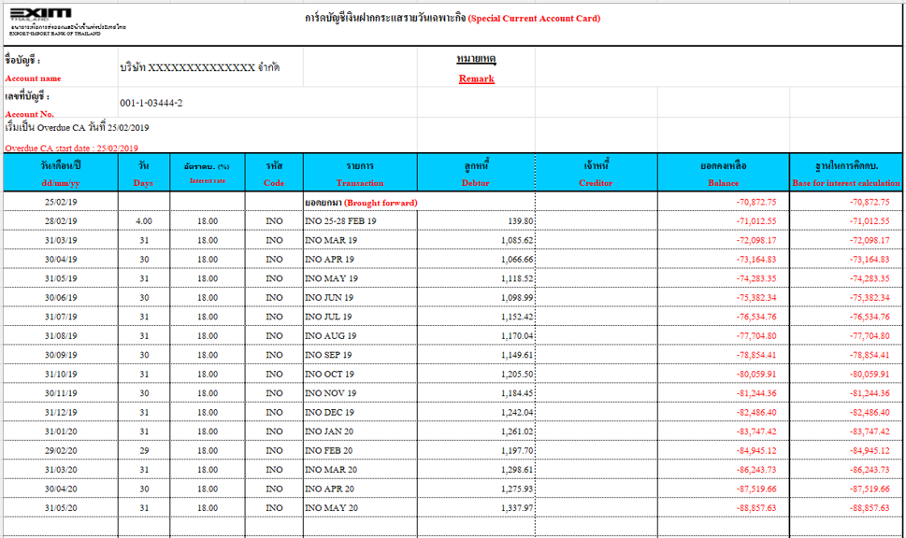

**Example 2 : OD Projection simple interest computation**



### Additional Impacts

Not Applicable.

**\*\*\*\* เพิ่มชื่อธนาคาร / ชื่อรายงาน/ Total Amount / ***End of report*** (ทุกรายงาน)**